

LOCAL ROADS CONNECTIVITY PROJECT
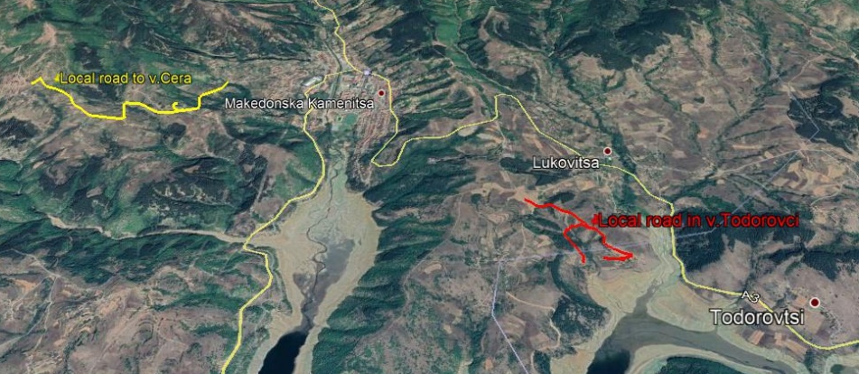

December 2020
ENVIRONMENTAL AND SOCIAL MANAGEMENT PLAN (ESMP)
Upgrading of local road in village Todorovci and local road in village Cera, section from Krapevska Maala to Stipcarska Maala and road branch to neighborhood Cemetery, in Municipality of Makedonska Kamenica

Prepared by:
Slavjanka Pejchinovska-Andonova, MSc, Environmental Engineer
Environmental and Social (E&S) Specialist
TABLE OF CONTENTS
1. INTRODUCTION 2
2. PROJECT DESCRIPTION 3
2.1 Baseline condition of Municipality of Makedonska Kamenica 3
2.1.1 Demography 4
2.1.2 Climate features 4
2.1.3 Seismology 5
2.1.4 Water 5
2.1.5 Air quality 6
2.1.6 Waste 7
2.1.7 Geology and soil 7
2.1.8 Flora and fauna 8
2.1.9 Noise 9
2.1.10 Cultural heritage 9
2.2 Project location 10
2.3 Project Activities 12
2.4 Sensitive receptors 13
3. POTENTIAL ENVIRONMENTAL IMPACTS AND RISK AND IMPACTS AND RISK ASSESSMENT 13
Implementation of ESMP 16
Public disclosure and citizen engagement 18
4. ENVIRONMENTAL AND SOCIAL MITIGATION PLAN 21
5. ENVIRONMENTAL AND SOCIAL MONITORING PLAN 24
6. ANNEX 29

FIGURES
Figure1 Location of the projects area in relation with the Municipality of Makedonska Kamenica 4
Figure 2 Map with potential natural hazards (erosion, floods, landslides and earthquakes) in RNM 5
Figure 3 Project location regarding the watershed of river Bregalnica 6
Figure 4 Project location according the proposed protected area “Osogovski Planini” 8
Figure 5 Location of the upgrading of local road in village Todorovci and local road in village Cera, section from Krapevska Maala to Stipcarska Maala and road branch to neighborhood Cemetery, in Municipality of Makedonska Kamenica 10
Figure 6 Current situation with the local road to the village of Cera, section from Krapevska maala to Stipcarska maala, and access road to the neighborhood cemetery 11
Figure 7 Location of the sub project local road to village Todorovci 11
Figure 8 Current situation with the local road to the village Todorovci 12
Figure 9 Location of IPA “Osogovski planini” related to sub projects location 29
Figure 10 Location of IBA “Osogovo” related to sub - projects location 29
Figure 11 Location of Emerald site “Osogovski Planini” related to sub projects location 29
TABLES
Table1 Planned project activities for the upgrading of local road in village Todorovci and local road in village Cera, section from Krapevska Maala to Stipcarska Maala and road branch to neighborhood Cemetery, in Municipality of Makedonska Kamenica 14
Table 2 The potential environmental impacts and risks during implementation of the project 15
Table 3 COVID-19 considerations in construction/civil works projects recommended by WB 42
ANNEXES
Annex 1 Map of sensitive areas in the wider surrounding of the sub - projects location in Municipality of Makedonska Kamenica 29
Annex 2 Layouts of the local road in v. Todorovci in Municipality of Makedonska Kamenica 29
Annex 3 COVID-19 considerations in construction/civil works projects 40
Annex 4 Form for submitting comments 46
Annex 5 Grievance Form for whole project implementation period 47
ABBREVIATIONS
EIA | Environmental Impact Assessment
ESMF | Environmental and Social Management Framework
ESMP | Environmental and Social Management Plan
ES | Environmental and social
ESS | Environmental and social standards
IPA | Important Plant Area
IBA | Important Bird Area
LRCP | Local Road Connectivity Project
MoEPP | Ministry of Environment and Physical Planning
MOSHA | Macedonian Occupational Safety and Health Association
MSC | Macro seismic
MoTC | Ministry of Transport and Communications
OH&S;  OHS | Occupational Health and Safety
PCE | Public Communal Enterprise
PPE | Personal protection equipment
PIU | Project Implementation Unit
RM | Republic of Macedonia
RNM | Republic of North Macedonia
TMP | Traffic Management Plan
WB | World Bank
WHO | World Health Organization

INTRODUCTION
The transport sector in Republic of North Macedonia is characterized by poor condition of the local roads network, unsatisfactory level of financing of road maintenance on national level and there are weaknesses of international investment in distribution sector and transport sector. Such poor condition of the local roads is as result of lack of financial capacity of the Local Self Government that differs from region to region in the country. Some local roads in the rural areas are in an unacceptable condition with no access to the hospitals, schools and markets so this issue brings social problems as well.
In order to support the municipalities in the Republic of North Macedonia by 70 million Euro investment secured by the World Bank, Ministry of transport and communications will implement the Local Roads Connectivity Project (LRCP) mostly in rehabilitation of existing local road infrastructure (urban / rural streets, regional and local roads), rehabilitation, upgrading, pedestrian paths, street lighting, water drainage and capacity building of the municipal staff.
When preparing these types of projects, according to the national environmental requirements (Law on Environment and secondary legislation), it is necessary to submit a Notification Letter for intention to start the project to the MoEPP which initiates the environmental impact assessment procedure and based on the Opinion, to prepare the EIA Report. If the issued Opinion of the MoEPP is positive and EIA Report has to be prepared.
The prepared EIA Report is in accordance with Article 24 of the Law on Environment (Official Gazette of the Republic of North Macedonia No 53/05, 81/05, 24/07, 159/08, 83/09, 48/10, 124/10, 51/11, 123/12, 93/13, 187/13, 42/14, 44/15, 129/15, 192/15, 39/16 and 98/18) and the Rulebook on the Form and Contents of the EIA Report in accordance with the types of activities for which the report is being prepared, as well as in accordance with the entities performing the activity and the scope of activities being performed by the legal and natural entities, the procedure for their approval, as well as the method for keeping of the register of approved reports (Official Gazette of the Republic of North Macedonia No 44/13, 111/14).
Since the project “Upgrading of local road in village Todorovci and local road in village Cera, section from Krapevska Maala to Stipcarska Maala and road branch to neighborhood Cemetery, in Municipality of Makedonska Kamenica” in accordance with the national legislation belongs to the Chapter X – Infrastructure projects, item 1 Upgrading of local roads, the EIA Reports for the both sub projects were prepared in June 2020. The EIA Report for the upgrating of local road in village Cera was approved by the Mayor of the Municipality of Makedonska Kamenica with Decision that was issued on 16.06.2020 with number 12-1015/2. The EIA Report for the upgrating of local road in village Todorovci was approved by the Mayor of the Municipality of Makedonska Kamenica with Decision that was issued on 16.06.2020 with number 12-1018/2.
The Municipality of Makedonska Kamenica send a copy of the prepared EIA Reports together with the Decisions to the MoTC with other technical documents.
In order to address Project’s potential environmental and social concerns in accordance with the requirements of the World Bank Environmental and Social Standards, Environmental and Social Management Framework (ESMF) was prepared for the whole LRCP project in September/October 2019. ESMF issued, as the most appropriate tool for addressing environmental and social aspects of sub-projects identified in the course of project preparation and implementation.
The project “Upgrading of local road in village Todorovci and local road in village Cera, section from Krapevska Maala to Stipcarska Maala and road branch to neighborhood Cemetery, in Municipality of Makedonska Kamenica” has an aim to improve the road infrastructure in the villages Cera and Todorovci near the city of Makedonska Kamenica and provide better connection with the neighborhoods within the villages and also with the city of Makedonska Kamenica.
The existing asphalt on the local road to the village of Cera, section Krapevska maala to Stipcarska maala is very damaged with visible cracks, a large number of bumps, transverse excavations. The road has a total length of 2,409 km. Road width is around 4 m and 0,5 m earth shoulders from the both sides of the road.
The local road to village Todorovci is earth road, in bad condition. The road has a total length of 1,493 km.
Near the subject locations of the local roads in v. Todorovci and v. Cera is accumulation Kalimanci and city of Makedonska Kamenica. Along the road to v. Cera, on the both sides, there are arable agricultural areas and houses, as well as local cemetery for this neigborhoods on the left side. There are agricultural fields at the beginning and at the end of the local road to v.Todorovci, near the houses.
According the Main design for the project, the main project activities for the local road to village Cera will include: marking and securing the route, mechanical cutting of existing asphalt, machine excavation on the ground, making an earth embankment, making a bedding, making concrete gutters by precast concrete elements, concreting the bottom and walls of the drainage, making a buffer layer, placing road base layer, construction of bank with mechanical stabilization, bearing bitumen layer over existing asphalt.
According the Main design for the project, the main project activities for the local road to village Todorovci will include: marking and securing the route, machine excavation on the ground, making an earth embankment, making a bedding, making a buffer layer, placing road base layer.
Taking into account the nature of project activities, technical specifications, size of the local roads, location of upgrading activities, as well as the specifics of the potential environmental impacts during the upgrading of the roads, the Project Upgrading of local road in village Todorovci and local road in village Cera, section from Krapevska Maala to Stipcarska Maala and road branch to neighborhood Cemetery, in Municipality of Makedonska Kamenica was classified as project with substantial risks, which requires the preparation of Environmental and Social Management Plan (ESMP) in accordance with the WB environmental and social standards.

PROJECT DESCRIPTION

Baseline condition of Municipality of Makedonska Kamenica
The Municipality of Makedonska Kamenica is located in the Eastern Region of the R. Macedonia in the foothills of the Osogovo massif. In the east, it borders with the municipality of Makedonska Kamenica, in the south with the municipality of Vinica, in the west with the municipality of Kochani, and in the north with the municipality of Kriva Palanka and with the country’s border with the Republic of Bulgaria. Total area of the municipality is 189 km2.
The Municipality of Makedonska Kamenica belongs to the East Planning Region which covers the catchment area of the river Bregalnica and covers an area of 3,537 km². Makedonska Kamenica has a good geographical position, because it crosses the road that connects the east with the central parts of the country. Here passes the transversal road line that is separated in Veles and through Stip, Kocani and Makedonska Kamenica continues to Makedonska Kamenica and continued at the Macedonian - Bulgarian border.
The Municipality of Makedonska Kamenica consists of nine settlements, eight rural: Todorovci, Lukovica, Kostin Dol, Kosevica, Mostica, Dulica, Sasa and Cera, and the town of Makedonska Kamenica.
The municipality stretches from an altitude of 445 m (the estuary of the Kamenicka River in Lake Kalimanci) up to 2252 m - the peak of Ruen on the Osogovo Mountains.
The Municipality of Makedonska Kamenica has 8110 inhabitants (revised Census data from 2002).
On Figure1 is presented location of the project site regard the location of the Municipality of Makedonska Kamenica.
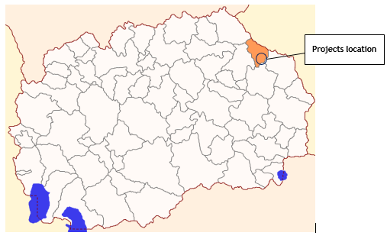
Figure1 Location of the projects area in relation with the Municipality of Makedonska Kamenica

Demography
According to the 2002 Census, there are 8110 inhabitants in the municipality of Makedonska Kamenica, of which 63 % live in the municipal center, the city of Makedonska Kamenica. The average population density is 40 inhabitants / km², which is below the average of the Republic of North Macedonia of 78.8 inhabitants/km². The state of population in Makedonska Kamenica is similar to the one in the East Planning Region. The population is relatively rapidly decreasing.
The Municipality of Makedonska Kamenica consists of nine settlements, eight rural: Todorovci, Lukovica, Kostin Dol, Kosevica, Mostica, Dulica, Sasa and Cera, and the town of Makedonska Kamenica. The main characteristic for these eight rural settlements is similarity to most mountainous villages from the north-east and east part of the country. Most of these rural settlements / villages are dispersed on different neighbourhoods located in different nearby hills. All households in each of these neighbor hoods are strongly connected on a family basis. The total population in the village of Cera is 379 and in village Todorovci is 235.

Climate features
The location and orographic features in Municipality of Makedonska Kamenica enable existence of a continental and mountain climate. In Makedonska Kamenica, the summers are warm and mostly clear and the winters are very cold, dry, and partly cloudy. Over the course of the year, the temperature typically varies from -5°C to 28°C and is rarely below -11°C or above 33°C.
Precipitation is unevenly distributed throughout the year and is higher on the mountainous sides. According to the land structure, the municipality is an area where agricultural land, pastures and forests predominate with more than 90% of the total area.
The general climate and soil conditions make Makedonska Kamenica favourable for the development of fruit production, especially walnuts, chestnuts, pears, apples and hazelnuts (in Mostica, Sasa, Cera, Kosevica, Lukovica and Kostin Dol).
Floods and erosion
Municipality of Makedonska Kamenica is part of Eastern planning region. According to desk research, taking into account the average values of erosion per municipality, the territory of Municipality of Makedonska Kamenica have about 710 m³/km²/year average value of erosion. This indicate medium level of erosion (medium level of erosion is about 400-800 m³/km²/year). As a result of the current way of land use, there is a pronounced deep and surface erosion, in the entire basin of the river Bregalnica. This process is especially pronounced in the vicinity of the accumulation "Kalimanci", which belongs to the municipality of Makedonska Kamenica.
In Figure 2 is presented location of the project area regards the potential natural hazards (erosion, floods, landslides and earthquakes) in RNM.
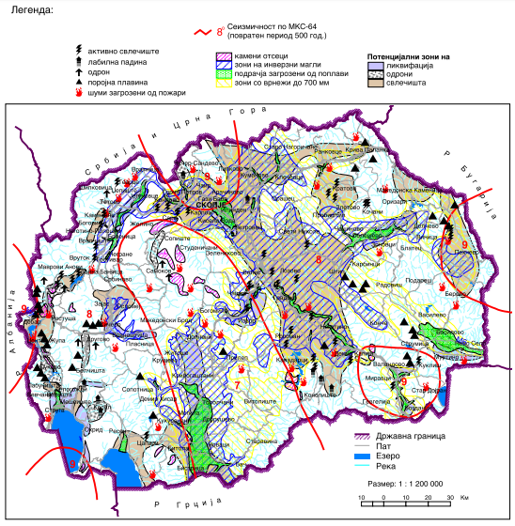
Project location
source: http://app.gov.mk/wp-content/uploads/2015/04/%D0%9030104-PP-na-RM-2002-2020.pdf
Figure 2 Map with potential natural hazards (erosion, floods, landslides and earthquakes) in RNM
According to Figure 2, the project location in Municipality of Makedonska Kamenica is characterized as area with high level of risk of flood and landslides.

Seismology
According to the seismic activity so far, the area of the municipality of Makedonska Kamenica belongs to areas with significant seismic instability. According to the macroseismic regionalization of the Republic, the territory of the Municipality of Makedonska Kamenica belongs to the zone with maximum expected seismic intensity VIII ° per MSC.

Water
The hilly mountain area in Makedonska Kamenica allowed the formation of a number of mountain watercourses, with small catchment areas, short lengths and large slopes. The largest water-economy significance for the municipality has the river Bregalnica, river Kamenica and the accumulation "Kalimanci".
The main water artery of the municipality is the river Kamenica, which springs under the highest peak of the Osogovo Mountain in the valley above the mine Sasa and flows through a tunnel along the dam of the tailings, and then flows into the lake "Kalimanci". The catchment area of this river is 115.2 km2, and the length of the river is 22.5 km. This water resource has 6 watercourses on the left side (Crvena, Svinja, Kozja, Petrova, Jagodna, Ponishte and Mostichka) and 2 on the right side (Gorestica and Susica), which together with the Kamenica river form a hydrographic network with a total length of 62,1 km2. The riverbeds of all the streams are deep valleys and have steep slopes on their streams and keep water during the whole year.
Lukovicka river is second in size water flow whose spring is located on the Macedonian – Bulgarian border. The river’s total length is 11.5 km with a basin area of 21.6 km². Other water flows cover small basins and are short in lengths, hence liable to drying out in the course of summer.
The total area of the Bregalnica Watershed is 742.5 km², with an average catchment height of 1000 m. The total annual average flow of Bregalnica on the profile "Kalimanci" is 264 million m³.
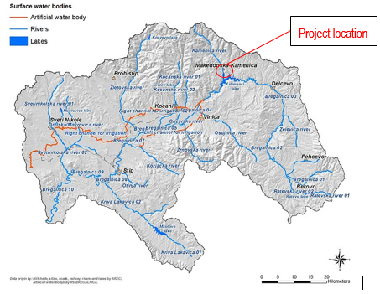
Figure 3 Project location regarding the watershed of river Bregalnica
An important potential hydrographic facility in the municipality is Kalimanci (Kalimansko Lake), an artificial lake set on the junction of the rivers Bregalnica and river Kamenica, built in 1969. The dam is rocky-clay with clay core, 92 m high and 240 m long. The lake has a length of 14 km, it is 0.3 km wide, and the maximum depth reaches 80 m. It covers an area of 4.23 km2 and accumulates 127 million cubic meters of water. The main purpose of the lake is irrigation of about 28,000 ha, mainly rice surfaces in the Kochani valley, but also on some of the cultivated areas in Ovche Pole. The remaining water is used to generate electricity through a built small hydropower plant with installed power of 13.8 MW.
The nearest river to the project location of the local road in v. Cera is river Kamenica, located on a distance of 900 m to the road, and accumulation Kalimanci on a distance of 500 m from the local road to v. Todorovci.

Air quality
In the Republic of North Macedonia, monitoring of the ambient air quality is performed by the Ministry of Environment and Physical Planning, which manages the State Automatic Air Quality System composed of 17 measuring stations of which 5 are located in Skopje, and the closest measuring station to the project location is the one in City of Kocani, located south - west from the project location in Municipality of Makedonska Kamenica. In this air quality measuring station, monitoring is performed of the following: sulphur dioxide, nitrogen dioxide, carbon monoxide, ozone and suspended particles with size of 10 micrometers (PM₁₀)
The sources of suspended particles are activities in the mine Sasa, burning of fossil fuels and biofuels, different industrial processes, traffic, incineration of waste and wild fires. One of the most important sources after the mine activities is heating of homes and administrative capacities, mainly due to the incomplete incineration of wood in the old furnaces. The number of times the average daily threshold limit value of PM₁₀ at the Kocani measuring point in 2019 was exceeded for 66 days, in the year of 2020 (until June) there were 41 days in which the average daily threshold limit value was exceeded.
In the Republic of North Macedonia, the key and dominant source of sulphur oxides in the air are the processes of burning of fuels (coal and fuel-oil). The average daily SO₂ concentrations at this measuring station have not exceeded the threshold value for the year of 2019 and the year 2020 (until June).
Carbon monoxide is formed during the incomplete incineration of fuels in internal combustion engines and energy plants, as well as during different industrial processes, public institutions and households. The maximum daily 8 hour average values of CO concentrations at this measuring station for the year 2019 and the year 2020 (until June) there have not been any exceedance of the threshold value.
The maximum daily 8-hour average values for the ozone concentration in the year 2019 and the year 2020 (until June) there have not been any exceedance of the threshold value. For the 1-hour average values of NO₂ there were no exceedances of the upper threshold limit.

Waste
Deposition of municipal solid wastes, is one of the most serious problems in the Municipality of Makedonska Kamenica. Organized disposal of municipal and other solid waste is available only in the city Makedonska Kamenica, by PCE “Kamena Reka” from Makedonska Kamenca. Waste management in the Municipality of Makedonska Kamenica includes organized collection, transportation and waste disposal at the landfill located 3 km from the city of Makedonska Kamenica. The public communal enterprise "Kamena Reka" from Makedonska Kamenica is responsible for organized collection, transport of municipal waste disposal as well as maintenance of the city landfill. The percentage of the population within the Municipality of Makedonska Kamenica, which regularly receives services, is 91%, (i.e the urban population is 100% covered with waste collection services) while in the rural areas of the municipality the percentage of coverage collection services is 75%. The landfill does not meet the minimum sanitary standards and regulations. The waste is disposed of without any treatment (only leveled and filled with soil and sand). The landfill is from temporary character, and belongs to the category of so-called "temporary landfills".
There is no organized waste collection, transportation and disposal of municipal waste in the rural areas of the municipality, due to which near rural settlements there are illegal landfills. Waste is dumped in streams and rivers, creating landfills that seriously degrade and endanger the quality of the environment and human health.
Because there is no appropriate alternative landfill for waste disposal from project activities, the generated communal waste should be disposed at municipal landfill.

Geology and soil
The eastern region in the Republic of North Macedonia is mainly mountainous with fertile soil that can be used for the development of tourism, agriculture and wood processing industry, provided there are no problems with the road infrastructure5 . This area is abounding with non-ferrous metals and non-metals. Thus, in the region of Makedonska Kamenica there are large amounts of lead and zinc mine (lead galena and zinc sphalerite) which are mainly concentrated in the “Sasa” mines. Reserves of the medium metal rich mines are estimated in the amount of above 100 million tons, which is approximately 70% of the total lead and zinc reserves in the RNM . The region of Makedonska Kamenica disposes with coal and quartz in the vicinity of Kostin Dol, construction and decorative stones, sand and other construction materials of local and broader economic importance.
There is visible deep and surface erosion thoroughly Bregalnica’s confluence. It is a consequence of the way of soil cultivation, especially in the area of “Kalimanci” accumulation. Approximately 600.000m3 slit is annually precipitated in the basin, which considerably shortens lake’s exploitation age.

Flora and fauna
Forests in the Municipality of Makedonska Kamenica cover an area of approximately 9000 hectares (47.3%) from its territory, with a forestation of more than 12% above the national average. The Municipality has a high percentage of forested areas (80% or 7200 hectares) which is exceptionally favorable. According to the forest structure, tall forests with most of the timber mass participate with 60%, i.e., twice as much as the national average, while low forests cover an area of 1,700 hectares (24%) and the forest cultures participate with 1,200 hectares (16%). Clean forests (leaf and coniferous) are the most common ones (94%), while mixed forests participate with 400 hectares (6%). Forests are characterized with rich biodiversity in terms of flora and fauna, especially in terms of various plants and tea plants.
Around the sub - projects area (around the village Cera and village Todorovci) are identified numerous plant species present in forest habitats. In terms of identified types of habitats, the following is stated:
- In the wider surrounding of the project area, at the higher terrain, beech forest habitats are present. While at the lower points of the project area, mainly oak forest habitats are present. Riparian habitats are found along the rivers, which are represented by fragments of smaller forests of willows, alders or poplars.
- Most common habitats, characteristic for the project area are: beech forest with plant association Festuco heterophyllae-Fagetum Em; located at altitude of 1300-850m a.s.l. with dominant plant species Fagus sylvatica L.; Within oak forest area, two plant associations are identified: ass. Orno-Quercetum petraeae Em 1968 и ass. Quercetum frainetto – cerris macedonicum Oberd. Emend Ht. These plant associations are located at altitude of 750-1000m a.s.l. with dominant plant species Quercus petraea (Matt. Liebl.). Characteristic plant species for these associations are: beech (Fagus sylvatica L.), manna ash (Fraxinus ornus L.), hornbeam (Carpinus orientalis Mill.), etc. In addition to the aforementioned natural habitats, anthropogenic forests are found in many places, which are caused by afforestation of many different types of trees such as: black pine (Pinus nigra Arn.), white pine (Pinus silvestris L.), silver fir (Abies alba Mill.), spruce (Picea abies (L.) H. Karst.), Larch (Larix decidua Mill.) and others.
On the hilly terrain around the project site are dominant beech forest (Fagus sylvatica L.); on the lower/flat point of the project site, unplanted vegetation of birch (Betula sp.), pine (Pinus sp.), dog rose (Rosa canina L.), bulrush (Typha latifolia), willow (Salix sp.) and other plant species were evidenced. Also, some ornithofauna was registered near the project site: common buzzard (Buteo buteo), white wagtail (Motacilla alba) and raven (Corvus corax).
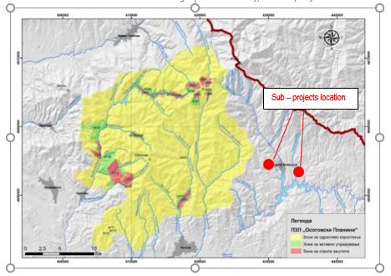
No important/significant habitat types (according to the EUNIS and Habitat Directive) are located near the project area.
Identified and proposed Protected areas
At the national level, according the prepared Valorization Study with a proposal for establishing a protected area of parts of Osogovo Mountain, in 2019 a proposal for designation of parts of Osogovo Mountains in category V "Protected Landscape" was submitted by the mayors of the municipalities in the Eastern planning region to the MoEPP. Until now, the process of designation is ongoing.
Figure 4 Project location according the proposed protected area “Osogovski Planini”
In terms of international importance, the part of Osogovo Mountains have been identified as Important Plant Area (IPA) due to the presence of significant plants species and habitats (unique peat bogs, alpine pastures). The Osogovo Mountain’s biodiversity is also represented by various important bird species - birds of prey, vultures, etc. That was the reason for the designation of the part of Osogovo Mountains as an Important Bird Area IBA (Important Bird Area - IBA) in 2008. Important Plant Area (IPA) “Osogovo” is located in the wider surrounding (about 2km west from the project area). This area cover part of the eastern region of RNM (Kocani, Makedonska Kamenica) is located on altitude 1,000 – 2,252 m a.s.l. and represent trans-boundary IPA with Bulgaria. (IPA) “Osogovo” belong in Middle-South-European mountain biogeographic region (Mesian province). One of the characteristic plant species for this IPA are: Fritillaria graeca Boiss. and Hericium erinaceum (Bull.) Pers.
Important bird area (IBA) “Osogovo” is located in the wider surrounding (about 15 km west from the project area). This IBA cover part of the area of 7,049 ha near Osogovo Mountains. Trigger species for this IBA is Lanner Falcon (Falco biarmicus).
Emerald site Osogovski Planini covers a surface area of 56630 ha and overlaps to a great extent with the landscape “Osogovski Planini” proposed for protection. The area has been proposed for species and habitats conservation (type “C”). Emerald site “Osogovo” is located north west from the sub – project locations.
In the wider surrounding of the project site are located following protected areas: Important Bird Area (IВA) “Osogovski Planini” (located about 11 km west from the project site in v.Cera and 13,5 km from v.Todorovci); Emerald site “Osogovo” (located southeast from the project site in v.Cera, very close to the borders of the site (around 1km)); Important Plant Area (IPA) “Osogovski Planini” (located about 3,5 km west from the project site in v.Cera and 7 km from the v.Todorovci), are presented in Annex 1.

Noise
In the RNM only in the bigger cities, the environmental noise is monitored, whereas in the Municipality of Makedonska Kamenica there is no monitoring station, therefore the noise pollution is not monitored.
There are not recorded any complains about increased level of noise at the project site.

Cultural heritage
The favorable natural and geographical conditions and the favorable climate conditions contributed the territory of the Municipality of Makedonska Kamenica to be inhabited since the prehistoric period. Archaeological remains of the population that lived in these areas were found in several places in the Neolithic period (10,000 - 3,000 BC). According to the Archaeological map of the Republic of Macedonia (Volume II of 1996), the most significant archaeological sites in the municipality are the following:
Registered Archeological sites in the Municipality of Makedonska Kamenica
Settlement | Archaeological findings
Municipality of Makedonska Kamenica
Dulica | Begov Dab – Late Christian Basilica  Gradishte - Late Antique settlement  Kalata - Late Antique settlement  Manastir - Roman times settlement  Selishte – Sveti Ilija, Roman times settlement  Keramidnica – Late Christian Church  Crkva– Late Christian Church
Kamenica | Govedarnik - Late Antique Necropolis  Grobishta - Old Christian Church and Necropolis  Popova Glava - Late Antique Tumulus  Stari Grobishta – Medieval Necropolis  Crkva – Roman Times Mound  Chukarche - Iron Age Tumulus
Kostin Dol | Jachkov Rid – Selishte – Roman and Neolithic Times Settlement  Selishte – Roman Times Settlement and Tumulus and Old Christian Church  Chukar – Neolithic and Late Antique Settlement
Kosevica | Gradishte - Late Antique Settlement  Grobishta – Selishte - Roman Times Settlement, Necropolis and Old Christian Church  Kukli – Chukli – Necropolis – Late Iron Age Tumulus
Lukovica | Gjurgjina Livada – Iron Age Tumulus, Roman Times Settlement and Old Christian Church  Mogili - Roman Times Mounds
Cera | Elenec - Late Antique Settlement  Frlavishte - Late Antique Settlement
Todorovci | Presechnik – Iron Age settlement

Project location
The project area, where the project activities for upgrading of local road in village Todorovci and local road in village Cera, section from Krapevska Maala to Stipcarska Maala and road branch to neighborhood Cemetery, will be performed, is located in the south part of the Municipality of Makedonska Kamenica.
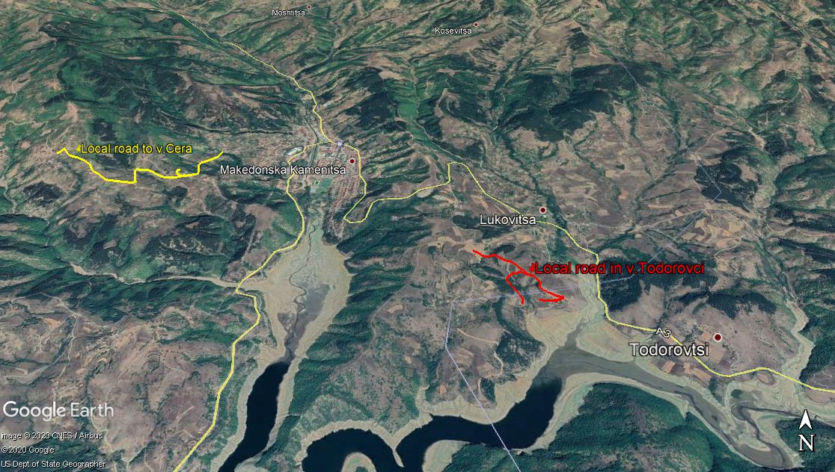
Figure 5 Location of the upgrading of local road in village Todorovci and local road in village Cera, section from Krapevska Maala to Stipcarska Maala and road branch to neighborhood Cemetery, in Municipality of Makedonska Kamenica
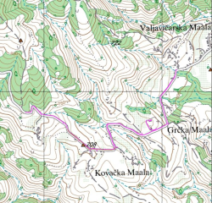
The access to the local road to v.Cera is provide from the regional road R1210. The terrain through which the road passes is mountainous. The local road to the village of Cera, section from Krapevska maala to Stipcarska maala extends at an altitude of 601.00m to 780.00m, and the access road to the neighborhood cemetery extends at an altitude of 655.00m to 670.00m.
The roads will be guided by the already existing routes that are with width from 3 to 4 meters. This road is a part of the local road infrastructure in the Municipality of Makedonska Kamenica and has significant importance for local citizens, connecting the neighbors and also providing access to the local cemetery.
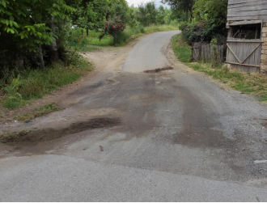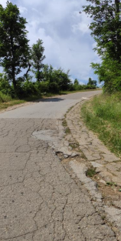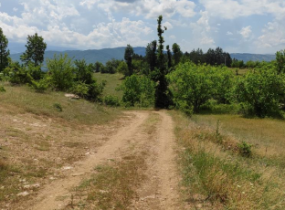
Figure 6 Current situation with the local road to the village of Cera, section from Krapevska maala to Stipcarska maala, and access road to the neighborhood cemetery
Other sub – project road toward village Todorovci is accessed from the regional road Makedonska Kamenica – Delcevo. The subject road is dirty road for the whole length in all sub sections.
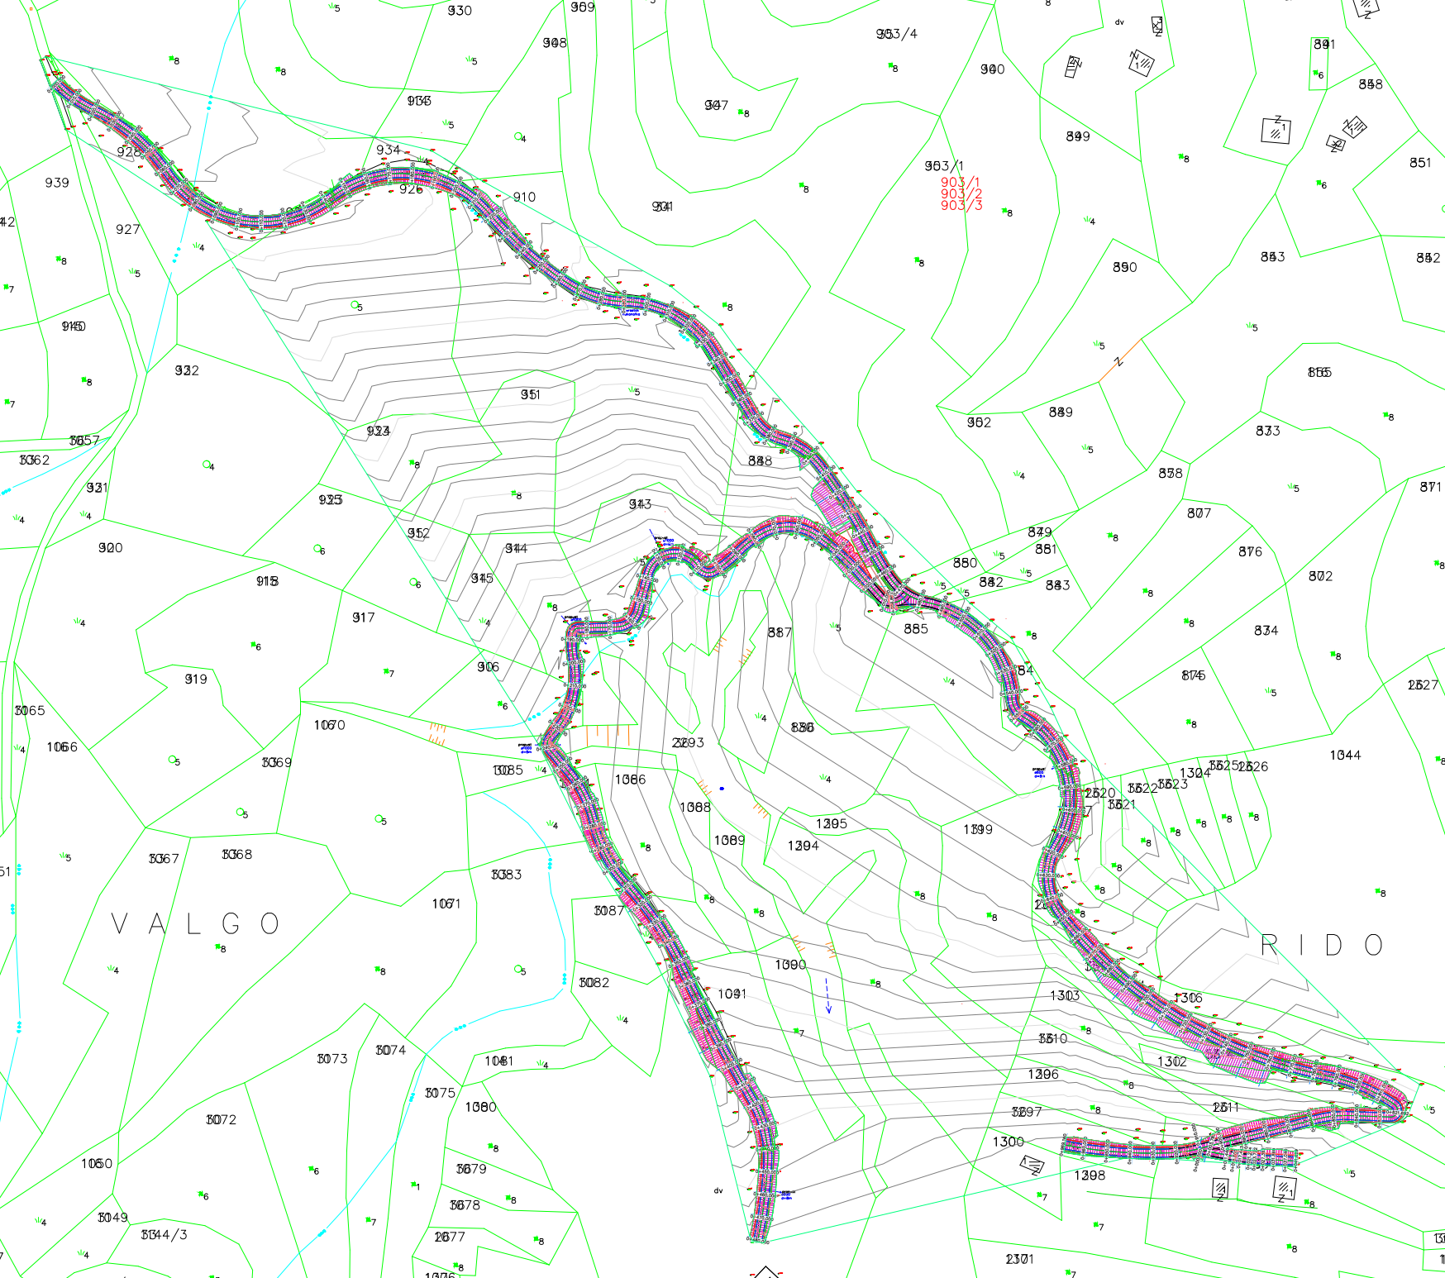
Figure 7 Location of the sub project local road to village Todorovci
The terrain through which the road to village Todorovci passes is at an altitude from 530 to 600.00 m. Current situation with this road is presented on following figures.
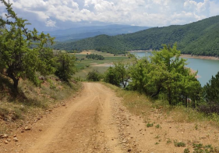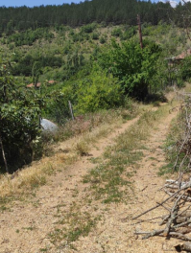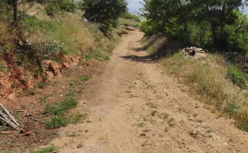
Figure 8 Current situation with the local road to the village Todorovci
According the data from the Census of population in 2002, the Municipality of Makedonska Kamenica was counting 8110 people. The population in the village Cera is 379 and in village Todorovci is 235. Within the Municipality, around 52,4 % are male and 47,6 % female. Greater part of the population is from 15 – 54 years old and the main income for the population is from industry (mine Sasa) and agriculture.
The existing asphalt on the local road to the village of Cera, section Krapevska maala to Stipcarska maala is very damaged with visible cracks, a large number of bumps, transverse excavations. The road has a total length of 2,409 km. Road width is around 4 m and 0,5 m earth shoulders from the both sides of the road.
The local road to village Todorovci is earth road, in bad condition. The road has a total length of 1,493 km.
Near the subject locations of the local roads in v. Todorovci and v. Cera is accumulation Kalimanci and city of Makedonska Kamenica. Along the road to v. Cera, on the both sides, there are arable agricultural areas and houses, as well as local cemetery for this neigborhoods on the left side. There are agricultural fields at the beginning and at the end of the local road to v.Todorovci, near the houses.
According the Main design for the project, the main project activities for the local road to village Cera will include: marking and securing the route, mechanical cutting of existing asphalt, machine excavation on the soil, making an earth embankment, making a bedding, making concrete gutters by precast concrete elements, concreting the bottom and walls of the drainage, making a buffer layer, placing road base layer, construction of bank with mechanical stabilization, bearing bitumen layer over existing asphalt.
The sub-project for the local road to village Cera will include: marking and securing the route, machine excavation on the ground, making an earth embankment, making a bedding, making a buffer layer, placing road base layer.
The sub-project for the local road to v. Todorovci will consist of: marking and securing the route at the project location, machine excavation of soil, making an earth embankment, placing tampon material, placing BHS 16 and shoulders.
In accordance with the existing state and the requirements given by the Investor, the subject roads are classified as local road. The traffic speed on the local roads is planned to be 30 km/h.

Project Activities
The planned project activities for both sub – projects will be performed in three phases: preparatory activities (marking and securing the route,), upgrading of the local road (mechanical excavation of soil, making an earth embankment, making a bedding, making a buffer layer, placing road base layer etc.), and operational phase – activities related to regular and preventive maintenance of local roads. The layouts of the planned upgrading for both sub – projects are shown in Annex 2 Layouts of the local roads in Municipality of Makedonska Kamenica. The main project activities are presented in Table 1.

Table1 Planned project activities for the upgrading of local road in village Todorovci and local road in village Cera, section from Krapevska Maala to Stipcarska Maala and road branch to neighborhood Cemetery, in Municipality of Makedonska Kamenica
Local road in village Todorovci and local road in village Cera, section from Krapevska Maala to Stipcarska Maala and road branch to neighborhood Cemetery, in Municipality of Makedonska Kamenica
Project phases | Project Activities for local road in v. Todorovci  (length =1,493 km) | Project Activities for local road in v. Cera  (length =2,409 km)
Preparatory activities | - Marking and securing the route at the project location; | - Marking and securing the route at the project location;
Upgrading phase | - Mechanical excavation of soil (loading and transport to landfill) 3235,99 m³  - Construction of an embankment (603,98 m³) with soil from borrow at distance of 8 km, with the necessary compaction in layers of 30 cm  - Planning and compaction of basement for the road and shoulders  - Making a buffer layer (d=37 cm) and for the shoulders (d=30 cm)  - Placing a bearing bitumen layer BHS 16 d=7cm;  - Placing a secondary layer; | - Mechanical cutting of existing asphalt and transport to local landfill (7.374,58 m²);  - Mechanical excavation of soil (loading and transport to landfill) 4.590,37 m³  - Mechanical making of embankment obtained from excavation;  - Construction of the bedding;  - Making concrete gutters by precast concrete elements;  - Concreting the bottom and walls of the drainage;  - Placing road base layer  - Construction of shoulder with mechanical stabilization  - Bearing bitumen layer BHS 16 d=7cm over existing asphalt
Operational phase | - Clean up the upgrading site;  - Regular maintenance (especially in the winter period); | - Clean up the upgrading site;  - Regular maintenance (especially in the summer and winter period);

Sensitive receptors
During the preparation activities and upgrading phase of the both sub - projects, sensitive receptors that will be affected, are: workers (who will be engaged during the upgrading phase), local population living in the v. Todorovci and v. Cera with all neighborhoods using this road (who will gravitate along the project site toward city of Makedonska Kamenica or local cemetery) and the people that are working on the agricultural area along the project location. Sensitive objects that need to be taken into consideration during the implementation of the project activities, are the agricultural area and local houses. This conclusion is referring in aspect of increased level of noise and air emissions.
Potential environmental impact and risk and impact and risk assessment for each aspect, is given below. The subject roads are used by the communities for transit to bigger urban centers for work (Makedonska Kamenica, Delcevo, Kocani) visit the health centers, attending elementary school, high school, studying. During implementation of the project activities, vertical signalization will be installed according the prepared Main Trafic Project for each of the subject roads in Municipality of Makedonska Kamenica in order to improve the security of the drivers and local people on that sections.

POTENTIAL ENVIRONMENTAL IMPACTS AND RISK AND IMPACTS AND RISK ASSESSMENT
According the national legislation, the Environmental Impact Assessment Report for the both sub projects were prepared in June 2020., by the company “Euromak Kontrol” from Skopje. The adoption of the EIA Reports was performed by the Mayor of the Municipality of Makedonska Kamenica, Mrs. Sonja Stamenkova (Decision for approval of the EIA Report for local road to v.Cera no.12-1015/2 from 16.6.2020 and Decision for approval of the EIA Report for local road to v.Todorovci no.12-1018/2 from 16.6.2020). The EIA Reports contain description of the location where the upgrading activities will be performed, the main project activities, environmental conditions in the project area, main environmental impacts and proposed general environmental mitigation measures.
Air emissions, increased level of noise, possible improper waste management, OH&S risk and risk on local community safety are main identified adverse environmental impacts and risks. Adverse impact on cultural heritage sites are not expected. Detailed analyses of each possible impact and risk is shown below.

Due to the fact that for this project the land acquisition was needed, the Resettlement Action Plan was developed according the Resettlement Policy Framework. The Municipality of Makedonska Kamenica informed and include all concern owners of the land and the expropriation process was held on transparent and participatory way and all actions were implemented. The process was completed in November 2020 with payment of compensation costs to the owners. All property expropriated is now owned by the Republic of North Macedonia and can be used for upgrading of local roads.
For the needs of the Contractor for temporary placement of machinery and equipment at a location in the immediate vicinity to the project that is privately owned (if there is a need), it is necessary to sign a Contract with the owner of the parcel for temporary land usage during project implementation period. The Contract will define terms and obligations for land usage or other premises (ex. garage, storage area, etc...) in line with the Project RPF Furthermore, all compensation will be paid before the respective land is accessed.
The presentation of the possible impacts and risk that can occur during implementation of the both sub- projects activities is shown in Table 2
Table 2 The potential environmental impacts and risks during implementation of the project
Possible impacts from the sub – project for upgrading the local road to v. Todorovci
Preparatory phase | Upgrading phase | Operational phase
- OH&S risks for the workers and local population  - Safety risk for local population (especially near the houses) | - OH&S risks  - Community safety risks,  - Air quality,  - Noise,  - Waste generation  - Water pollution | - Local community safety  - Noise  - Waste generation
Possible impacts from the sub – project for upgrading the local road to v. Cera
Preparatory phase | Upgrading phase | Operational phase
- OH&S risks for the workers and local population  - Safety risk for local population (especially near agricultural fields) | - OH&S risks  - Community safety risks,  - Accessing the agricultural fields  - Air quality,  - Noise,  - Waste generation  - Water pollution | - Local community safety  - Noise  - Waste generation
As a result of implementation of project activities, the main adverse environmental impacts from both sub – projects can be seen through: expected increased level of noise (generated from construction machinery during the preparatory and upgrading phase), possible air emissions, improper waste management, non-compliance with the OHS requirements and possible risk on local population. Before the sub-project activities, one of the main obligations of the Contractor is preparation and implementation of the OHS Plan including Labor management procedures (for prevention of worker injuries); Traffic Management Plan with time schedule of project activities and directions for re-routing the traffic flow (provision of proper transportation of goods, directions for re-routing the traffic and secure passage of the local people as well as horizontal or vertical signalization along the project road during the upgrading phase); Community Safety Plan (with proper preventive measures which should be part of the project design documentation, marking and securing the project site and Grievance mechanism and forms for complaints by the surrounding population to be on their disposal during the upgrading activities. The forms could be post in the municipality office and local community office); Information note/Press should contain information about the type of upgrading activities should be submitted to the municipal staff to post on their web-site (https://makedonskakamenica.gov.mk/) and place on their municipality board.
For the both sub-projects, Main Traffic Project is prepared in May 2020 by the “MS Stop Proekt” from Strumica in order improving the traffic security and also security of drivers and local people and installment of new horizontal and vertical signalization on the local roads.
The workers on the project location need to always wear their PPE in order to avoid possible injuries, also they must be informed about the Grievance Redress Mechanism and their rights to organize workers organization by their employer (Contractor/Sub-contractor). The current workers must be employed fulltime, have their health and pension insurance covered in full for their engagement by the employer. The grievance forms could be post in the mobile containers for the workers.
Considering the current situation with COVID-19 in the country ( the number of cases is increasing, so, on 27th of July there are 4199 cases, total deaths 460 and total number of healed persons is 5427) in addition to the measures for safety and protection at work, the OH&S plan also should include measures for prevention of COVID -19. Detailed description of the measures and recommendations from the World Bank/WHO and MOSHA are presented in Annex 3. The CОVID-19 prevention measures contains recommendations from the World Bank / WHO, as well as recommendations from the Macedonian Occupational Safety and Health Association in the form of a Guide that the Contractor of the construction works needs to implement. The Contractor is required to follow/update and implement the measures that are currently in force and adopted by the Government as binding at national level. Official site for information related to COVID 19 on national level is www.koronavirus.gov.mk.
Aspect: Air quality
During the preparatory and upgrading project activities the possible air emissions (dust and gas emissions) could occur during transportation of construction materials and operation of heavy machinery and equipment. In operational phase of the local road, air emissions will be generated from mobile sources of pollution – vehicles. To prevent and avoid adverse environmental impacts the Contractor should imply mitigation measures given in the Mitigation Plan (table below).
Aspect: Level of Noise
Increased level of noise and vibration is expected during the preparatory and upgrading phase of the project. Taking into consideration the noise sensitivity of the project location and national legislation for noise protection (Official Gazette of RM No.79/07, 124/10, 47/11, 163/13 and 146/15) the project for Upgrading of local road in village Todorovci and local road in village Cera, section from Krapevska Maala to Stipcarska Maala and road branch to neighborhood Cemetery, in Municipality of Makedonska Kamenica is considered to be an area of III degree of noise protection because of the mixed area with family houses and agricultural fields (the maximum limit values should not exceed 55 dB(A) for night and 60 dB(A) for evening and day)..
Aspect: Waste management
The main waste streams that may occur during construction activities are: excavation of soil, construction and demolition waste (old asphalt), communal waste and possibly contaminated soil from occasionally oil leakage (from construction machinery). The Contractor should respect national regulation requirements for proper waste management and should prepare Waste Management Plan. The proper waste management can be carried out trough: categorization of waste streams (according List of Waste codes – Official Gazette of RM No.100/05), separation and recycle of the waste streams, transportation and final disposal of the waste stream at appropriate landfill (this process will be performed from PCE "Kamena Reka” from Makedonska Kamenica on municipal landfill located about 3 km distance from Makedonska Kamenica). Also, during project activities, the Contractor should sign contract with authorized legal entities for collection of different waste streams.
- Estimated quantities of the waste form the upgrading the local road in v. Todorovci
The estimated quantities of the waste form the excavation of soil (generated from the project activities and according to the Main Design) are: excavation of soil and transport to the landfill (3235,99 m³). The options for reuse/recycling of the generated waste streams should be taking into consideration (e.g. reuse of the excavated soil, etc.).
- Estimated quantities of the waste form the upgrading the local road in v. Cera
The estimated quantities of the waste form the excavation of soil and removal of the existing asphalt (generated from the project activities and according to the Main Design) are: excavation of soil (4.590,37 m³) and asphalt (7.374,58 m²). The options for reuse/recycling of the generated waste streams should be taking into consideration (e.g. reuse of the removed layer of asphalt, excavated soil, etc.).

Aspect: Water pollution
The closest river passing by the sub- project location of local road to v.Cera is river Kamenica at distance of around 1 km. The water categorization of this water bodies is III class (medium level of pollution-eutrophic status, which can be used for irrigation and industry) according Regulation for Categorization of Water Courses and Lakes - Official Gazette of the RM No. 18/99.
The second location, local road to v.Todorovci is near the accumulation of Kalimanci (distance of 500 m) which is classified as II class (low level of pollution-mezotrophic status, high level of autopurification which can be used for fish growing, bathing, water sports and recreation) according Regulation for Categorization of Water Courses and Lakes - Official Gazette of the RM No. 18/99. Also, near the project location passes river Lukovica (at distance of 200m) toward the Kalimanci lake.
The Contractor should forbid temporary or final waste disposal near or in river bands of this water recipients (e.g disposal of soil, leakages of motor oils and lubricants, etc.), in order to prevent decreasing of the water quality.
Aspect: Biodiversity
As mentioned before, few protected areas are located in the wider surrounding of the project site in Municipality of Makedonska Kamenica: Important Bird Area (IВA) “Osogovski Planini” (located about 11 km west from the project site in v.Cera and 13,5 km from v.Todorovci); Emerald site “Osogovo” (located southeast from the project site in v.Cera, very close to the borders of the site (around 1km)); Important Plant Area (IPA) “Osogovski Planini” (located about 3,5 km west from the project site in v.Cera and 7 km from the v.Todorovci). No adverse impacts are expected on existing protected areas and protected natural rarities because of their wider distance, regards the project site in Municipality of Makedonska Kamenica. No endangered, significant flora and fauna species or protected areas, are recorded at/near the project site in Municipality of Makedonska Kamenica.
The proposed preventive and mitigation measures are presented in the Mitigation and Monitoring Plan tables in Chapter 4.

Implementation of ESMP
This ESMP is a part of the contract that the PIU will sign with the Contractor for implementation of the project activities. The Contractor is obligate to perform all proposed preventive or mitigation environmental and social measures in this plan and to keep the evidence of any documents related to applying these measures (e.g., letter asking the municipality for disposal of inert waste, records on OHS training performed for all workers before start of activities, all developed EHS plans, etc.). The OHS training should be organized by the Contractor for all workers prior start the project activities and prior any specific tasks with high health risks. The training should be delivered by the authorized OHS company and everyday OHS risks should be assessed by the Contractor’s OHS responsible person working on the location on daily basis. Evidence for all trainings delivered should be kept.
Measures prescribed in the EIA Reports for both sub-projects including measures within the ESMP will be a mandatory requirements for the Contractor during the implementation of the construction activities.
The implementation of proposed measures by the Contractor and Contractor’s subcontractors will be monitored by the Supervising Engineer by doing visual checking, reviewing the records of evidence that the measures have been applied and ask the Contractor to apply the measures as soon as possible. If there are any non-compliances they need to be recorded and the Report containing them needs to be sent immediately to the municipality (Project Manager), and from here it will be reported to the PIU. The Environmental/Social Specialist engaged by the PIU will report the non-compliance and accidents/ emergencies cases to the Bank immediately upon occurrence. Each incompliance needs to be addressed and the evidence of the appropriate measures taken need to be kept. The regular monthly report should contain all environmental and social issues raised during that period and the evidence on solutions should be provided as well.
The main responsibilities of the PIU will be in regards to the Project implementation, project coordination, monitoring activities and reporting.
The Environmental/Social Specialist engaged by the PIU will be responsible for ensuring proper environmental management of all Project activities, conduct environmental supervision by carrying out document reviews, site visits and interviews with Contractor, Supervising Engineer and municipality staff. He/she will supervise Contractors’ compliance with ESMP and visit the project location at least once a month and the Monitoring Report reflecting main issues and arrangements and timing for their solution will be prepared and submitted to the PIU. The semi-annual Project Report should contain a chapter with Environmental/Social risks/impacts of the project and the status of implementation the ESMP proposed measures.
The municipality of Makedonska Kamenica has a main role for daily monitoring of project activities engaging the Supervising Engineer and coordinating all activities on location nominating the responsible person – Project Manager.
The PIU needs to organize regular meetings with the Project Manager, Contractor, representatives from MoTC, responsible person from the Municipality of Makedonska Kamenica and the ES specialist on a monthly basis or during any site visit.
Very important for providing continuous performance of the project activities and successful completion of overall project is establishing good communication between all involved stakeholders (Contractor, Supervisor, municipal staff, Environmental Inspector, Communal Inspector, PIU from MoTC and other relevant persons from Municipality of Makedonska Kamenica). The PIU from MoTC and project manager from the Municipality of Makedonska Kamenica will facilitate good communication and coordination of the project activities on project location.
Grievance mechanism
PIU within the MoTC has introduce a Grievance Mechanism to ensure that it is responsive to any concerns and complaints particularly from affected stakeholders and communities. In order to provide procedure of receiving comments from the stakeholders (local citizens and workers onsite) PIU establish Grievance Form for the construction phase of the project (Annex 5) that will be available in electronic form on the MoTC web site, Municipality web site and the Contractors web site. Grievance Form for the construction phase of the project is prepared for the local population on both sub-projects locations (if an incident or damage to private property occurs) and for the workers (grievance for lack of protective equipment, increased working hours, no period for rest, etc...) who will be involved in the construction activities.
Contractor should inform the workers about the Grievance Form before starting with construction activities and the opportunity to express their compliances regarding the operation on the construction site. Local population will be informed for this possibility by the Information posted on the Informative board within the Local Community, Municipal web site, and via local radio and TV station.
The PIU will ensure that the Grievance Redress Mechanism (GRM) is responsive to any concerns and complaints particularly from affected stakeholders and vulnerable groups. Following steps are to be taken to ensure full GRM functioning:
Step 1: Recording received grievance in the GRM registry;
Step 2: Providing the person who filed the grievance with an acknowledgment of receipt within 5 days of receipt;
Step 3: Investigating the grievance;
Step 4: Resolution of Grievance within 15 days of grievance receipt;
Step 5: Follow up.
In cases when the grievance/complaint is indefinite or not clear enough, the PIU will assist and provide advice in formulating/redrafting the submission, in order for the grievance/complaint to become clear, for purposes of an informed decision by the PIU, in the best interests of persons affected by the Project.
If the PIU is not able to address the issues raised by immediate corrective action, a long-term corrective action will be identified. The complainant will be informed about the proposed corrective action and follow-up of corrective action within 25 calendar days upon the acknowledgement of grievance. In situation when the PIU is not able to address the particular issue verified through the grievance mechanism or if action is not required, it will provide a detailed explanation/ justification on why the issue was not addressed. The response will also contain an explanation on how the person/ organization that raised the complaint can proceed with the grievance in case the outcome is not satisfactory. At all times, complainants may seek other legal remedies in accordance with the legal framework of Republic of North Macedonia, including formal judicial appeal.
Grievances can be filled verbally, by phone, in writing (by post or e-mail) or by filling in a grievance form (Annex 1). The grievance form will be made available on the implementing agencies website together with clear information on how feedback, questions, comments, concerns and grievances can be submitted by any stakeholder and information concerning the PIU’s managing of the GRM both in terms of process and deadlines. Furthermore, the website will include the possibility to submit grievances electronically.
Dedicated GRM register is planned in order to capture and track grievances received under the project. Specifically nominated members of staff will record grievance information in the grievance registry, including:
- Number of Grievance
- Date of receipt
- Stakeholder name, sex, age and contact details;
- Date of acknowledgement
- Description of grievance
- Description of action taken
- Date of grievance resolution
The PIU will share the Grievance Registry with the WB on a monthly basis.

Public disclosure and citizen engagement
The Municipality of Makedonska Kamenica will submit draft version of this ESMP to PIU Environmental and Social Experts to review and approve it, who will then (when confident that the document meets WB quality and content requirements) submit the draft document for the review and clearance by the World Bank. After the clearance is obtained, the document will be publicly disclosed.
The Draft ESMP will be available for the public on web site of the Municipality of Makedonska Kamenica https://makedonskakamenica.gov.mk/) and the web site of the MoTC PIU (http://www.mtc.gov.mk/) accompanied by a Form for submitting comments (Annex 4). The social Media channel of the Municipality of Makedonska Kamenica that will be used for the purpose of raising awareness about the Project implementation and identified E&S risks, impacts and mitigation measures is the facebook page (https://www.facebook.com/makedonskakamenicamk/).
Municipality of Makedonska Kamenica will conduct video public consultation in order to inform the public on the proposed sub-project activities, anticipated impacts and the ways of their mitigation, during the 14 days after the disclosure of the prepared ESMP document for both sub-projects.
Public announcement will be developed with brief description about the purpose of the project, project activities and duration of the activities, environmental and social impacts, proposed measures, availability of the ESMP together with the Form for submitting comments on the MoTC web site and Municipality web site, Informative board within the Local Community. Announcement will also contain information about the possibility for citizens to raise opinion/ suggestion/comments on the prepared ESMP by filling the Form for comments and submission to the responsible person from MoTC Mrs. Irena Paunovikj (e-mail: irena.paunovikj.piu@mtc.gov.mk). Form for submitting can be filled with a full identity or anonymously, and the comment or suggestion should be fully described in order to take it into account in the final version of ESMP. Information about the date and time for conducting the video public consultation, way how the stakeholder can take part on the video public consultation will also be a part of the announcement.
Public announcement will be published on the local radio or TV station and on the Informative board within the Local Community.
Public consultation for the ESMP
Considering the current situation with COVID 19 and the inability for organizing an ordinary public hearing event in the premises of the Municipality where the project will be implemented, the video public consultation will be organized, The MoTC PIU in cooperation with the municipality will define the date for the video public consultation (by using Vebex operational tool).
Municipalities will need to inform all relevant stakeholders on its territory about the timing of the video public consultation (and to ask them for their e-mail address if they like to join the event), so that all from their homes/offices can follow the event and be active participants. If the stakeholders do not have the technical capabilities, the municipality will ensure an appropriate solution in order to be able to follow the event. The mailing list for participants will be prepared taking into account all relevant stakeholders and Invitation will be sent to those with brief explanation for the:
- Purpose of the video public consultation;
- Registration link and instructions for connection;
- Exact time and date for the event;
- Availability of the disclosed draft ESMP for comments and
- Possibility for submitting comments on the prepared ESMP by filling in the Form for submitting comments and suggestions on the ESMP to the responsible person from PIU
After the presentation of the main project activities and main findings from the ESMP during the video consultation event, attending stakeholders can raise their comments/questions/suggestions and any concern about the project.
The final version of the ESMP will be prepared after maintaining the video public consultation and the 14-day period for submitting comments and will include the public consultation report (including announcement of the event (media or personal) detailed description of the event, list of participants, minutes of meeting , the expressed comments) and the appropriate corrections in the document according to the received comments and remarks. Approved Final version of ESMP should be included in the Grant Agreement with sub-project proponent, and then into the respective bidding documents and construction contracts.
Final version of the ESMP will be available on the MoTC web site and Municipality of Makedonska Kamenica web site for the whole period of the sub project implementation.

Contact person for project awareness and public consultation from MoTC:
Mrs. Irena Paunovikj, Responsible for public relations for the project,
e-mail: irena.paunovikj.piu@mtc.gov.mk

Contact person for project awareness and public consultation
from Municipality of Makedonska Kamenica:
Ms. Aleksandra Dimoska Angelovska urban planning councilor
e-mail: dimoska.aleksandra@gmail.com
mob.tel: 078 485 113

ENVIRONMENTAL AND SOCIAL MITIGATION PLAN
Potential impact | Impact scale | Proposed mitigation measures | Responsibility
Project activities: Preparation activities before upgrading the local road in village Todorovci and local road in village Cera, section from Krapevska Maala to Stipcarska Maala and road branch to neighborhood Cemetery, in Municipality of Makedonska Kamenica
Aspect: OHS and Community Safety  Possible adverse social and health impacts to the population, drivers and workers due to:  - Lack of ensured safety measures at the start of upgrading works;  - Injury passing near by the upgrading sites;  - Not compliance with strict OHS standards and work procedure. | Local/ within the local roads (in v.Todorovci and v.Cera), in Municipality of Makedonska Kamenica  Short term during the upgrading period  Significance - major | - Preparation, approval and implementation of OHS Plan prior start of activities;  - Preparation, approval and implementation of Community Safety Plan including Labor management procedures prior the start of activities;  - Preparation, approval and implementation of Traffic management Plan during project activities (in correlation with municipality staff, prior start the upgrading activities);  - It is essential for the Contractor to provide safety measures for the workers and local population who will use these subject roads for accessing their homes and agricultural fields, (e.g. usage of environmentally friendly type of equipment in term of noise level, vibration, easy rotation; short training to the workers should be delivered prior start working in order to provide careful handling with construction machinery, etc.)  - Preparation, approval and implementation of Waste Management Plan (with reuse/recycling activities included) prior start up activities;  - Provision of the information about the construction activities – start and finish of work for each day and location of activities, duration of work and traffic access on other roads, on the municipal web site (https://makedonskakamenica.gov.mk/), local community, and municipal board;  - The Contractor is required to submit a preliminary Traffic management Plan, which will be part of the ESMP. Before the start of the project activities, the updated Traffic management Plan with Community Safety Plan will be submitted to ESS. It will be presented to the workers on regular basis. Traffic management Plan will specifically deal with safety of the local population using the local roads (walking / driving);  - Contractor will make assessment and record the state of the property and objects that are close to the road, prior commencement of any works. Records should be kept in case of future damage claims by the local property owners;  - Application of good upgrading practice for marking out the project sites including:  - Appropriate marking out the project sites, section by section along the roads;  - Placement of alert signs especially for limitation of speed driving near the roads that will be upgraded (v.Todorovci and v.Cera);  - Placement of warning tapes;  - Installation of Notice board with general information about the project, Contractor and Supervisor at each project location;  - Forbidden of entrance of unemployed persons within the warning tapes;  - Community and Worker’s OH&S measures should be applied (first aid, protective clothes for the workers, appropriate machines and tools);  - During the project activities, the Contractor should provide easy access of the local population to their houses/agricultural fields/cemetery.  - The both subject roads should be kept clean;  - Mobile toilets should be placed on the project sites;  - Machines should be handled only by experienced and trained personnel, thus reducing the risk of accidents;  - Trying to avoid compliance, if any appeared recording grievances and promptly response and overcome the problem;  - Constant presence of firefighting devices should be ensured in case of fire or other damage;  - All workers must be familiar with the fire hazards and fire protection measures and must be trained to handle fire extinguishers, hydrants and other devices used for extinguishing fires;  - Larger quantities of flammable liquids should not be kept on the sites along the roads that will be upgraded.  - All engaged workers on this project must have regulated employment status by Contractor/sub-contractor and must receive full health and pension insurance, all in compliance with local labor related legislation and International labour standards. | - Contractor –Bidder  - Supervisor  - Municipality staff (Communal Inspector and Environmental Inspector)
Project activities: upgrading the local road in village Todorovci and local road in village Cera, section from Krapevska Maala to Stipcarska Maala and road branch to neighborhood Cemetery, in Municipality of Makedonska Kamenica
Aspect: Air quality  Possible emissions in the air by transportation vehicles and impact air quality along the local road in village Todorovci and local road in village Cera, section from Krapevska Maala to Stipcarska Maala and road branch to neighborhood Cemetery, in Municipality of Makedonska Kamenica due to:  - Gases emissions of operation with construction machinery CO₂, NOx, PAH, SO₂ and suspended particulates (PM₁₀, PM _{2.5}). | Local/  Short term/ medium | - The construction site, transportation routes and materials handling sites should be water-sprayed on dry and windy days;  - Materials used for upgrading should be stored in appropriate places covered to minimize dust;  - Vehicle loads that are likely to emit dust need to be covered;  - In the event of dust episode, the workers must use protective masks;  - Restriction of the vehicle speed within the upgrading locations;  - Perform regular maintenance of the vehicles and upgrading machinery in order to reduce the leakages of motor oils, emissions and dispersion of pollution;  - Burning of debris from ground clearance not permitted. | - Contractor –Bidder  - Supervisor
Aspect: Water pollution  Possible environmental impact on the relevant water recipients could occur due to ground contamination (from the spillage of materials such as vehicle fuel, motor oils and lubricants) and waste disposal near or in river bed of river Likovica or accumulation Kalimanci | Local/near river Lukovica, which passes along the route of the project location in v.Todorovci on a distance of 200 m and accumulation Kalimanci (500 m)  Short term/ major | - Possible hazardous waste (motor oils, vehicle fuels, lubricants) should be collected separately and authorized company should be sub-contracted to transport and finally dispose the hazardous waste;  - According to national legislative for waste management, it is forbidden temporary or final disposal in or near the river bed of the river Lukovica and accumulation Kalimanci, in order to prevent decreasing of the good ecological status - II class (low level of pollution-mezotrophic status, high level of autopurification which can be used for fish growing, bathing, water sports and recreation).  - Minimize storage or disposal of substances harmful to waters;  - The both subject roads should be kept clean and tidy to prevent the build-up of oil and dirt that may be washed into a water course or drain during heavy rainfall. | - Contractor –Bidder  - Supervisor
Aspect: Temporary land acquisition  Temporary land acquisition/ damage to private property | Local | - Avoidance of the use of private lands;  - In case avoidance is not possible, minimization of size of the area used and impacts on the vegetation  - Implementation of RPF provisions.  - Arrangements with owner and payment must be executed prior to land access | - Contractor, PIU
Aspect: Level of Noise  Possible noise disturbance as a result of outdoor equipment usage and transportation vehicles driving around the sites | Local/along the project locations in Municipality of Makedonska Kamenica  short term /medium | - The equipment should be fitted with appropriate noise devices that will reduce sound level;  - According to national legislative ambient noise and vibration (Official Gazette No. 79/07, 124/10, 47/11, 163/13 and 146/15), the project locations have been identified with area of III degree of noise protection because of the mixed area with family houses and agricultural fields (the maximum limit values should not exceed 55 dB(A) for night and 60 dB(A) for evening and day).;  - The construction work should be not permitted during the nights, the operations on sites shall be restricted to the hours 7.00 -19.00;  - The vehicles that are excessively noisy shall not be operated until corrective measures have been taken; | - Contractor –Bidder  - Supervisor
Aspect: Waste management  Possible adverse environmental impact and health effects could occur as a result of generation of the different waste streams. The inappropriate waste management and not in time collection and transportation of waste streams | Local/ within the project locations in Municipality of Makedonska Kamenica  Short term/ major | - Identification of the different waste types at the upgrading sites (soil, humus, old asphalt, bottles, food, etc.);  - Classification of waste according the national List of Waste (Official Gazette no.100/05);  - The main waste would be classified under the Waste Chapter 17 “Construction and demolition wastes (including excavated soil from contaminated sites)” with the waste code, 17 05 – Excavated soil and stones and 17 09 04 – Mixed waste from construction site;  - The recycle and re-use of some waste materials is obligatory (not to dispose them as a waste);  - Small amount of solid municipal waste could be found (food, beverages), as well as packaging waste (paper, bottles, glass, etc.). Proper containers/waste bins should be provided at the project site during the upgrading activities;  - Collection and transportation of the inert and communal waste by the PCE “Kamena Reka” from Makedonska Kamenica (the waste disposal will be performed on municipal landfill, located at about 3 km from the city of Makedonska Kamenica; The options for reuse/recycling of the generated waste streams should be taken into consideration (e.g. reuse of the removed layer of excavated soil, etc.).  - Inert waste will be disposed on the location approved by the Municipality of Makedonska Kamenica  - Possible hazardous waste (motor oils, vehicle fuels) should be collected separately and authorized collector and transporter should be sub-contracted to transport and finally dispose the hazardous waste;  - The materials should be covered during the transportation to avoid waste dispersion;  - Burning of waste along or around the project locations is prohibited. | - Contractor –Bidder  - Supervisor  - Municipality staff (Communal Inspector)  - Mayor of the Municipality of Makedonska Kamenica  - PCE “Kamena Reka” from Makedonska Kamenica
Project activities: Operational phase of the local road in village Todorovci and local road in village Cera, section from Krapevska Maala to Stipcarska Maala and road branch to neighborhood Cemetery, in Municipality of Makedonska Kamenica
No adverse impacts are expected in the operational phase of the project.
Regular maintenance of the local roads in the Municipality of Makedonska Kamenica, should be carried out (e.g. removal of snow in winter period, regular repair of the road surface, etc.).
The vehicles that will gravitate in this project phase of the subject local roads, should limited their speed according to the road conditions and installed horizontal and vertical signalization according the prepared Main Traffic Design for both sub projects. The Investor should develop and implement the mitigation measures in the operational phase of the projects like: post of the horizontal and vertical traffic signalization for speed limitation of the vehicles, limitation of the generated noise as road conditions allows, implementation of road speed limitation barriers (speed road barriers, road shoulders, convex wide angle etc.). All mitigation measures should be in compliance with national legislation for traffic safety - Law for road traffic safety (Official Gazette of RM, No.54/07, 86/08, 98/08, 64/09, 161/09, 36/11, 51/11,114/12, 27/14 and 169/15).

ENVIRONMENTAL AND SOCIAL MONITORING PLAN
What  parameter to be monitored? | Where  is the parameter to be monitored? | How  is the parameter monitored? | When  is the parameter monitored (frequency of measurement)? | Why  is the parameter monitored? | Cost |  | Responsibility
 |  |  |  |  | Upgrading | Operations | Upgrading of local road in village Todorovci and local road in village Cera, section from Krapevska Maala to Stipcarska Maala and road branch to neighborhood Cemetery, in Municipality of Makedonska Kamenica | Operations of the local roads in v.Todorovci and in v. Cera, in Municipality of Makedonska Kamenica
Project stage: Preparation activities before upgrading the local road: Marking out the route for upgrading of local road in village Todorovci and local road in village Cera, section from Krapevska Maala to Stipcarska Maala and road branch to neighborhood Cemetery, in Municipality of Makedonska Kamenica
Constant wearing of the PPE and compliance with the protection measures for workers in order to minimize possible injuries at the construction sites | At the both project sites | Visual checks | During the clean-up activities  At the beginning of each working day during the sub-project activities | To prevent health and safety risks – mechanical injuries  To be in compliance with national communal health regulation and OH&S standards | Included in the project budget |  | Contractor/sub-contractors - Bidder  Supervisor  Communal Inspector at the Municipality of Makedonska Kamenica
Whether all required documents related to OH&S, Community safety, Traffic Management are prepared | Within the both project locations | Review of the prepared documentation (OHS Plan,  Community safety Plan,  Traffic Management Plan (TMP) for each sub -project location | During the clean-up activities  At the beginning of each working day during the sub-project activities | To prevent health and safety risks – mechanical injuries;  To be in compliance with national communal health regulation and OHS standards. | Included in the project budget |  | Contractor - Bidder  Supervisor  Communal Inspector at the Municipality of Makedonska Kamenica
Training of workers and informing of the local population about the planned sub - projects activities | At each project site | OHS training  by an authorized OHS company engaged by the Contractor  Provision of the information via TV, radio and municipality web site (https://makedonskakamenica.gov.mk/) about the project activities | Before the start of the project activities for both sub - projects | To prevent health and safety risks – mechanical injuries of the worker and local population;  To be in compliance with national communal health regulation and OHS standards. | Included in the project budget |  | Contractor - Bidder  Supervisor  Communal Inspector at the Municipality of Makedonska Kamenica
Project stage: upgrading the local road in village Todorovci and local road in village Cera, section from Krapevska Maala to Stipcarska Maala and road branch to neighborhood Cemetery, in Municipality of Makedonska Kamenica
Existence of applicable Traffic Management Plan for the project and Notices for the availability of the plan and information on traffic regulation set on bulletin board in the settlements | Within the project locations | Visual monitoring | During the working day | To ensure the coordinated traffic flow through the project locations and easy access of local population to their agricultural fields and their homes. | Included in the project budget |  | Contractor - Bidder  Supervisor  Communal Inspector at the Municipality of Makedonska Kamenica
Use of PPE by the workers | At upgrading sites | Visual monitoring | During the works | To ensure workers safety on site | Included in the project budget |  | Municipality of Makedonska Kamenica, Labor inspection
Primary selection of the generated different waste streams at the project location | On the upgrading sites | Review the documentation | At the beginning of work with new material/s | In order to ensure separation of hazardous from the non-hazardous waste as well as inert from biodegradable waste | Included in the project budget |  | Contractor – Bidder  Supervisor
Forbidden disposal of the waste streams (solid and liquid) near or in the river bed of river Lukovica and accumulation Kalimanci in order to prevent possible water pollution | Along the river Lukovica and accumulation Kalimanci, near the project location in v.Todorovci | Visual check if the waste is disposed near river Lukovica and accumulation Kalimanci | During the projects activities (once per week) | To ensure good status of water quality of river Lukovica and accumulation Kalimanci | Included in the project budget |  | Contractor - Bidder  Supervisor
Collection and transport of hazardous waste (if any occurs) | On safety temporary storage | Review the transportation list and conditions at the storage facility | Before the transportation of the hazardous waste (if there is any) | To improve the waste management practice on municipality and national level/ Not to dispose the hazardous waste on the waste disposal spots | Included in the project budget |  | Authorized Contractor for collection and transportation of hazardous waste (if any occurs)
Collection transportation and final disposal of the solid waste | Along and around the upgrading sites | Visual monitoring and reviewing the transportation and disposal lists from the sub-contractor | After the collection and transportation of the solid waste on regular base each day for the both sub projects locations | Not to leave and dispose the waste streams on the sites in order to avoid the environmental and health impact on local population  To have the real data for generated waste streams and to improve the waste management | Included in the project budget |  | Contractor – Bidder  Supervisor and PCE “Kamena Reka” from Makedonska Kamenica
Fulfilled Annual Report for collection, transportation and disposal of waste for both sub-projects locations (in v. Cera and v.Todorovci) | Local self-government administration | Review of documentation – Identification of waste list | After the accomplishment the task of collection, transportation, temporary disposal and final disposal of waste | To improve the waste management on local and national level  To be in compliance with national legal requirements | Included in the project budget |  | Mayor of Municipality of Makedonska Kamenica / Ministry of Environment and Physical Planning
Baseline monitoring of noise and additional upon public complaint (if happens) | Along the road near v.Cera and/or v.Todorovci | With noise measurement calibrated equipment | Before the start of the project activities and during the work peaks | To ensure noise level limits according to the national regulation | Part of the regular Contract |  | Contractor;  Accredited company for measuring the level of provided by the contractor;  Authorized environmental inspector, Construction inspector
Project stage: Operational phase of the local road in village Todorovci and local road in village Cera, section from Krapevska Maala to Stipcarska Maala and road branch to neighborhood Cemetery, in Municipality of Makedonska Kamenica
Implementation of mitigation measures (e.g. placement of the horizontal and vertical traffic signalization for speed limitation of the vehicles, etc.) for both sub – projects.  Regular maintenance of the local roads (e.g. overgrown vegetation, generated waste, rocks or soil sediments, removal of snow in winter period, regular repair of the road surface, etc.) | Along the roads (v.Cera and v.Todorovci) in municipality of Makedonska Kamenica | Visual checks  Decreased number of traffic accidents along the subject local roads | Continuously (the parameter should be monitored in compliance with - Law for road traffic safety (Official Gazette of RM, No.54/07, 86/08, 98/08, 64/09, 161/09, 36/11, 51/11, 114/12, 27/14 and 169/15). | To achieve safety of the local population and their private properties and to be in compliance with national regulative for traffic safety |  | Municipality budget |  | Ministry of internal affairs (branch office in Municipality of Makedonska Kamenica

ANNEX
Annex 1 Map of sensitive areas in the wider surrounding of the sub - projects location in Municipality of Makedonska Kamenica
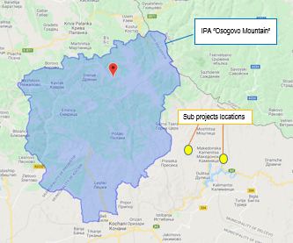 | 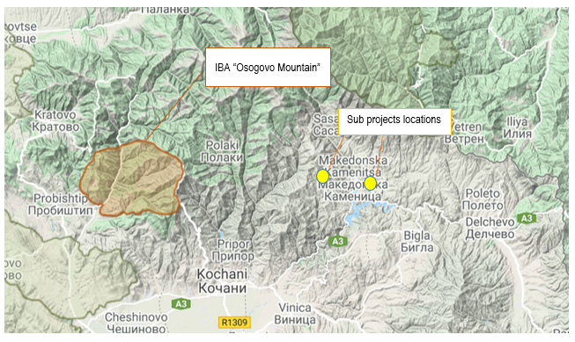
Figure 9 Location of IPA “Osogovski planini” related to sub projects location | Figure 10 Location of IBA “Osogovo” related to sub - projects location
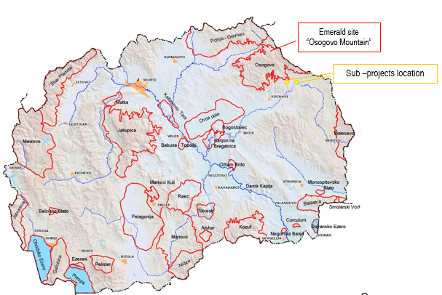
Figure 11 Location of Emerald site “Osogovski Planini” related to sub projects location

Annex 2 Layouts of the local road in v. Todorovci in Municipality of Makedonska Kamenica
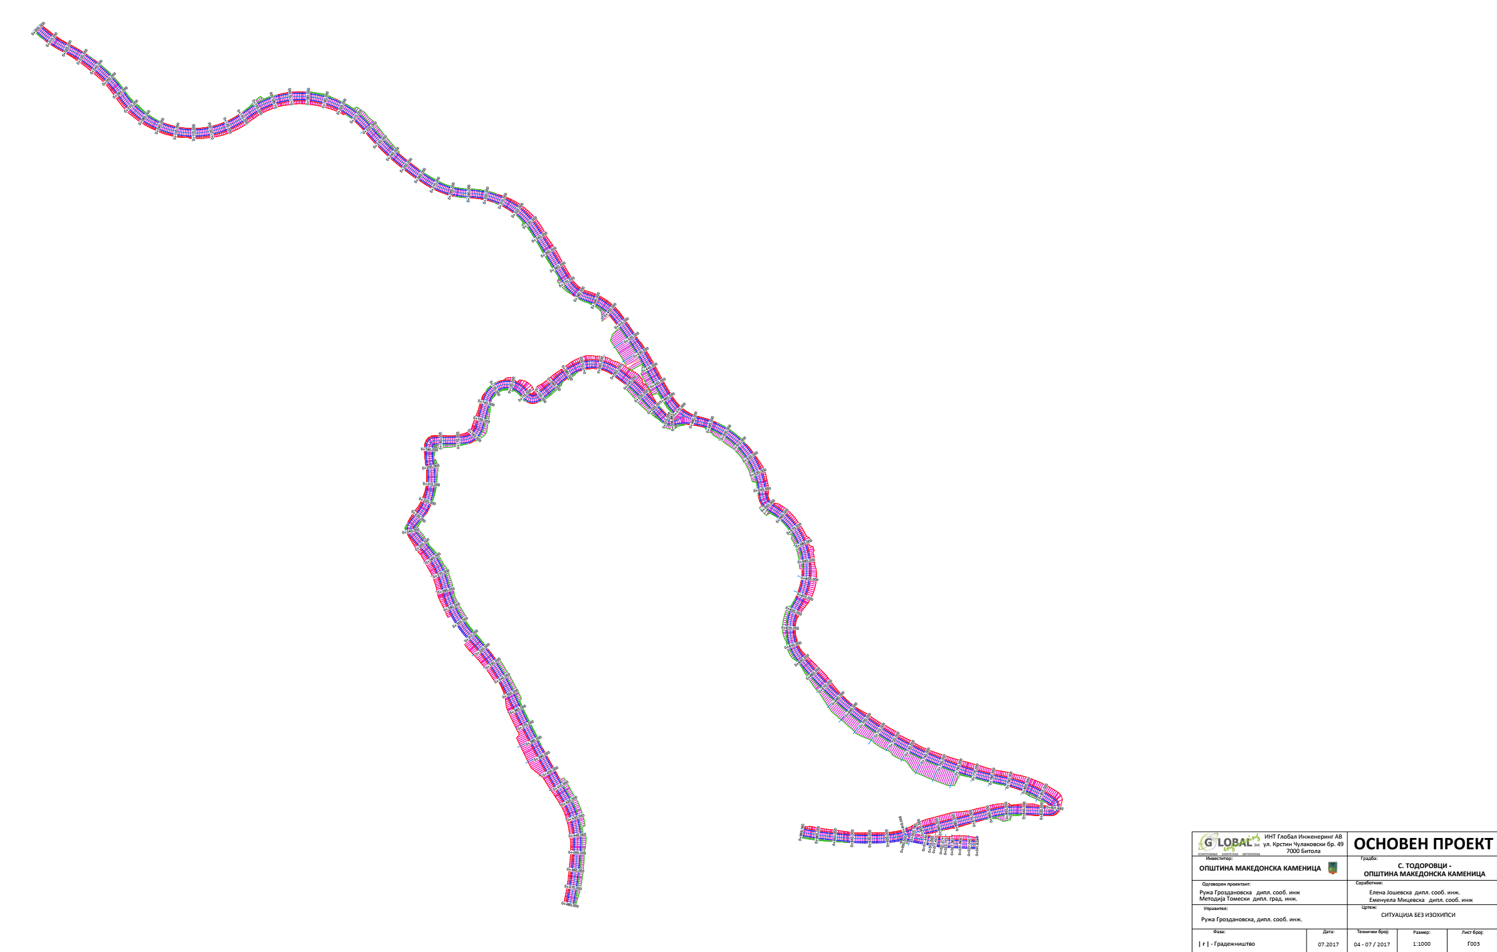

Layouts of the local road in v. Cera in Municipality of Makedonska Kamenica
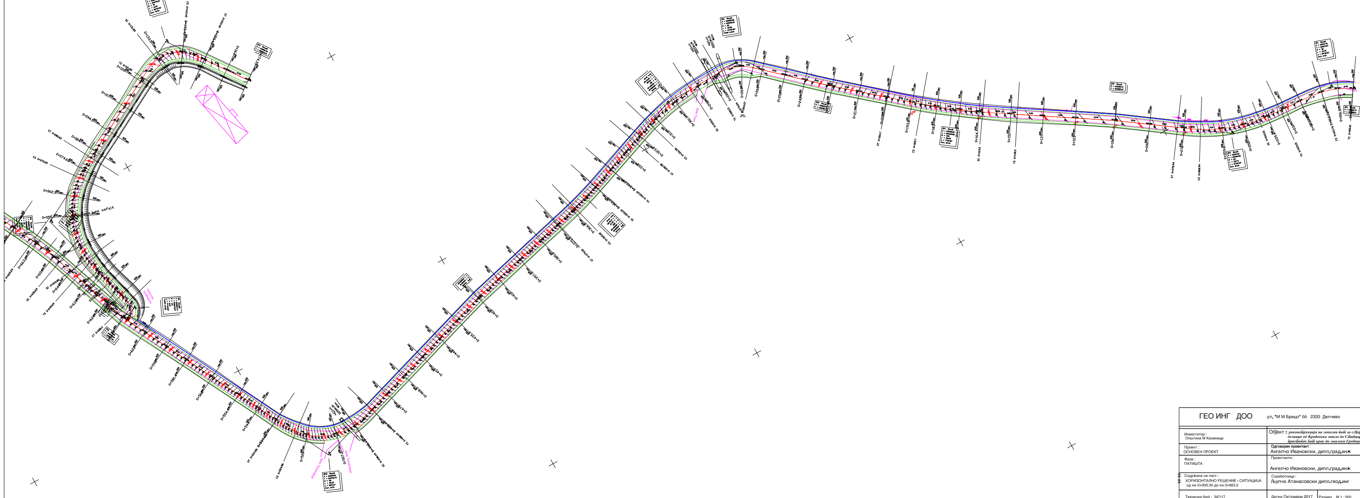

Graphic figures of the cross section of relevant local road in v.Todorovci , Municipality of Makedonska Kamenica
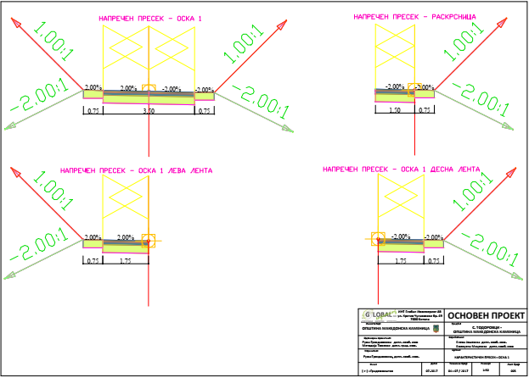
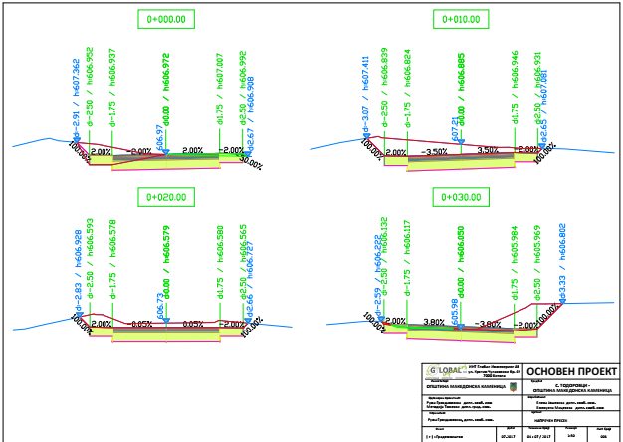

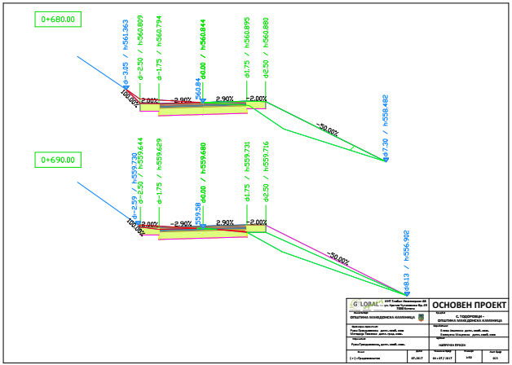
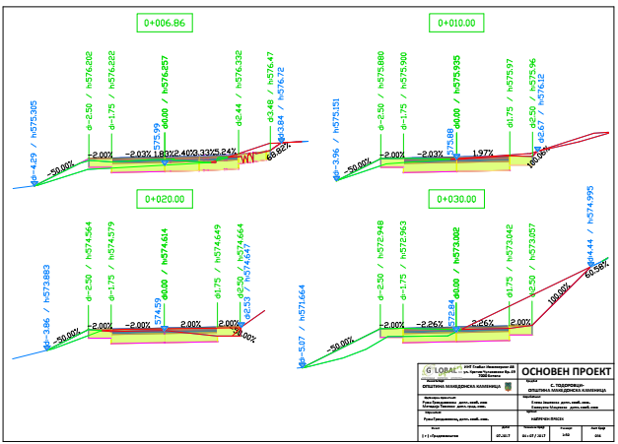

Graphic figures of the cross section of relevant local road in v. Cera, Municipality of Makedonska Kamenica
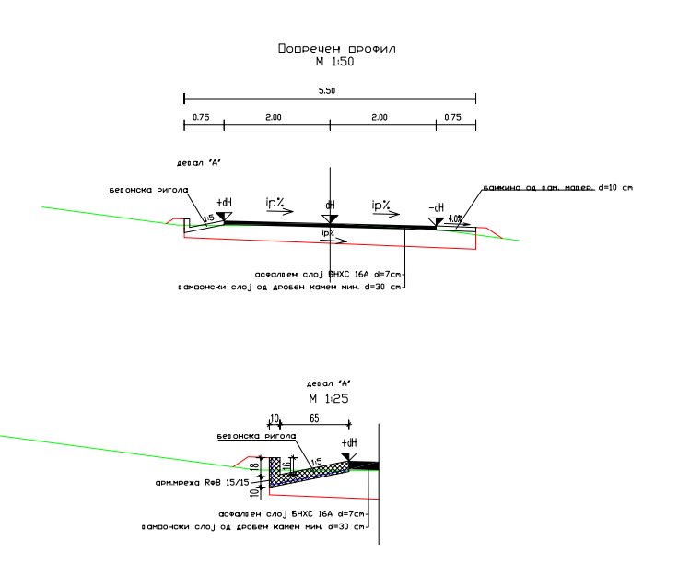

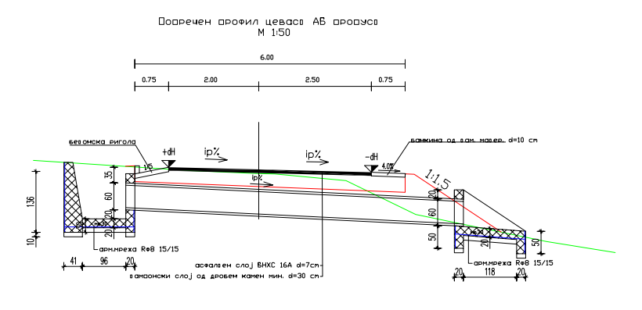

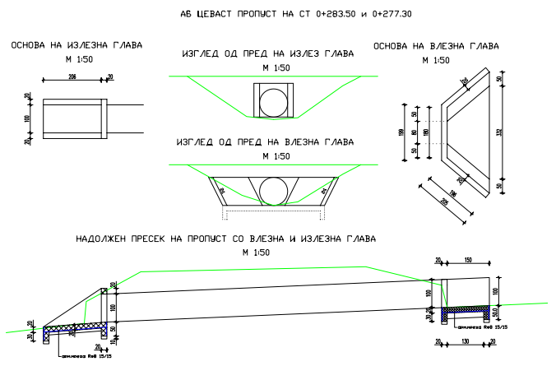

Cross section of the profile toward local cemetery
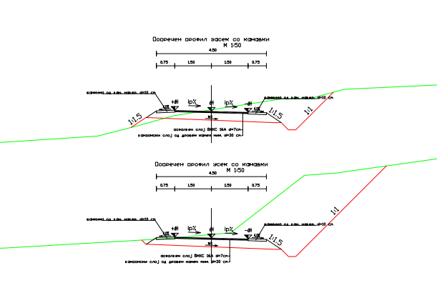
Annex 3 COVID-19 considerations in construction/civil works projects
Taking into account the new situation with the appearance of the virus COVID 19, besides the standard measures for safety and protection at work it is necessary to implement measures for protection from COVID 19.
Undoubtedly, the Contractors will face many challenges in the new situation, such as:
- Inability to purchase protective equipment and disinfectants due to lack on the market,
- Lack of labour due to limited movement and absences from work,
- Inability to provide materials and work equipment due to congestion in all segments of life in the country,
- Employees' concerns about their livelihoods due to reduced workload, etc.
First, it is necessary to implement the measures for protection from COVID 19 adopted by the Government of the Republic of Northern Macedonia at the proposal of the Commission for Infectious Diseases and the Ministry of Health. These measures should be constantly updated in accordance with the latest provisions introduced by the Government. The Contractor is required to nominate a responsible person who will follow the measures adopted by the Government and will apply them in the operation of the construction site at the project location.
Links of the national institutions responsible for COVID 19 where the Contractor could find updated information and recommendations:
- Government of the Republic of North Macedonia - https://vlada.mk/node/20488?ln=en-gb
- Ministry of Health - http://zdravstvo.gov.mk/korona-virus/
- Ministry of Labour and Social Policy - http://mtsp.gov.mk/covid-19.nspx
- Ministry of transport and communications - http://mtc.gov.mk/Preporaki%20od%20Vlada
- Official site for COVID – 19 - https://koronavirus.gov.mk/en
On national level in addition to the measures introduced by the Government for protection from COVID 19, the Macedonian Occupational Safety and Health Association developed a Guide to Safety and Health at Work in Construction Prevention from the Corona virus. The Guide contains measures that the Contractor is required to implement in order to eliminate the possible ways of obtaining and transmitting COVID 19 among the workers on construction site.
In more detail in several chapters, the Guide contains:
- Challenges in construction;
- Obligations for the Contractor;
- Obligations for workers;
- Liabilities for Investors;
- Ways of proceeding in cases of suspected case or cases infected with COVID 19;
- Contact phones of national institutions responsible for contacting the occurrence of the event infected with COVID 19.
The text of the Guide to Safety and Health at Work in Construction Prevention from the Corona virus on the Macedonian language is given on the following link http://mzzpr.org.mk/wp-content/uploads/2020/04/covid19-%D0%B3%D1%80%D0%B0%D0%B4%D0%B5%D0%B6%D0%BD%D0%B8%D1%88%D1%82%D0%B2%D0%BE.pdf.
The Contractor also needs to implement the requirements introduced by the World Bank related to the protection of COVID 19.
Regarding the COVID-19 considerations in construction/civil works projects given by the World Bank, they are divided in several segments/issues and in details are shown on Table 3.

Table 3 COVID-19 considerations in construction/civil works projects recommended by WB
COVID-19 considerations in construction/civil works projects
Covid-19 issues | Type of activities
The Contractor should identify measures to address the COVID-19 situation taking into account the location, existing project resources, availability of supplies, capacity of local emergency/health services, the extent to which the virus already exist in the area.
PIU and Contractor should establish specific procedures for addressing COVID 19 issues on the construction site. Procedures should be implemented, documented and updated in accordance with the latest changes introduced by the Government and the conditions on the construction site.
Assessing workforce characteristics | • The Contractor should prepare a detailed profile of the project work force, key work activities, schedule for carrying out such activities, different durations of contract and rotations;  • This should include a breakdown of workers who reside at home (i.e. workers from the community), workers who lodge within the local community and workers in on-site accommodation (i.e. workers camp). Where possible, it should also identify workers that may be more at risk from COVID-19, those with underlying health issues or who may be otherwise at risk;  • Consideration should be given to ways in which to minimize movement in and out of site. This could include lengthening the term of existing contracts, to avoid workers returning home to affected areas, or returning to site from affected areas.
Entry/exit to the work site and checks on commencement of work | • Establishing a system for controlling entry/exit to the site, securing the boundaries of the site, and establishing designating entry/exit points (if they do not already exist). Entry/exit to the site should be documented;  • Training security staff on the (enhanced) system that has been put in place for securing the site and controlling entry and exit, the behaviors required of them in enforcing such system and any COVID -19 specific considerations;  • Training staff who will be monitoring entry to the site, providing them with the resources they need to document entry of workers, conducting temperature checks and recording details of any worker that is denied entry;  • Confirming that workers are fit for work before they enter the site or start work. While procedures should already be in place for this, special attention should be paid to workers with underlying health issues or who may be otherwise at risk. Consideration should be given to demobilization of staff with underlying health issues;  • Checking and recording temperatures of workers and other people entering the site or requiring self-reporting prior to or on entering the site;  • Providing daily briefings to workers prior to commencing work, focusing on COVID-19 specific considerations including cough etiquette, hand hygiene and distancing measures, using demonstrations and participatory methods;  • During the daily briefings, reminding workers to self-monitor for possible symptoms (fever, cough, and other respiratory symptoms) and to report to their supervisor or the COVID-19 focal point if they have symptoms or are feeling unwell;  • Preventing a worker from an affected area or who has been in contact with an infected person from returning to the site for 14 days or (if that is not possible) isolating such worker for 14 days;  • Preventing a sick worker from entering the site, referring them to local health facilities if necessary or requiring them to isolate at home for 14 days.
General hygiene | • Placing posters and signs around the site, with images and text in local languages (MK/ALB);  • Ensuring handwashing facilities supplied with soap, disposable paper towels and closed waste bins exist at key places throughout site, including at entrances/exits to work areas; where there is a toilet, canteen or food distribution, or provision of drinking water; in worker accommodation; at waste stations; at stores; and in common spaces. Where handwashing facilities do not exist or are not adequate, arrangements should be made to set them up. Alcohol based sanitizer (if available, 60-95% alcohol) can also be used;  - Training workers and staff on site on the signs and symptoms of COVID-19, how it is spread, how to protect themselves (including regular handwashing and social distancing) and what to do if they or other people have symptoms;  • Setting aside part of worker accommodation for precautionary self-quarantine as well as more formal isolation of staff who may be infected.
Cleaning and waste disposal | • Providing cleaning staff with adequate cleaning equipment, materials and disinfectant;  • Training cleaning staff on appropriate cleaning procedures and appropriate frequency in high use or high-risk areas;  • Where it is anticipated that cleaners will be required to clean areas that have been or are suspected to have been contaminated with COVID-19, providing them with appropriate PPE: gowns or aprons, gloves, eye protection (masks, goggles or face screens) and boots or closed work shoes. If appropriate PPE is not available, cleaners should be provided with best available alternatives;  • Training cleaners in proper hygiene (including handwashing) prior to, during and after conducting cleaning activities; how to safely use PPE (where required); in waste control (including for used PPE and cleaning materials);  • Any medical waste produced during the care of ill workers should be collected safely in designated containers or bags and treated and disposed of following relevant requirements (e.g., national - http://www.moepp.gov.mk/?nastani=%d0%bf%d1%80%d0%b5%d0%bf%d0%be%d1%80%d0%b0%d0%ba%d0%b8-%d0%b7%d0%b0-%d1%83%d0%bf%d1%80%d0%b0%d0%b2%d1%83%d0%b2%d0%b0%d1%9a%d0%b5-%d1%81%d0%be-%d0%be%d1%82%d0%bf%d0%b0%d0%b4-%d0%b7%d0%b0-%d0%b3%d1%80,  WHO). If open burning and incineration of medical wastes is necessary, this should be for as limited a duration as possible. Waste should be reduced and segregated, so that only the smallest amount of waste is incinerated.
Adjusting work practices | • Decreasing the size of work teams;  • Limiting the number of workers on site at any one time;  • Changing to a 24-hour work rotation;  • Adapting or redesigning work processes for specific work activities and tasks to enable social distancing, and training workers on these processes;  • Continuing with the usual safety trainings, adding COVID-19 specific considerations. Training should include proper use of normal PPE. While as of the date of this note, general advice is that construction workers do not require COVID-19 specific PPE, this should be kept under review;  • Arranging (where possible) for work breaks to be taken in outdoor areas within the site;  • Consider changing canteen layouts and phasing meal times to allow for social distancing and phasing access to and/or temporarily restricting access to leisure facilities that may exist on site, including gyms;  • At some point, it may be necessary to review the overall project schedule, to assess the extent to which it needs to be adjusted (or work stopped completely) to reflect prudent work practices, potential exposure of both workers and the community and availability of supplies, taking into account Government advice and instructions.
Project medical services | • Expanding medical infrastructure and preparing areas where patients can be isolated. Isolation facilities should be located away from worker accommodation and ongoing work activities. Where possible, workers should be provided with a single well-ventilated room (open windows and door). Where this is not possible, isolation facilities should allow at least 1 meter between workers in the same room, separating workers with curtains, if possible. Sick workers should limit their movements, avoiding common areas and facilities and not be allowed visitors until they have been clear of symptoms for 14 days. If they need to use common areas and facilities (e.g. kitchens or canteens), they should only do so when unaffected workers are not present and the area/facilities should be cleaned prior to and after such use.  • Training medical staff, which should include current WHO advice on COVID-19 and recommendations on the specifics of COVID-19. Where COVID-19 infection is suspected, medical providers on site should follow WHO interim guidance on infection prevention and control during health care when novel coronavirus (nCoV) infection is suspected;  • Assessing the current stock of equipment, supplies and medicines on site, and obtaining additional stock, where required and possible. This could include medical PPE, such as gowns, aprons, medical masks, gloves, eye protection, etc..;  • Review existing methods for dealing with medical waste, including systems for storage and disposal.
Local medical and other services | • Conducting preliminary discussions with specific medical facilities, to agree what should be done in the event of ill workers needing to be referred;  - Obtaining information as to the resources and capacity of local medical services (e.g. number of beds, availability of trained staff and essential supplies);  • Clarifying the way in which an ill worker will be transported to the medical facility, and checking availability of such transportation;  • Agreeing with the local medical services/specific medical facilities the scope of services to be provided, the procedure for in-take of patients and (where relevant) any costs or payments that may be involved;  • A procedure should also be prepared so that project management knows what to do in the unfortunate event that a worker ill with COVID-19 dies. While normal project procedures will continue to apply, COVID-19 may raise other issues because of the infectious nature of the disease. The project should liaise with the relevant local authorities to coordinate what should be done, including any reporting or other requirements under national law;
Instances or spread of the virus | • If a worker has symptoms of COVID-19 (e.g. fever, dry cough, fatigue) the worker should be removed immediately from work activities and isolated on site;  • The worker should be transported to the local health facilities to be tested (if testing is available and permitted under national legislation);  • If the test is positive for COVID-19 or no testing is available, the worker should continue to be isolated. This will either be at the work site or at home. If at home, the worker should be transported to their home in transportation provided by the project;  • Extensive cleaning procedures with high-alcohol content disinfectant should be undertaken in the area where the worker was present, prior to any further work being undertaken in that area. Tools used by the worker should be cleaned using disinfectant and PPE disposed of;  • Co-workers (i.e. workers with whom the sick worker was in close contact) should be required to stop work, and be required to quarantine themselves for 14 days, even if they have no symptoms;  • Family and other close contacts of the worker should be required to quarantine themselves for 14 days, even if they have no symptoms;  • If a case of COVID-19 is confirmed in a worker on the site, visitors should be restricted from entering the site and worker groups should be isolated from each other as much as possible;  • If workers live at home and has a family member who has a confirmed or suspected case of COVID-19, the worker should quarantine themselves and not be allowed on the project site for 14 days, even if they have no symptoms;  • Workers should continue to be paid throughout periods of illness, isolation or quarantine, or if they are required to stop work, in accordance with national law;  • Medical care (whether on site or in a local hospital or clinic) required by a worker should be paid for by the employer.
Continuity of supplies and project activities | • Identify back-up individuals, in case key people within the project management team (PIU, Supervising Engineer, Contractor, sub-contractors) become ill, and communicate who these are so that people are aware of the arrangements that have been put in place;  • Document procedures, so that people know what they are, and are not reliant on one person’s knowledge;  • Understand the supply chain for necessary supplies of energy, water, food, medical supplies and cleaning equipment, consider how it could be impacted, and what alternatives are available. Early pro-active review of international, regional and national supply chains, especially for those supplies that are critical for the project, is important (e.g. fuel, food, medical, cleaning and other essential supplies). Planning for a 1-2 month interruption of critical goods may be appropriate for projects in more remote areas;  • Place orders for/procure critical supplies. If not available, consider alternatives (where feasible);  • Consider existing security arrangements, and whether these will be adequate in the event of interruption to normal project operations;  • Consider at what point it may become necessary for the project to significantly reduce activities or to stop work completely, and what should be done to prepare for this, and to re-start work when it becomes possible or feasible.
Contingency planning for an outbreak | The contingency plan to be developed at each site should set out what procedures will be put in place in the event of COVID-19 reaching the site. The contingency plan should be developed in consultation with national and local healthcare facilities and follow state guidance for COVID-19 response, to ensure that arrangements are in place for the effective containment, care and treatment of workers who have contracted COVID-19. The contingency plan should also consider the response if a significant number of the workforce become ill, when it is likely that access to and from a site will be restricted to avoid spread.  Contingencies should be developed and communicated to the workforce for:  • Isolation and testing procedures for workers (and those they have been in contact with) that display symptoms;  • Care and treatment of workers, including where and how this will be provided;  • Getting adequate supplies of water, food, medical supplies and cleaning equipment in the event of an outbreak on site, especially should access to the site become restricted or movements of supplies limited.  Specifically, the plan should set out what will be done if someone may become ill with COVID-19 at a worksite. The plan should:  • Set out arrangements for putting the person in a room or area where they are isolated from others in the workplace, limiting the number of people who have contact with the person and contacting the local health authorities;  • Consider how to identify persons who may be at risk (e.g. due to a pre-existing condition such as diabetes, heart and lung disease, or as a result of older age), and support them, without inviting stigma and discrimination into your workplace; and  • Consider contingency and business continuity arrangements if there is an outbreak in a neighboring community.  Contingency plans should consider arrangements for the storage and disposal arrangements for medical waste, which may increase in volume and which can remain infectious for several days (depending upon the material). The support that site medical staff may need, as well as arrangements for transporting (without risk of cross infection) sick workers to intensive care facilities or into the care of national healthcare facilities should be discussed and agreed.  Contingency plans should also consider how to maintain worker and community safety on site should sites closed to comply with national or corporate policies, should work be suspended or should illness affect significant numbers of the workforce. It is important that worksite safety measures are reviewed by a safety specialist and implemented prior to work areas being stopped.
Training and communication with workers | • Regular information and engagement with workers (e.g. through training, town halls, tool boxes) that emphasizes what management is doing to deal with the risks of COVID-19. Workers should be given an opportunity to ask questions, express their concerns, and make suggestions;  • Training should address issues of discrimination or prejudice if a worker becomes ill and provide an understanding of the trajectory of the virus, where workers return to work;  • Training should cover all issues that would normally be required on the work site, including use of safety procedures, use of construction PPE, occupational health and safety issues, and code of conduct, taking into account that work practices may have been adjusted;  • Communications should be clear, based on fact and designed to be easily understood by workers, for example by displaying posters on handwashing and social distancing, and what to do if a worker displays symptoms.
Communication and contact with the community | • Communications should be clear, regular, based on fact and designed to be easily understood by community members;  • Communications should utilize available means. In most cases, face-to-face meetings with the community or community representatives will not be possible. Other forms of communication should be used; online platforms, social media, posters, pamphlets, radio, text messages, virtual meetings. The means used should take into account the ability of different members of the community to access them, to make sure that communication reaches these groups;  • The community should be made aware of procedures put in place at site to address issues related to COVID-19. This should include all measures being implemented to limit or prohibit contact between workers and the community. The community should be made aware of the procedure for entry/exit to the site, the training being given to workers and the procedure that will be followed by the project if a worker becomes sick.
Covid-19 reporting | Contractor should report an outbreak for a ‘Serious’ incident. The Contractor should keep the Borrower informed of any concerns or problems associated with providing care to infected workers on project sites, particularly if infection rate is approaching 50% of the workforce.

Annex 4 Form for submitting comments
Form for submitting comments and suggestions for Environmental and Social Management Plan ESMP for the project “Upgrading of local road in village Todorovci and local road in village Cera, section from Krapevska Maala to Stipcarska Maala and road branch to neighborhood Cemetery, in Municipality of Makedonska Kamenica”
Main description of the project
The project for upgrading of local road in village Todorovci and local road in village Cera, section from Krapevska Maala to Stipcarska Maala and road branch to neighborhood Cemetery, in Municipality of Makedonska Kamenica is located in the south part of the Municipality of Makedonska Kamenica. The total length of the road to the v. Todorovci is 1,493 km and total length of the road to the v. Cera is 2,409 km. The main activities for both sub-projects are: marking and securing the route, machine excavation on the soil, making an earth embankment, making a bedding, putting asphalt layer, etc. Since both roads are existing roads, no significant environmental impacts are expected, but for the identified impacts, the ESMP is prepared where appropriate measures for their mitigation and minimization are prescribed.
Electronic version of Environmental and Social Management Plan (ESMP) for the project “Upgrading of local road in village Todorovci and local road in village Cera, section from Krapevska Maala to Stipcarska Maala and road branch to neighborhood Cemetery, in Municipality of Makedonska Kamenica is available on the following web pages:
- Municipality of Makedonska Kamenica: www.makedonskakamenica.gov.mk
- MoTC PIU: http://mtc.gov.mk/
Name and surname of the person who provides comment*

Contact information* | E-mail:  ______________________________  Phone:  _____________________________
Comment on the ESMP:

Signature  ______________________ |  | Date  ____________________
If you have any comments/suggestions or amendments to the proposed measures of Environmental and Social Management Plan ESMP for the project “Upgrading of local road in village Todorovci and local road in village Cera, section from Krapevska Maala to Stipcarska Maala and road branch to neighborhood Cemetery, in Municipality of Makedonska Kamenica, please submit it to the responsible persons from the following institution:
Contact person: Irena Paunovikj
e-mail: irena.paunovikj.piu@mtc.gov.mk
Within the 14 days period after the announcement of ESMP for the project “Upgrading of local road in village Todorovci and local road in village Cera, section from Krapevska Maala to Stipcarska Maala and road branch to neighborhood Cemetery, in Municipality of Makedonska Kamenica
(date of announcement: ……. )
Referent number: ______________________________
(fulfilled by the responsible persons for the project implementation)
* Fulfillment of the fields with personal data is not obligatory

Annex 5 Grievance Form for whole project implementation period
Reference Number
Full name (optional)
- I wish to raise my grievance anonymously.
- I request not to disclose my identity without my consent.
Contact information  Please mark how you wish to be contacted (by post, telephone, e-mail). | - By Post: Please provide mailing address:  ________________________________________________________________________________________________________________________________________________________________________  - By telephone: ___________________________________________________  - By E-mail
Preferred language of communication | - Macedonian  - Albanian  - Turkish  - Other: ____________________
Gender | - Female  - Male
Description of Incident for Grievance |  | What happened? Where did it happen? Whom did it happen to? What is the result of the problem?
Date of Incident / Grievance
- One-time incident/grievance (date ________________)
- Happened more than once (how many times? ______)
- On-going (currently experiencing problem)
What would you like to see happen?

Signature: _______________________________
Date: _______________________________

Please return this form to:

Name and surname | Irena Paunovikj | Aleksandra Dimoska Angelovska | ------------------------
E-mail | irena.paunovikj.piu@mtc.gov.mk | dimoska.aleksandra@gmail.com | --------------------------------
Institution | Ministry of Transport and communications | Municipality of Makedonska Kamenica | Contractor Company
Local Roads Connectivity Project
St. Dame Gruev 6,1000 Skopje, R. N. Macedonia

