


LOCAL ROADS CONNECTIVITY PROJECT
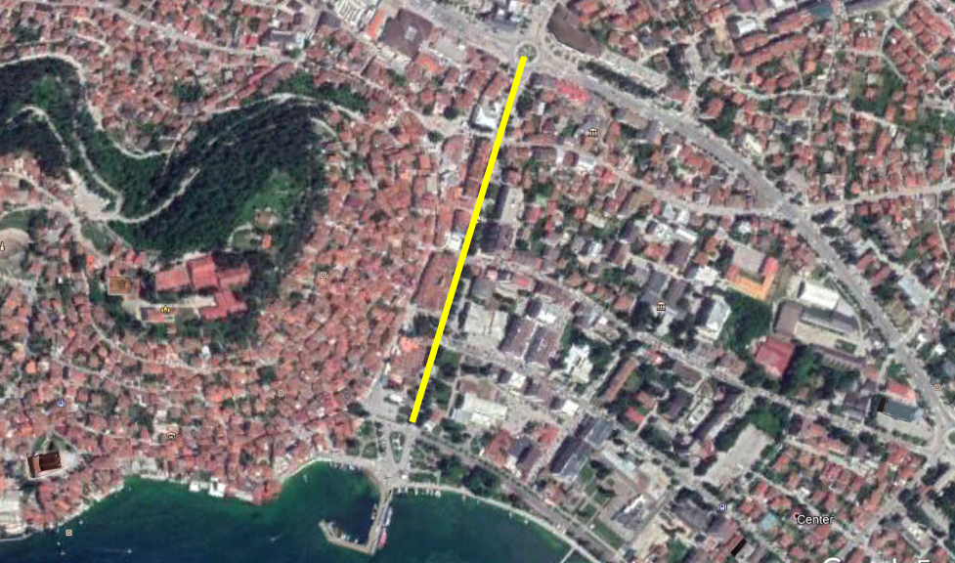
October 2020
ENVIRONMENTAL AND SOCIAL MANAGEMENT PLAN (ESMP)
Reconstruction of local street “Makedonski Prosvetiteli”, in the Municipality of Ohrid

Prepared by:
Slavjanka Pejchinovska-Andonova, MSc, Environmental Engineer
Environmental and Social (E&S) Specialist

TABLE OF CONTENTS
1. INTRODUCTION 3
2. PROJECT DESCRIPTION 4
2.1 Baseline condition of Municipality of Ohrid 4
2.1.1 Demography 5
2.1.2 Climate features 5
2.1.3 Seismology 6
2.1.4 Water 6
2.1.5 Air quality 6
2.1.6 Waste 7
2.1.7 Geology and soil 7
2.1.8 Flora and fauna 7
2.1.9 Noise 10
2.1.10 Cultural heritage 10
2.2 Project location 11
2.3 Project Activities 12
2.4 Sensitive receptors 12
3. POTENTIAL ENVIRONMENTAL IMPACT AND RISK AND IMPACT AND RISK ASSESSMENT 12
Implementation of ESMP 14
Public disclosure and citizen engagement 16
4. ENVIRONMENTAL AND SOCIAL MITIGATION PLAN 19
5. ENVIRONMENTAL AND SOCIAL MONITORING PLAN 26
6. ANNEX 32

FIGURES
Figure 1 City of Ohrid and Lake Ohrid 4
Figure 2 Location of the project within the Municipality of Ohrid 4
Figure 3 Map with potential natural hazards (erosion, floods, landslides and earthquakes) in RNM 5
Figure 4 Seismology card for RNM 6
Figure 5 Some endemic representatives related to the project site in Municipality of Ohrid 8
Figure 6 Landscape of transboundary reserve “Ohrid-Prespa” 9
Figure 7 Some flora and fauna representatives of NP “Galichica” 9
Figure 8 Location of the project road 11
Figure 9 Location of IPA “Lake Ohrid” related to project location 32
Figure 10 Location of IВA “Lake Ohrid” related to project location 32
Figure 11 Location of Emerald sites “Lake Ohrid” and “Galichica” 32
Figure 12 Location of the project location related to PBA “Galichica” 32
Figure 13 Location of Project location regard the Balkan Green Belt 33
Figure 14 Location of UNESCO site related to project location 33
Figure 15 Location of NP “Galichica” regard the project location 33
Figure 16 Location of project site regard the transboundary reserve “Ohrid-Prespa” 33
Figure 17 Local street “Makedonski Prosvetiteli” 34

TABLES
Table1 Planned project activities for the project road, in Municipality of Ohrid 12
Table 2 The potential impact and risks during implementation of the project 12
Table 3 COVID-19 considerations in construction/civil works projects recommended by WB 36

ANNEXES
Annex 1 Map of sensitive areas in the wider surrounding of the project location in Municipality of Ohrid 32
Annex 2 Photo gallery from the site visit by representatives from MTC and Municipality of Ohrid 34
Annex 2 COVID-19 considerations in construction/civil works projects 35
Annex 3 Form for submitting comments 41
Annex 4 Grievance Form for whole project implementation period 42

ABBREVIATIONS
EIA | Environmental Impact Assessment
ESMF | Environmental and Social Management Framework
ESMP | Environmental and Social Management Plan
ES | Environmental and social
ESS | Environmental and social standards
IPA | Important Plant Area
IBA | Important Bird Area
LRCP | Local Road Connectivity Project
MoEPP | Ministry of Environment and Physical Planning
MOSHA | Macedonian Occupational Safety and Health Association
MSC | Macro seismic
MoTC | Ministry of Transport and Communications
OH&S;OHS | Occupational Health and Safety
PCE | Public Communal Enterprise
PPE | Personal protection equipment
PIU | Project Implementation Unit
RM | Republic of Macedonia
RNM | Republic of North Macedonia
TMP | Traffic Management Plan
WB | World Bank
WHO | World Health Organization

INTRODUCTION
The transport sector in Republic of North Macedonia is characterized by poor condition of the local roads network, unsatisfactory level of financing of road maintenance on national level and there are weaknesses of international investment in distribution sector and transport sector. Such poor condition of the local roads is as a result of lack of financial capacity of the Local Self Government that differs from region to region in the country. Some local roads in the rural areas are in an unacceptable condition with no access to the hospitals, schools and markets so this issue brings social problems as well.
In order to support the municipalities in the Republic of North Macedonia by 70 million Euro investment secured by the World Bank, Ministry of transport and communications will implement the Local Roads Connectivity Project (LRCP) mostly in rehabilitation of existing local road infrastructure (urban / rural streets, regional and local roads), rehabilitation, upgrading, pedestrian paths, street lighting, water drainage and capacity building of the municipal staff.
When preparing these types of projects, according to the national environmental requirements (Law on Environment and secondary legislation), it is necessary to submit a Notification Letter for intention to start the project to the MoEPP which initiates the environmental impact assessment procedure and based on the Opinion, to prepare the EIA Report. If the issued Opinion of the MoEPP is positive and EIA Report has to be prepared,
The EIA Report shall be prepared in accordance with Article 24 of the Law on Environment (Official Gazette of the Republic of Macedonia No 53/05, 81/05, 24/07, 159/08, 83/09, 48/10, 124/10, 51/11, 123/12, 93/13, 187/13, 42/14, 44/15, 129/15, 192/15, 39/16 and 98/18) and the Rulebook on the form and contents of the EIA Report in accordance with the types of activities for which the report is being prepared, as well as in accordance with the entities performing the activity and the scope of activities being performed by the legal and natural entities, the procedure for their approval, as well as the method for keeping of the register of approved reports (Official Gazette of the Republic of Macedonia No 44/13, 111/14).
Since the project in accordance with the national legislation belongs to the Chapter X – Infrastructure projects, item 1 Upgrading of local roads, the EIA Report for the project “Reconstruction of local street Makedonski Prosvetiteli”, in Municipality of Ohrid was prepared by the company “IEGE” Skopje in June 2019. The EIA Report was approved by the Mayor of the Municipality of Ohrid and a Decision was issued on 28.11.2019 with number UP 21-788. The Municipality of Ohrid needs to send a copy of the EIA Report together with the Decision for its approval to the MoTC with other technical documents.
In order to address Project’s potential environmental and social concerns in accordance with the requirements of the World Bank Environmental and Social Standards, Environmental and Social Management Framework (ESMF) was prepared for the whole LRCP project in September/October 2019. ESMF issued, as the most appropriate tool for addressing environmental and social aspects of sub-projects identified in the course of project preparation and implementation.
The road is planned to have: lanes with a width of 3.25 m, sidewalks with an average of 3 m on the side of the shops and 2 m on the side of the municipal buildings, one-sided bicycle path at the municipal buildings, 2.4 m wide, two-way and provided separated middle green belt 2 m wide.
Taking into account that the project street along its entire length belongs to the protected area of the old part of the city of Ohrid which is protected as a cultural heritage of particular meaning, in accordance with the Law on Proclamation of The old city core of Ohrid for cultural heritage of special importance ("Official Gazette of RM no. 47/2011), and within the limits of the protected good which in 1980 was placed on the list of UNESCO, as a world natural and cultural inheritance, as well as the nature of project activities, technical specifications, size of the street, location of upgrading activities, the specifics of the potential environmental impacts during the reconstruction of the street, the Project Reconstruction of local street Makedonski Prosvetiteli, in Municipality of Ohrid was classified as project with substantial risks, which requires the preparation of Environmental and Social Management Plan (ESMP) in accordance with the WB environmental and social standards.

PROJECT DESCRIPTION

Baseline condition of Municipality of Ohrid
The Municipality of Ohrid is a municipality in the southwestern part of North Macedonia with total area of 389,9 km². Ohrid is also the city where the municipal seat is found.
City of Ohrid, with its natural, cultural, spiritual and historical peculiarities is the most developed tourist and cultural center in the Republic of Northern Macedonia. The city of Ohrid and Lake Ohrid, as a rare cultural and natural heritage are on the UNESCO list. It is known that in Ohrid there is continuous life for 7000 years, and the remains of civilizations are noticeable in over 250 archeological sites discovered so far.
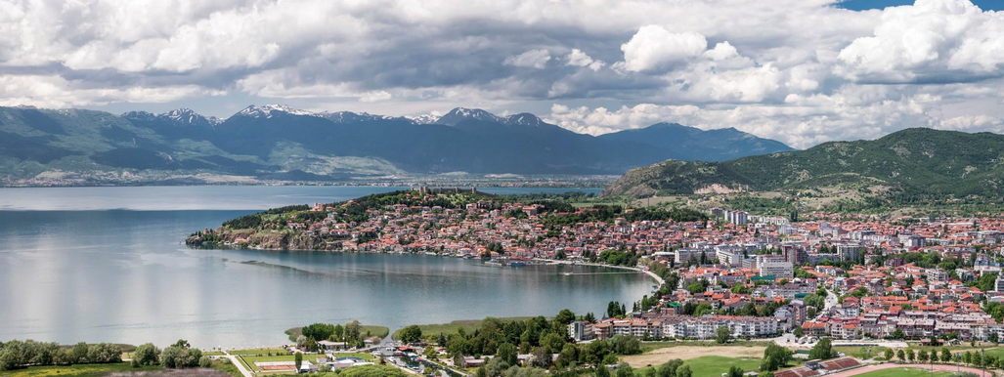
Figure 1 City of Ohrid and Lake Ohrid
In Figure 2 is presented location of the project site regard the location of the Municipality of Ohrid.
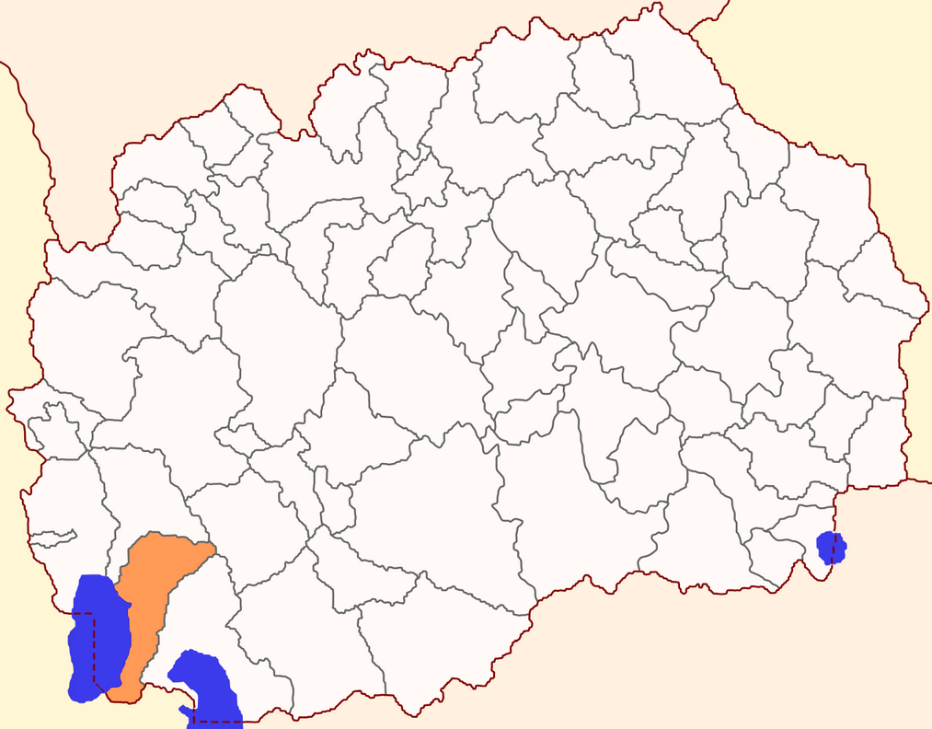
Municipality Ohrid
Figure 2 Location of the project within the Municipality of Ohrid

Demography
The municipality of Ohrid has 29 settlements with 55,749 inhabitants, according to the 2002 census. Data for 2014 show that the municipality had 52,262 inhabitants, of which 49% are men and women represent 51% of the population. In the municipality about 84.93% are Macedonians, 5.31% are Albanians 4.07% Turks and less than 1% are Roma, Vlahs, Serbs and Bosnians.
According to municipal data, Ohrid has 180 commercial objects (restaurants, bars and etc….) and 60 accommodation facilities.

Climate features
The Ohrid region is dominated by a moderate-continental climate, to some extent modified, as a consequence of the currents that penetrate from the Adriatic Sea through the river Crn Drim. These currents, together with the impact of the Lake, contribute primarily to the formation of a specific thermal and pluviometric regime, which are characterized by small amplitudes of air temperature throughout the year and concentration of heavier precipitation in the winter-spring months.
The average annual temperature is 11 ° C, with maximum average monthly temperatures in July and August of 21.2 ° C and 34.4 ° C. The average winter temperature is 2.7 ° C, while the average summer temperature is 19.6 ° C. The lowest average monthly temperature recorded in January, at -17.2 ° C, is the absolute minimum. The average annual rainfall in Ohrid is 703 mm, while the average rainfall in the vicinity of the lake is approximately 759 mm per year. The most rainy in Ohrid is November-98.4 mm, then December and January with 78.9 mm and 76.4 mm, respectively, while the least rainfall is July-23.2 mm and August-29.1 mm. The snow appears from November to April and has an average of 19 days of snow cover per year.
Floods and erosion
The Municipality of Ohrid is part of the Southwest Planning Region. According to the office research, the territory of the Municipality of Ohrid is prone to liquidation. Figure 3 shows the project location in relation to potential natural hazards (erosion, floods, landslides and earthquakes) in RSM.
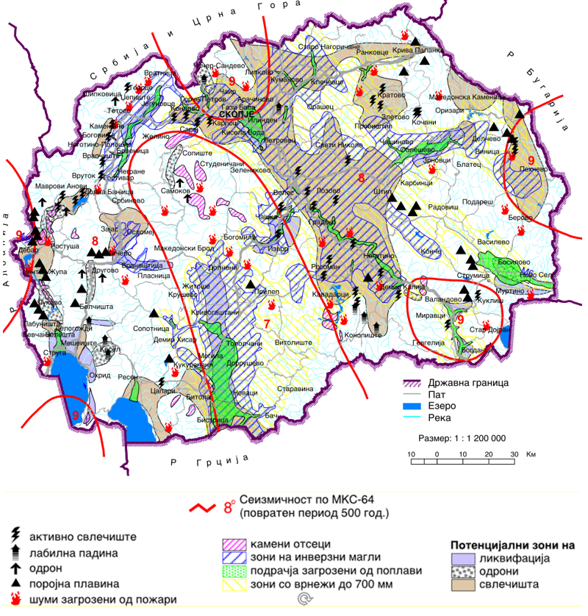
Project Location
source: http://app.gov.mk/wp-content/uploads/2015/04/%D0%9030104-PP-na-RM-2002-2020.pdf
Figure 3 Map with potential natural hazards (erosion, floods, landslides and earthquakes) in RNM

Seismology
According to the seismic repartition, the Municipality Ohrid belongs to seismic zone with maximum intensity of earthquake of VIII degrees as seen in Figure 4.
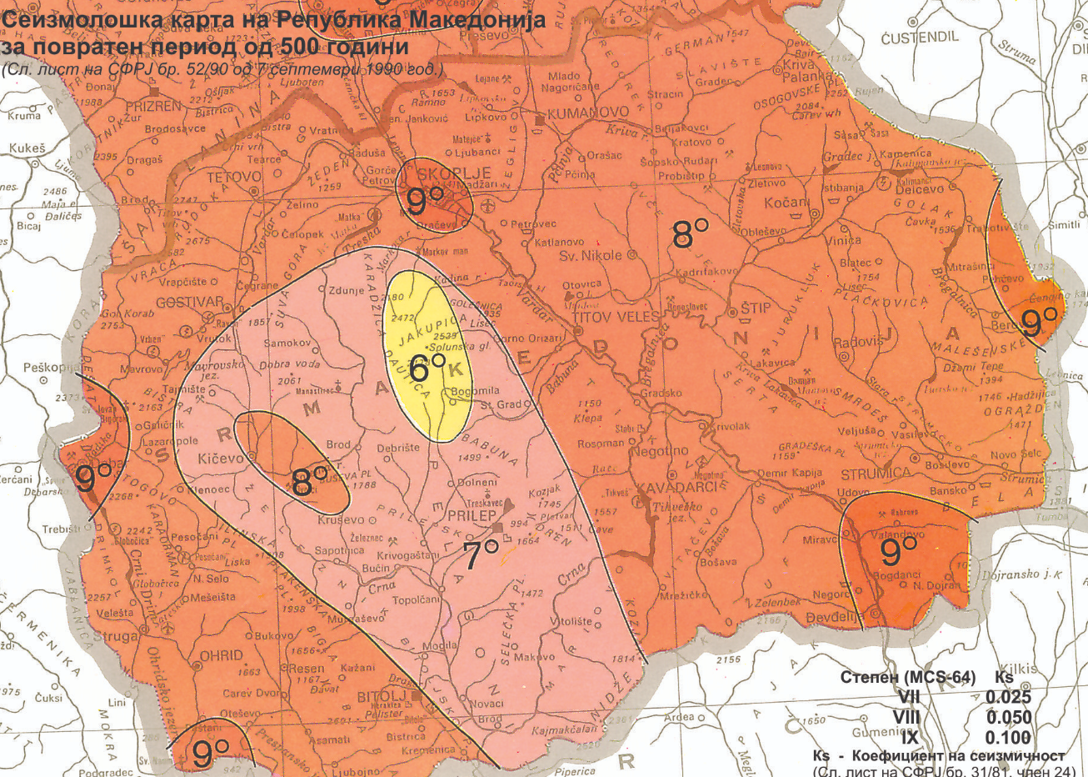
Project Location
Figure 4 Seismology card for RNM

Water
The wider surroundings of the project site are characterized by one water body, Lake Ohrid, which covers an area of ​​358 km² and has an average depth of 151 m, and the maximum depth is 286 m. The waters that fill Lake Ohrid come from its watershed or drainage area. 40 smaller rivers and streams flow into the lake, 23 on Albanian and 17 on Macedonian territory. Except for the rivers: Sateska, Koselska, Grashnica and Cherava, all the others are short and dry. The rivers have a small basin, length and flow and at the inflow into the lake they create a deltimal river that is not used for irrigation due to the fact that the water in this river depends on the spring and autumn rains. The river Trebicka flows near the road.
Most of the surface springs are located along the south coast, around the monastery of St. “Naum”, in the vicinity of Tushemishte and Starova and the town of Pogradec on the Albanian side. At the foot of Petrino, the most important are the springs near Studenchishta, Biljanini izvori and Bejbunar.
A large role in the water supply of the Lake is played by the numerous underwater springs, which are found both individually distributed and as a sum of several such, marked as hot. Special micro-ecological conditions have been recorded around them and are of particular importance for the endemic wildlife of the Lake.
The supply of sanitary and drinking water at the project site is through the regional water supply network.

Air quality
In the Republic of North Macedonia, monitoring of the ambient air quality is performed by the Ministry of Environment and Physical Planning, which manages the State automatic air quality system composed of 17 measuring stations of which 5 are located in Skopje, and the closest measuring station to the project location is the one in City of Kicevo, located north-east from the project location. In this air quality measuring station, monitoring is performed of the following: sulphur dioxide, nitrogen dioxide, carbon monoxide, ozone and suspended particles with size of 10 micrometers (PM₁₀).
The sources of suspended particles are burning of fossil fuels and biofuels, different industrial processes, traffic, incineration of waste and wild fires. One of the most important sources is heating of homes and administrative capacities, mainly due to the incomplete incineration of wood in the old furnaces. The number of times the average daily threshold limit value of PM₁₀ at the Strumica measuring point in 2019 was exceeded for 77 days, in the year of 2020 (until August) there were 74 days in which the average daily threshold limit value was exceeded.
In the Republic of North Macedonia, the key and dominant source of sulphur oxides in the air are the processes of burning of fuels (coal and fuel-oil). The average daily SO₂ concentrations at this measuring station have not exceeded the threshold value for the year of 2019 and the year 2020 (until August).
Carbon monoxide is formed during the incomplete incineration of fuels in internal combustion engines and energy plants, as well as during different industrial processes, public institutions and households. The maximum daily 8 hour average values of CO concentrations at this measuring station for the year 2019 and the 2020 (until August) there have not been any exceedances of the threshold value.
The maximum daily 8-hour average values for the ozone concentration in the year 2019 exceed the threshold limit 7 times, in the year 2020 (until July) the threshold limit value has not been exceed. For the 1-hour average values of NO₂ for the year 2019 have exceeded the threshold limit only 1 time and 2020 (until July) there were no exceedances of the upper threshold limit.

Waste
Deposition of municipal solid wastes, is one of the most serious problems in the Municipality of Ohrid.
The waste in Municipality of Ohrid is disposed of at the landfill “Bukovo”, located around 14,5 km to the north-east of the project location. The landfill does not meet the minimum sanitary standards and regulations. There are no infrastructures (water, electricity), no disinfectant, no death animal pits etc. The waste is disposed of without any treatment (only leveled and filled with soil and sand).
In the municipality of Ohrid the solid municipal waste is collected and disposed by PE “Ohridski Komunalec”, with own vehicles.
Because there is no appropriate alternative landfill for waste disposal from project activities, the generated inert waste and communal waste should be disposed at landfill “Bukovo” (located about 14,5 km north-east from the project location).

Geology and soil
The geological structure of the wider area in the Municipality of Ohrid consists predominantly of alluvial formations, semi-vial sediments, spread in the plain part. Alluvial deposits in terms of engineering-geological characteristics are mostly labile terrains with low values of physical-mechanical properties. From a regional geological aspect, this area is located in the Western Macedonian geotectonic zone, ie within the Ohrid Neogene Basin. The following geological formations are distinguished in this region: Paleozoic, Triassic, Cretaceous, Neogene, Quaternary. From the igneous rocks in the region are represented: granites, sienites, gabbro, diorites, diabases, trachites, serpentinites and dunites.

Flora and fauna
The project site is located in urban area of City of Ohrid. In the near vicinity of the project site, several important and significant sites/areas with high natural values: Ohrid Lake (UNESCO site, IPA, IBA and PBA site), National Park “Galichica”, Emerald sites “Ohrid lake” and “Galichica”, Transboundary reserve “Ohrid-Prespa” and Balkan Green belt. In Annex 1 are presented locations of these biodiversity sensitive areas, regards the project location. Following will be given brief description of each important and significant sites/areas with high natural values.
Ohrid Lake (UNESCO site)
The Lake Ohrid region, a Natural and Cultural Heritage property (covering c. 94,729 ha), was first inscribed for its nature conservation values in 1979 and for its cultural heritage values a year later. These inscriptions related to the part of the lake located in North Macedonia. Lake Ohrid is a superlative natural phenomenon, providing refuge for numerous endemic and relict freshwater species of flora and fauna dating from the tertiary period. As a deep and ancient lake of tectonic origin, Lake Ohrid has existed continuously for approximately two to three million years. Its oligotrophic waters conserve over 200 species of plants and animals unique to the lake, including algae, turbellarian flatworms, snails, crustaceans and 17 endemic species of fish including two species of trout (Salmo letnica and Belvica acantolingua ohridana), as well as a rich birdlife. In Figure 5 are given some endemic species of the UNESCO site.
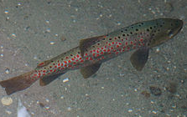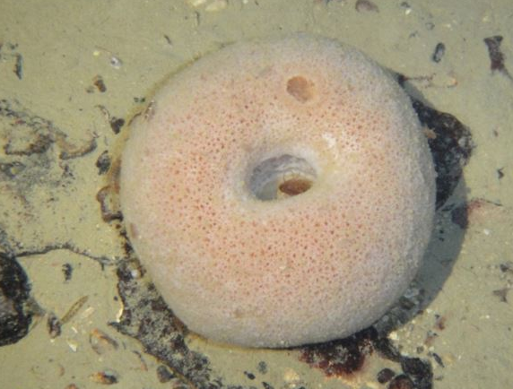
Source: https://gdb.rferl.org/B5479F5C-4089-43A3-B3F2-6A7A118A5636_mw800.jpg
https://upload.wikimedia.org/wikipedia/commons/thumb/2/2c/Ohridforelle_1.jpg/375px-Ohridforelle_1.jpg
Salmo letnica Ochridaspongia rotunda
Figure 5 Some endemic representatives related to the project site in Municipality of Ohrid
The last remaining significant coastline wetland at Lake Ohrid is Studenchishte Marsh, which is located on the eastern shore near the City of Ohrid. Despite degradation from a variety of sources such as large-scale disposal of construction waste, major land conversion, disruption of water connections to Lake Ohrid, beach urbanization and loss of reed belts, Studenchishte Marsh is still an important buffer to prevent lake eutrophication and a key habitat for biodiversity, including relict plants and endemic species.
Transboundary reserve “Ohrid-Prespa”
This transboundary reserve is located in South-Eastern Europe on the Balkan Peninsula between Albania and North Macedonia. The area is a combination of water bodies and surrounding mountain reliefs while flat areas border the external limits of the territories stretching across the two countries. The biosphere reserve was declared on 11.7.2014, with total surface Area of 446,244.52 ha (386,915.21 ha terrestrial; 59,329.31 ha aquatic).
The Ohrid-Prespa Transboundary Biosphere Reserve includes a significant difference in terms of ecological systems, ranging from mountainous areas around the three lakes, to temperate sub-tropical forests found at lower altitudes around the water basins. Together, the Ohrid and Prespa Lake system is one of the largest in Europe of this sort. Both lakes are of special value at national and international levels due to their geological and biological uniqueness.
There is also a unique and endemic forest community composed of Pinetum peuces, paeonian grecian juniper woods, Helleno-moesian quercus frainetto forests, and southwestern moesian fir beech forests. The Prespa region hosts original biotopes vital for preservation, such as the extensive deciduous forests of Ostryo-Carpinion orientalis, the evergreen Box-Jupiner shrub lands, the evergreen coniferous forests consisting of 12 m high Juniperus foetidissima and Juniperous excelsa, and the important endemic vegetation species of Ezerani.
Mammals represent the second most important group of species whose protection is crucial in the transboundary biosphere reserve, including Talpa stankovici (Balkan mole), Lynx lynx martinoi (Balkan Lynx), Canis lupus (gray wolf), Ursus arctos (brown bear), etc. The Balkan Lynx is an exceptionally rare species of very high symbolic value. As far as bird species are concerned, the Dalmatian Pelican (Pelecanus crispus) is the epitome of a flagship species. In the Prespa region there are over 260 species of birds, representing more than half of the types of birds in Europe, 140 of which nest in the area. The landscape of this Transboundary Biosphere Reserve is presented in Figure 6. The project location is part of the transboundary reserve “Ohrid-Prespa”.

Source: transboundary reserve "Ohrid-Prespa"
Figure 6 Landscape of transboundary reserve “Ohrid-Prespa”
National Park “Galichica”
The National Park “Galichica” is situated on Mount Galicica, which is a part of the mountain range of Sara-Pind. Due to its exceptional natural beauty and extremely opulent and endemic flora and fauna, in 1958 the Macedonian section of the mountain was proclaimed a National Park. The Park covers an area of 227 km² between the Lakes of Ohrid and Prespa, and it stretches in a meridian direction.
Galicica is a unique mount with well-preserved natural flora in several ecosystems. The flora in the National Park Galicica covers more than 800 species, among which there are numerous relict and endemic forms whose farthest limit of distribution is Mount Galicica itself.
The presence of eleven local endemic forms discovered so way is quite remarkable. These forms exist only on the slopes of the Mount Galicica, and are clear evidence of the specific floral structure of the mountain. It should be underlined that there is an on-going intensive research of the flora in the Park. There are indications of an even greater number of endemic forms. The fauna on Galicica is also prolific and diverse. There are no precise data about the number of invertebrate species. Vertebrates are present with 170 species: 10 amphibians, 18 reptiles, 124 birds, and 18 mammals.

Source: http://galicica.org.mk/en/flora-and-fauna/
Pelecanus crispus Algyroides nigropunctatus Crocus cvijicii
Figure 7 Some flora and fauna representatives of NP “Galichica”

The National Park “Galicica” is located about 2 km southeast from the project site.
Important Bird Area (IBA) “Lake Ohrid”
The establishment of Important Bird Areas (IBAs) is an initiative implemented by (BirdLife International) globally to ensure the conservation of areas important for the protection of wild bird species. So far, a total of 24 such areas have been identified, covering an area of 6,709 km² or 26.9% of the total territory of the country. About 100 m south from the project site, IBA “Lake Ohrid” is located.
Important Plant Area (IPA) “Lake Ohrid”
Identification of the IPAs in the RNM has been conducted in the period from 2003 to 2009 when 42 IPAs were identified, covering about 459.425 ha which is almost 18 % of the country’s territory. The nearest IPA, relevant for the project site, is IPA “Lake Ohrid” located about 13 km west from project location.
Prime Butterfly Areas (PBA) “Galichica”
There are five target butterfly species in Macedonia according to which Prime Butterfly Areas are identified: Euphydryas aurinia, Euphydryas maturna, Lycaena ottomana, Maculinea arion and Parnassius apollo. Considering the distribution of these species in the territory of Macedonia, eight prime butterfly areas have been identified. (PBA) “Galichica” is the nearest relevant PBA, located about 2 km southeast from the project site.
Emerald sites “Lake Ohrid” and “Galichica”
Emerald network represents a network of areas of special conservation interest designated to preserve the network of natural habitats and it is developed on the territory of the Parties to Bern Conventions. The 35 areas of the national Emerald network covers total area of 752.223 ha, which is around 29% of the territory of the RNM. Emerald site “Lake Ohrid” is located about 100 m south from the project site. Emerald site “Galichica” is located about 2 km southeast from the project site.
Balkan green belt
The Balkan green belt is an initiative of IUCN for establishment of ecological network along the former “iron curtain” with an aim to protect and conserve the natural values, while taking into account the economic, social and cultural needs of the local communities. This belt consists of 11 protected areas: the National Parks: Pelister, Mavrovo, and Galichica; Nature Park Ezerani; the Nature monuments: Ohrid Lake, Prespa Lake, Dojran Lake, Vevchanski Izvori, Smolarski Vodopad, Koleshinski Vodopad; and the floristic locality Majdan.

Noise
In the RNM only in the bigger cities, the environmental noise is monitored, whereas in the Municipality of Ohrid there is no monitoring station, therefore the noise pollution is not monitored.
There are no recorded complains about increased level of noise at the project site.

Cultural heritage
Ohrid was built mainly between the VII and XIX centuries, it is the seat of the oldest Slavic monastery (St. Panteleimon) and home to more than 800 icons of world fame in Byzantine style, painted between XI and XIV century. In the city of Ohrid is one of the oldest Slavic monasteries, founded by St. Clement of Ohrid in the ninth century (considered the first "University" in the Balkans), who spread literacy, education and culture throughout the ancient Slavic world. Archaeological excavations have so far uncovered seven basilicas in the old part of Ohrid, dating from the period between the IV and the beginning of the VI century, and containing architectural and decorative properties that indisputably indicate the strong rise and glory of ancient Ohrid (Lychnidos). The structure of the city core is enriched with a number of archeological sites, with an emphasis on early Christian basilicas, which have numerous mosaic floors.
City of Ohrid is protected as a cultural heritage of particular meaning, in accordance with the Law on Proclamation of The old city core of Ohrid for cultural heritage of special importance ("Official Gazette of RM no. 47/2011), and in 1980 was placed on the list of UNESCO.

Project location
The location where the project activities for restoration and reconstruction of the street "Makedonski Prosvetiteli" will be performed is in the central city area. The street starts from the boulevard “Tourist” to “Kej Makedonija", ie the move from the roundabout at Ohridska banka to the intersection with the street "Kej Makedonija" with a length of 0.4 km. The street belongs to a protected area which includes the old town of Ohrid.
The street starts from the city market through the "Platanus orientalis" tree, then continues through the city bazaar to the complexes "Tabana" and "Kay" to the city port and due to the specific scope as a border in a protected area, is treated as a separate environmental communication unit. There are pedestrian paths on both sides of the boulevard. On the west side there are small structural buildings with small heights from P+1 to P+2, mainly with business content, while on the east side of the boulevard there are tall and large buildings with public contents such as "Dom na kultura", "Post Office", "Central Registry”, “Court ”and several residential buildings.
The street is an asphalt road with a tree line, pedestrian and bicycle paths, with different type of processing, and in parts it is paved with inappropriate material, there is inappropriate urban equipment that is outdated, damaged and unattractive that disturb the environment. The lighting of the space is insufficient and inadequate.
"Makedonski Prosvetiteli" street is a natural end of the plain part of the city of Ohrid where there are modern buildings with public content and is slowly moving to a slightly hilly terrain where the old part of the city is located.
The main income for the population in the city of Ohrid is tourism and commercial activities.
The current condition of the street is with pronounced motor and pedestrian traffic on the sidewalks due to the urban character of the street (with only shops on one side and municipal buildings on the other) where the vehicles, mainly passenger, move at a minimum speed.
According to the Main Design, the new buffer layer will be composed of existing asphalt that will be completely crushed and mixed with crushed stone, trenches will be laid, load-bearing asphalt layer BNHS-16 with a thickness of 7 cm and finally new trees will be procured and planted (liriodendron tulipifera). Figure 8 shows the location of the project area.
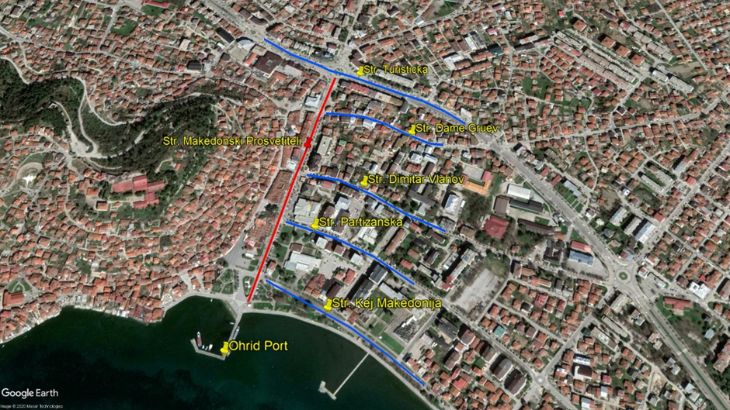
Ohrid Port

St “Dame Gruev”

St “Turisticka”

St “Dimitar Vlahov”

St “Partizanska”

St. “Kej Makedonija”
St “Makedonski Prosvetiteli”

Figure 8 Location of the project road
Edrenikovo

Project Activities
The planned project activities will be performed in three phases: preparatory activities (marking out and clearing up of the project site to be upgraded), reconstruction of local street (installation of crushed stone material, putting asphalt layer, etc.), and operational phase – activities related to regular and preventive maintenance of local road. The main project activities are presented in Table1.
Table1 Planned project activities for the project road, in Municipality of Ohrid
Local street Makedonski Prosvetiteli ( length = 400 m)
Project phases | Project Activities
Preparatory activities | - Marking and securing the route at the project location;  - Marking and securing curbs.
Reconstruction phase | - Removal and transport of existing curbs;  - Removal and transport of existing asphalt for construction of a new road;  - Mechanical excavation of soil (loading and transport to landfill) 361 m3;  - Placing of tampon layer with crushed stone and crushed asphalt pavement;  - Placing of road shoulders, gutters  - Setting BNHS 16 with d = 7cm;  - Connecting new gutters with existing storm sewer;  - Procurement and planting of new trees, liriodendron tulipifera
Operational phase | - Clean up the reconstruction site;  - Regular maintenance (especially in the winter period);

Sensitive receptors
Local population (working and living in the city center area), tourists (domestic and foreign, who visit Ohrid mostly during the summer period) and workers (who will be engaged during project activities) will be defined as sensitive receptors during project implementation. The project street belongs to a protected area under UNESCO which includes the old town of Ohrid. The potential environmental impact and risk and impact and risk assessment for each aspect are given below. The road is used by the residents of Ohrid who live and work in the central area as well as daily visitors and tourists on holiday. Therefore, project activities should take place outside the tourist season in order to avoid inconveniences.

POTENTIAL ENVIRONMENTAL IMPACT AND RISK AND IMPACT AND RISK ASSESSMENT
For this sub – project land acquisition is not envisaged, as the property of the land where the local street is located is state owned.
For the needs of the Contractor for temporary placement of machinery and equipment at a location in the immediate vicinity to the project that is privately owned (if there is a need), it is necessary to sign a Contract with the owner of the parcel for temporary land usage during project implementation period. The Contract will define terms and obligations for land usage or other premises (ex. garage, storage area, etc.) in line with the Project RPF Furthermore, all compensation will be paid before the respective land is accessed.
In addition to the planned project activities presented in Table1 the potential impact and risks that can occur during implementation of the project phases are given in Table 2 .
Table 2 The potential impact and risks during implementation of the project
Possible impacts
- OHS risks  - Safety risk for local population (especially those who live and work close to the street) and tourist | - OHS risks  - Community safety risks,  - Air quality,  - Noise,  - Waste generation  - Water pollution  - Temporary land acquisition/damage to private property | - Waste generation,  - Noise  - Air emissions
As a result of implementation of project activities in the central area of City of Ohrid, Municipality of Ohrid, the main adverse environmental impact can be seen through: expected increased level of noise (generated from construction machinery), possible air emissions and water pollution, improper waste management, non-compliance with the OHS requirements and possible risk on local population. Preceding the project activities, the Contractor is required to prepare and implement OHS Plan for risky terrains including Labor management procedures (for prevention of worker injuries); Traffic Management Plan with time schedule of project activities and directions for re-routing the traffic flow (provision of proper movement and functioning of people living and working in the central area in as well as horizontal or vertical signalization along the project road ); Community Safety Plan with proper preventive measures which should be part of the project design documentation, marking and securing the project site. In order to prevent possible risk because of the higher frequency of people using that street during the summer period (domestic and foreign tourist), the Contractor should not schedule the project activities in the summer period,). To ensure maximum safety for the local population during the sub-project activities the contractor should mark and secure the project site (placement of alert signalization) and provide Grievance mechanism and forms for complaints for the surrounding population and be on their disposal during the reconstruction activities. The forms could be post in the municipality office and local community office). An Information note/Press should be prepared by municipal staff that should contain information about the type of reconstruction activities and post on their web-site (https://ohrid.gov.mk/) and place on their municipal information board.
The workers on the project location need to always wear their PPE in order to avoid possible injuries, also they must be informed about the Grievance Redress Mechanism and their rights to organize workers organization by their employer (Contractor/Sub-contractor). The current workers must be employed fulltime, have their health and pension insurance covered in full for their engagement by the employer. The grievance forms could be post in the mobile containers for the workers.
Considering the current situation with COVID-19 in the country (the number of cases is increasing, so, on 16th of August there are 3.021 active cases, total deaths 544 and total number of healed persons is 9.174) in addition to the measures for safety and protection at work, the OH&S plan also should include measures for prevention of COVID -19. Detailed description of the measures and recommendations from the World Bank/WHO and MOSHA are presented in Annex 2.. The CОVID-19 prevention measures contains recommendations from the World Bank / WHO, as well as recommendations from the Macedonian Occupational Safety and Health Association in the form of a Guide that the Contractor of the construction works needs to implement. The Contractor is required to follow/update and implement the measures that are currently in force and adopted by the Government as binding at national level. Official site for information related to COVID 19 on national level is www.koronavirus.gov.mk.
During the preparatory and reconstruction project activities the possible air emissions will be caused by the operation of the mechanical machinery and equipment (dust and gas emissions). During the operational phase the air emissions will be mostly generated by mobile sources like the vehicles using the road. For the prevention and mitigation of the adverse environmental impacts the Contractor should see the Mitigation Plan (table below).
Increased level of noise and vibration is expected during the preparatory and reconstruction phase of the project. Taking into consideration the noise sensitivity of the project location and national legislation for noise protection (Official Gazette of RM No.79/07, 124/10, 47/11, 163/13 and 146/15) the project for reconstruction is considered to be an area with III degree of noise protection because of the mixed area with a few houses and agricultural fields (the maximum limit values should not exceed 55 dB(A) for night and 60 dB(A) for evening and day.
The Contractor should properly manage the different waste streams (such as soil, asphalt and communal waste) that will be generated at the project location in city of Ohrid by proper selection, transportation and final disposal (according to the national legislation, the Law on Waste and the List of Waste Types - Official Gazette of RM no. 100/05). It is expected that the Contractor will prepare and implement a Waste Management Plan so that no waste will be disposed unregularly in order to prevent possible disposal of waste near / or in Lake Ohrid which is located about 50 m south of the project site. As part of this plan, the options for reuse / recycling of generated waste should be included. The waste in the municipality is collected and disposed by the PE “Ohridski Komunalec” (at the municipal landfill “Bukovo” located about 14 km northeast from the project area). The estimated values of excavated soil (17 05 04) is 361 m³.
The categorization of the water of the Lake Ohrid is class I (very clean, oligotrophic water that can be used for drinking with disinfection) according to the Rulebook for categorization of water courses and lakes - Official Gazette of RM no. 18/99. The Contractor should prohibit the temporary or permanent disposal of waste in or near this water receiver in order to prevent a reduction in water quality.
As mentioned before, few protected areas are located in the wider surrounding of the project site in Municipality of Ohrid: a) Important Plant Area (IPA) “Lake Ohrid” (located about 13 km west from project location); b) Important Bird Area (IВA) “Lake Ohrid” (located about 100 m south from the project site); c) Emerald site “Lake Ohrid” and “Galichica” (emerald site “Lake Ohrid” is located about 100 m south from the project site, emerald site “Galichica” is located about 2 km southeast from the project site). In the preparatory phase, according to the Main Design, the vegetation belt (about 76 trees) will be removed/cut down that is currently exists along the street. In this case, Contractor must prepare and imply a Vegetation Restoration Plan.
During construction phase, despite the vicinity of some sensitive biodiversity areas, no adverse impacts are expected (such as: animal disturbance, habitat fragmentation, etc.) because of the character of the project site – urban area in the central part of the City of Ohrid. As possible adverse impact, in this project phase, the improper waste disposal near the the shore of Lake Ohrid. This impact can be taken as negligible, if Contractor will imply good construction practice during the construction phase.
In operational phase of the street in City of Ohrid, adverse impacts are not expected.
The monitoring of the implementation of the proposed environmental measures should be performed by the Supervision, but also by the municipal staff (communal inspector, environmental inspector, project manager) who will visit the project site more often and together with the Supervision will monitor whether the proposed measures are applied.
The proposed preventive and mitigation measures are presented in the Mitigation and Monitoring Plan tables in Chapter 4 and Chapter 5.

Implementation of ESMP
This ESMP is a part of the contract that the PIU will sign with the Contractor for implementation of the project activities. The proposed preventive and/or mitigation environmental and social measures in this plan must be executed by the Contractor and therefore the respected documentation related to applying these measures (e.g., letter asking the municipality for disposal of inert waste, records on OHS training performed for all workers before start of activities, all developed OHS plans, etc.). For all the workers especially those at high risk must attend an OHS training organized by the Contractor prior the start of the project activities. The training should be delivered by the authorized OHS company and everyday OHS risks should be assessed by the Contractor’s OHS responsible person working on the location on daily basis. Evidence for all trainings delivered should be kept.
Measures prescribed in the EIA Report including measures within the ESMP will be a mandatory requirement for the Contractor during the implementation of the construction activities.
The implementation of proposed measures by the Contractor and Contractor’s subcontractors will be monitored by the Supervising Engineer by doing visual checking, reviewing the records of evidence that the measures have been applied and ask the Contractor to apply the measures as soon as possible. If there are any non-compliances they need to be recorded and the Report containing them needs to be sent immediately to the municipality (Project Manager), and from here it will be reported to the PIU. The Environmental/Social Specialist engaged by the PIU will report the non-compliance and accidents/ emergencies cases to the Bank immediately upon occurrence. Each incompliance needs to be addressed and the evidence of the appropriate measures taken need to be kept. The regular monthly report should contain all environmental and social issues raised during that period and the evidence on solutions should be provided as well.
The main responsibilities of the PIU will be in regards to the Project implementation, project coordination, monitoring activities and reporting.
The Environmental/Social Specialist engaged by the PIU will be responsible for ensuring proper environmental management of all Project activities, conduct environmental supervision by carrying out document reviews, site visits and interviews with Contractor, Supervising Engineer and municipality staff. He/she will supervise Contractors’ compliance with ESMP and visit the project location at least once a month and the Monitoring Report reflecting main issues and arrangements and timing for their solution will be prepared and submitted to the PIU. The semi-annual Project Report should contain a chapter with Environmental/Social risks/impacts of the project and the status of implementation the ESMP proposed measures.
The municipality is tasked with daily monitoring of the project activities engaging the Supervising Engineer and coordinating all activities on location nominating the responsible person – Project Manager.
The PIU needs to organize regular meetings with the Project Manager, Contractor, representatives from MoTC, responsible person from the Municipality of Ohrid and the ES specialist on a monthly basis or during any site visit.
Good communication between all involved stakeholders (Contractor, Supervisor, municipal staff, Environmental Inspector, Communal Inspector, PIU from MoTC and other relevant persons from Municipality of Ohrid) is very important for providing continuous performance of the project activities and successful completion of overall project. The PIU from MoTC and project manager from the Municipality of Ohrid will facilitate good communication and coordination of the project activities on spot.
Grievance mechanism
PIU within the MoTC has introduced a Grievance Mechanism to ensure that it is responsive to any concerns and complaints particularly from affected stakeholders and communities.
For the purposes of receiving comments from the stakeholders (local citizens and workers onsite) PIU established a Grievance Form for the construction phase of the project (Annex 4) that will be available in electronic form on the MoTC web site, Municipality web site and the Contractors web site.
Grievance Form for the construction phase of the project is prepared for the local population (if an incident or damage to private property occurs) and for the workers (grievance for lack of protective equipment, increased working hours, no period for rest, etc..) who will be involved in the construction activities.
Before starting with construction activities Contractor should inform the workers about the Grievance Form and the opportunity to express their compliances regarding the operation on the construction site. Local population will be introduced with this possibility by the Information posted on the Informative board within the Local Community, Municipal web site, and via local radio and TV station.
The PIU will ensure that the GRM is responsive to any concerns and complaints particularly from affected stakeholders and vulnerable groups.
Following steps are to be taken to ensure full GRM functioning:
Step 1: Recording received grievance in the GRM registry;
Step 2: Providing the person who filed the grievance with an acknowledgment of receipt within 5 days of receipt;
Step 3: Investigating the grievance;
Step 4: Resolution of Grievance within 15 days of grievance receipt;
Step 5: Follow up.
In cases when the grievance/complaint is indefinite or not clear enough, the PIU will assist and provide advice in formulating/redrafting the submission, in order for the grievance/complaint to become clear, for purposes of an informed decision by the PIU, in the best interests of persons affected by the Project.
If the PIU is not able to address the issues raised by immediate corrective action, a long-term corrective action will be identified. The complainant will be informed about the proposed corrective action and follow-up of corrective action within 25 calendar days upon the acknowledgement of grievance. In situation when the PIU is not able to address the particular issue verified through the grievance mechanism or if action is not required, it will provide a detailed explanation/ justification on why the issue was not addressed. The response will also contain an explanation on how the person/ organization that raised the complaint can proceed with the grievance in case the outcome is not satisfactory. At all times, complainants may seek other legal remedies in accordance with the legal framework of Republic of North Macedonia, including formal judicial appeal.
Grievances can be filled verbally, by phone, in writing (by post or e-mail) or by filling in a grievance form (Annex 1). The grievance form will be made available on the implementing agencies website together with clear information on how feedback, questions, comments, concerns and grievances can be submitted by any stakeholder and information concerning the PIU’s managing of the GRM both in terms of process and deadlines. Furthermore, the website will include the possibility to submit grievances electronically.
In order to capture and track grievances received under the project, a dedicated GRM register is planned. Specifically nominated members of staff will record grievance information in the grievance registry. This will include:
- Number of Grievance;
- Date of receipt;
- Stakeholder name, sex, age and contact details;
- Date of acknowledgement;
- Description of grievance;
- Description of action taken;
- Date of grievance resolution.
The PIU will share the Grievance Registry with the WB on a monthly basis.

Public disclosure and citizen engagement
The Municipality of Ohrid will submit draft version of this ESMP to PIU Environmental and Social Experts to review and approve it, who will then (when confident that the document meets WB quality and content requirements) submit the draft document for the review and clearance by the World Bank. After the clearance is obtained, the document will be publicly disclosed.
The Draft ESMP will be available for the public on web site of the Municipality of Ohrid (https://ohrid.gov.mk/ ) and the web site of the MoTC PIU (http://www.mtc.gov.mk/) accompanied by a Form for submitting comments (Annex 3). The social Media channels of the Municipality of Ohrid that will be used for the purpose of raising awareness about the Project implementation and identified E&S risks, impacts and mitigation measures is the facebook page (https://www.facebook.com/MunicipalityofOhrid/ ).
During the 14 days after the disclosure of the prepared ESMP document, the Municipality of Ohrid will conduct video public consultation in order to inform the public on the proposed sub-project activities, anticipated impacts and the ways of their mitigation.
Public announcement will be developed with brief description about the purpose of the project, project activities and duration of the activities, environmental and social impacts, proposed measures, availability of the ESMP together with the Form for submitting comments on the MoTC web site and Municipality web site, Informative board within the Local Community. Announcement will also contain information about the possibility for citizens to raise opinion/ suggestion/comments on the prepared ESMP by filling the Form for comments and submission to the responsible person from MoTC Mrs. Irena Paunovikj (e-mail: irena.paunovikj.piu@mtc.gov.mk). Form for submitting can be filled with a full identity or anonymously, and the comment or suggestion should be fully described in order to take it into account in the final version of ESMP. Information about the date and time for conducting the video public consultation and the way how the stakeholder can take part on the video public consultation will also be a part of the announcement.
Public announcement will be published on the local radio or TV station and on the Informative board within the Local Community.
Public consultation
Considering the current situation with COVID 19 and the inability for organizing an ordinary public hearing event in the premises of the Municipality where the project will be implemented, the video public consultation will be organized, The MoTC PIU in cooperation with the municipality will define the date for the video public consultation (by using Vebex operational tool).
Municipalities will need to inform all relevant stakeholders on its territory about the timing of the video public consultation (and to ask them for their e-mail address if they like to join the event), so that all from their homes/offices can follow the event and be active participants. If the stakeholders do not have the technical capabilities, the municipality will ensure an appropriate solution in order to be able to follow the event. The mailing list for participants will be prepared taking into account all relevant stakeholders and Invitation will be sent to those with brief explanation for the:
- Purpose of the video public consultation;
- Registration link and instructions for connection;
- Exact time and date for the event;
- Availability of the disclosed draft ESMP for comments and
- Possibility for submitting comments on the prepared ESMP by filling in the Form for submitting comments and suggestions on the ESMP to the responsible person from PIU
During the video consultation event after the presentation of the main project activities and main findings from the ESMP, attending stakeholders can raise their comments/questions/suggestions and any concern about the project.
After maintaining the video public consultation and the 14-day period for submitting comments, the final version of the ESMP will be prepared and will include the public consultation report (including announcement of the event (media or personal) detailed description of the event, list of participants, minutes of meeting, the expressed comments) and the appropriate corrections in the document according to the received comments and remarks.
Approved Final version of ESMP should be included in the Grant Agreement with sub-project proponent, and then into the respective bidding documents and construction contracts.
Final version of the ESMP will be available on the MoTC web site and Municipality web site for the whole period of the sub project implementation.

Contact person for project awareness and public consultation from MoTC:
Mrs. Irena Paunovikj, Responsible for public relations for the project,
e-mail: irena.paunovikj.piu@mtc.gov.mk

Contact person for project awareness and public consultation from Municipality of Ohrid:
Mr. Tome Nanevski, Representative from the Sector for Communal services, traffic, and streets
e-mail: tome.nane@yahoo.com
mob.tel: 071/231105

ENVIRONMENTAL AND SOCIAL MITIGATION PLAN
Potential impact | Impact scale | Proposed mitigation measures | Responsibility
Project activities: Preparation activities before reconstruction of the local street: Marking out the route for reconstruction of local street “Makedonski Prosvetiteli” in the city of Ohrid , in Municipality of Ohrid
Possible adverse social and health impacts to the population, drivers and workers due to:  - Lack of ensured safety measures at the start of reconstruction works;  - Injury passing near by the reconstruction sites;  - No compliance with strict OHS standards and work procedure. | Local/ Short term during the reconstruction period with major significance  along the local street “Makedonski Prosvetiteli” in the city of Ohrid, in Municipality of Ohrid | - Preparation, approval and implementation of OHS Plan for risky terrains prior start of activities;  - Preparation, approval and implementation of Traffic management Plan during project activities (in correlation with municipality staff, prior start the upgrading activities);  - Preparation, approval and implementation of Community Safety Plan including Labor management procedures prior the start of activities;  - Preparation, approval and implementation of Waste Management Plan (with reuse/recycling activities included) prior the start of activities;  - Provision of the information about the type and duration of reconstruction activities on the municipal web site (https://ohrid.gov.mk/), local community, and municipal board;  - The Contractor is required to submit a preliminary Traffic management Plan, which will be part of the ESMP. Before the start of the project activities, the updated Traffic management Plan with Community Safety Plan will be submitted to the ESS. It will be presented to the workers on regular basis. Traffic management Plan will specifically deal with safety of the pupils and local population using the road (walking / driving);  - The rehabilitation works should be performed during the winter period i.e. outside the tourist season;  - Contractor will make assessment and record the state of the property and objects that are close to the road, prior commencement of any works. Records should be kept in case of future damage claims by the local property owners;  - Application of good reconstruction practice for marking out the project site including:  - Appropriate marking out the project site, section by section along the road;  - Placement of alert signs especially for limitation of speed driving near the road that will be upgraded especially at the places where there are road exits to the agricultural fields;  - Placement of warning tapes;  - Installation of Notice board with general information about the project, Contractor and Supervisor at project location;  - Forbidden entrance of unemployed persons within the warning tapes;  - Community and Worker’s OH&S measures should be applied (first aid, protective clothes for the workers, appropriate machines and tools);  - During the project activities the Contractor should provide easy access of the local population to their houses, schooсl, health center, etc.;  - The road should be kept clean;  - Mobile toilets should be placed on the project sites;  - Machines should be handled only by experienced and trained personnel, thus reducing the risk of accidents;  - Trying to avoid compliance, if any appeared recording grievances and promptly response and overcome the problem;  - Constant presence of firefighting devices should be ensured in case of fire or other damage;  - All workers must be familiar with the fire hazards and fire protection measures and must be trained to handle fire extinguishers, hydrants and other devices used for extinguishing fires;  - Larger quantities of flammable liquids should not be kept on the site along the road that will be upgraded.  - All engaged workers on this project must have regulated employment status by Contractor/sub-contractor and must receive full health and pension insurance, all in compliance with local labor related legislation and International labor standards. | - Contractor –Bidder  - Supervisor  - Municipality staff (Communal Inspector and Environmental Inspector)
Project activities: Reconstruction of local street “Makedonski Prosvetiteli” in the city of Ohrid, in Municipality of Ohrid
Possible emissions by transportation vehicles and impact on air quality along the street “Makedonski Prosvetiteli” in the city of Ohrid, in Municipality of Ohrid due to:  - Gases emissions of operation with construction machinery (CO₂, NO_{x}, PAH, SO₂ and suspended particulates (PM₁₀, PM_{2.5})) | Local/ Short term with major significance along the street “Makedonski Prosvetiteli” in the city of Ohrid , in Municipality of Ohrid | - The construction site and the sites for handling materials as well as the transportation routes should be water-sprayed on dry and windy days;  - The reconstruction materials should be stored in appropriate places covered to minimize dust;  - When using vehicles for transportation of loads likely to emit dust they need to be covered;  - The workers must always use protective masks especially when there is increase of the emitted dust at the project location;  - The vehicle speed within the reconstruction location must be restricted;  - Perform regular maintenance of the vehicles and reconstruction machinery in order to reduce the leakages of motor oils, emissions and dispersion of pollution;  - Burning of debris from ground clearance not permitted. | - Contractor –Bidder  - Supervisor
Temporary land acquisition/ damage to private property | Local within the project location in Municipality of Ohrid | - Avoidance of the use of private lands;  - In case avoidance is not possible, minimization of size of the area used and impacts on the vegetation;  - Implementation of RPF provisions;  - Arrangements with owner and payment must be executed prior to land access. | - Contractor, PIU
Possible noise disturbance as a result of outdoor equipment usage and transportation vehicles driving around the site | Local/ short term with medium significance along the project location in Municipality of Ohrid | - According to national legislative ambient noise and vibration (Official Gazette No. 79/07, 124/10, 47/11, 163/13 and 146/15), the project location belongs to an area with III degree of noise protection because there are commercial areas, areas with mixed housing/residential, craft activities and production activities (the maximum limit values should not exceed 55 dB(A) for night and 60 dB(A) for evening and day).  - The reconstruction work should be not permitted during the nights; the operations on sites shall be restricted to the hours 7.00 -19.00.  - The control of noise level should be performed before the start up with the working activities and during work peaks;  - The equipment should be fitted with appropriate noise devices that will reduce sound level;  - Limitation of the generated noise as road conditions allows, implementation of road speed limitation barriers (speed road barriers, road shoulders, convex wide-angle mirrors, etc.). All mitigation measures should be in compliance with national regulative for traffic safety - Law for road traffic safety (Official Gazette of RM, No.54/07, 86/08, 98/08, 64/09, 161/09, 36/11, 51/11,114/12, 27/14 and 169/15). | - Contractor –Bidder  - Supervisor
Possible adverse environmental impact and health effects could occur as a result of generation of the different waste streams  The inappropriate waste management and not in time collection and transportation of waste streams  In the Municipality of Ohrid the solid municipal waste is collected and disposed by PE "Ohridski Komunalec”, with their own vehicles.  Because there is no appropriate alternative landfill for waste disposal from the project activities, the generated waste streams should be disposed at landfill “Bukovo”, located around 14,5 km to the north-east of the project area in the city of Ohrid). | Local/ Short term with major significance within the project location in Municipality of Ohrid | - Identification of the different waste types at the reconstruction site (soil, humus, bottles, food, etc.);  - Classification of waste according the national List of Waste (Official Gazette no.100/05);  - The main waste would be classified under the Waste Chapter 17 “Construction and demolition wastes (including excavated soil from contaminated sites)” with the waste code, 17 05 – Excavated soil and stones and 17 09 04 – Mixed waste from construction site, and the existing asphalt (17 09 04) will be crushed and transported to a landfill (according to the Main Design);  - The recycle and re-use of some waste materials is obligatory (not to dispose them as a waste);  - Small amount of solid municipal waste could be found (food, beverages), as well as packaging waste (paper, bottles, glass, etc.). Proper containers/waste bins should be provided at the project site during the reconstruction activities;  - Collection and transportation of the inert and communal waste by the PE “Ohridski Komunalec” from Ohrid (the waste disposal will be performed on landfill “Bukovo”, located around 14,5 km to the north-east of the project area in the city of Ohrid);  - The options for reuse/recycling of the generated waste streams should be taken into consideration (e.g. reuse of the removed layer of excavated soil, etc.).  - Possible hazardous waste (motor oils, vehicle fuels) should be collected separately and authorized collector and transporter should be sub-contracted to transport and finally dispose the hazardous waste;  - The materials should be covered during the transportation to avoid waste dispersion;  - Burning of waste along or around the project location is prohibited. | - Contractor –Bidder  - Supervisor  - Municipality staff (Communal Inspector)  - Mayor of the Municipality of Ohrid  - PE “Ohridski Komunalec” from Ohrid
Possible environmental impact on the relevant water recipients could occur due to ground contamination (from the spillage of materials such as vehicle fuel, motor oils and lubricants) and waste disposal near or in the lake Ohrid | Local/Short term with medium significance  near the water recipient Lake Ohrid | - Possible hazardous waste (motor oils, vehicle fuels, lubricants) should be collected separately and authorized company should be sub-contracted to transport and finally dispose the hazardous waste;  - According to national legislative for waste management, it is forbidden for temporary or final disposal in or near the lake Ohrid in order to prevent decreasing of the ecological status of the lake – I class (very clean, oligotrophic water which with little disinfection could be used for drinking). | - Contractor –Bidder  - Supervisor
Expected impact:  Removal of existing vegetation (76 trees along the street), improper waste management and decreasing of the water quality of Lake Ohrid | Local/ short term/ with small significance along the project site in Municipality of Ohrid | - Minimization of the construction area as much as possible (carefully planning and design of the project activities according the Traffic Management Plan) ;  - A Vegetation Restoration Plan shall be done for the locations where these trees shall be planted (appropriate selection of the location / soil, number and types of trees, period for planting and watering in the first 3 months). Species of trees should be selected based on the species that are part of the natural ecosystem nearby. Planting ratio is 1:3 for excavated planted tree.  - Fully clean up of the construction site immediately after accomplishment of construction activities section by section;  - Collection of the generated waste on daily basis, selection of waste, transportation and final disposal on appropriate places (according the type of waste – more details in Waste management Plan)  - Temporary or final disposal of hazardous waste (motor oils, vehicle fuels, lubricants) should be forbidden near the shore of Lake Ohrid, in order to prevent possible impact on water quality and impacts on existing fauna of Lake Ohrid. | - Contractor –Bidder/subcontractor  - Supervisor  - Environmental Inspector)
Possible adverse impact on cultural heritage sites in municipality Ohrid (churches, monasteries, chapels, archeological sites) | Local/ short term with minor significance within the project location in Municipality of Ohrid | - Possible damages of the churches, monasteries, chapels, archeological sites due to the improper handling and manipulation of the construction machinery and equipment – only competent and trained staff should be working with this equipment during the reconstruction activities;  - Possible noise disturbance during the reconstruction activities – the Contractor should provide usage of construction machinery and equipment that generate lower noise level. | - Contractor –Bidder  - Supervisor  - Municipality staff (Communal Inspector)
Project activities: Operational phase of the local street Makedonski Prosvetiteli in the city of Ohrid , in Municipality of Ohrid
No adverse impact is expected in the operational phase of the project. Regular maintenance of the local street in the Municipality of Ohrid, should be carried out (e.g. removal of snow in winter period, regular repair of the road surface, etc.). The vehicles that will gravitate in his project phase of the local street, should limit their speed according to the road conditions.
The Investor should develop and implement the mitigation measures in the operational phase of the projects like: post of the horizontal and vertical traffic signalization for speed limitation of the vehicles, limitation of the generated noise as road conditions allows, implementation of road speed limitation barriers (speed road barriers, road shoulders, convex wide angle etc.). All mitigation measures should be in compliance with national legislation for traffic safety - Law for road traffic safety (Official Gazette of RM, No.54/07, 86/08, 98/08, 64/09, 161/09, 36/11, 51/11,114/12, 27/14 and 169/15).

ENVIRONMENTAL AND SOCIAL MONITORING PLAN
What  parameter to be monitored? | Where  is the parameter to be monitored? | How  is the parameter monitored? | When  is the parameter monitored (frequency of measurement)? | Why  is the parameter monitored? | Cost |  | Responsibility
 |  |  |  |  | Reconstruction | Operations | Reconstruction of the local street “Makedonski Prosvetiteli” in the city of Ohrid , in Municipality of Ohrid | Operations of the local street “Makedonski Prosvetiteli” in the city of Ohrid , in Municipality of Ohrid
Project stage: Preparation activities before reconstruction of the local street: Marking out the route for reconstruction of local street “Makedonski Prosvetiteli” in the city of Ohrid , in Municipality of Ohrid
Constant wearing of the PPE and compliance with the protection measures for workers in order to minimize possible injuries at the construction site | At the project site | Visual checks | During the clean-up activities  At the beginning of each working day during the sub-project activities | To prevent health and safety risks – mechanical injuries  To be in compliance with national communal health regulation and OH&S standards | Included in the project budget |  | Contractor/sub-contractors - Bidder  Supervisor  Communal Inspector at the Municipality of Ohrid
Preparation of required documents related to OH&S, Community safety and Traffic Management | Within the project location | Review of the prepared documentation (OHS Plan  Community safety Plan  Traffic Management Plan (TMP) | During the clean-up activities  At the beginning of each working day during the sub-project activities | To prevent health and safety risks – mechanical injuries;  To be in compliance with national communal health regulation and OHS standards. | Included in the project budget |  | Contractor - Bidder  Supervisor  Communal Inspector at the Municipality of Ohrid
Training of workers and informing of the local population about the project activities | At the project site | OHS training  by an authorized OHS company engaged by the Contractor  Provision of the information via TV, radio and municipality web site https://ohrid.gov.mk/) about the project activities | Before the start of the project activities | To prevent health and safety risks – mechanical injuries of the worker and local population;  To be in compliance with national communal health regulation and OHS standards. | Included in the project budget |  | Contractor - Bidder  Supervisor  Communal Inspector at the Municipality of Ohrid
Project stage: Reconstruction of the local street “Makedonski Prosvetiteli” in the city of Ohrid , in Municipality of Ohrid
Applicable Traffic Management Plan for the project and Notices for the availability of the plan and information on traffic regulation set on bulletin board in the city of Ohrid and on the web-page of the municipality (https://ohrid.gov.mk/) | Within the project locations | Visual monitoring | During the working day | To ensure the coordinated traffic flow through the project location and easy access of local population | Included in the project budget |  | Contractor - Bidder  Supervisor  Communal Inspector at the Municipality of Ohrid
Use of PPE by the workers | At the reconstruction site | Visual monitoring | During the works | To ensure workers safety on site | Included in the project budget |  | Contractor /Sub-contractor  Supervisor  Municipality of Ohrid, Labor inspection
Primary selection of the generated different waste streams at the project location | On the reconstruction site in Ohrid | Review the documentation | At the beginning of work with new material/s | In order to ensure separation of hazardous from the non-hazardous waste as well as inert from biodegradable waste | Included in the project budget |  | Contractor – Bidder  Supervisor
Collection and transport of hazardous waste (if any occurs) | On safety temporary storage | Review the transportation list and conditions at the storage facility | Before the transportation of the hazardous waste (if there is any) | To improve the waste management practice on municipality and national level/ Not to dispose the hazardous waste on the waste disposal spots | Included in the project budget |  | Authorized Contractor for collection and transportation of hazardous waste (if any occurs)
Collection transportation and final disposal of the solid waste | Along and around the reconstruction site | Visual monitoring and reviewing the transportation and disposal lists from the sub-contractor | After the collection and transportation of the solid waste on regular base each day | Not to leave and dispose the waste streams on the sites in order to avoid the environmental and health impact on local population  To have the real data for generated waste streams and to improve the waste management | Included in the project budget |  | Contractor – Bidder  Supervisor and PE “Ohridski Komunalec” from Ohrid
Possible waste disposal (solid and liquid) near or in the lake Ohrid | Near the project site | Visual check if the waste is disposed near or in the lake | During the project activities (once per week) | To ensure good status of water quality  To prevent possible water pollution of the Ohrid lake | Included in the project budget |  | Contractor - Bidder  Supervisor
Fulfilled Annual Report for collection, transportation and disposal of waste | Local self-government administration | Review of documentation – Identification of waste list | After the accomplishment the task of collection, transportation, temporary disposal and final disposal of waste | To improve the waste management on local and national level  To be in compliance with national legal requirements | Included in the project budget |  | Mayor of Municipality of Ohrid / Ministry of Environment and Physical Planning
Baseline monitoring of noise and additional upon public complaint (if happens) | Along the road | With noise measurement calibrated equipment | Before the start of the project activities and during the work peaks | To ensure noise level limits according to the national regulation | Part of the regular Contract |  | Contractor;  Accredited company for measuring the level of provided by the contractor;  Authorized environmental inspector, Construction inspector
Removal of existing vegetation (76 trees along the street), improper waste disposal of generated waste streams and decreasing of the water quality of Lake Ohrid | Along the project site in Municipality of Ohrid (especially near the shore line of Lake Ohrid) | Visual monitoring | During the reconstruction activities | To prevent and avoid improper waste management, water quality impact and impact on aquatic fauna of Lake Ohrid  To minimize the adverse impact on existing biodiversity | Part of contractors and SE contract |  | Contractor - Bidder  Supervisor  Environmental Inspector at the Municipality of Ohrid
Project stage: Operational phase of the local street “Makedonski Prosvetiteli” in the city of Ohrid , in Municipality of Ohrid
Implementation of mitigation measures (e.g. placement of the horizontal and vertical traffic signalization for speed limitation of the vehicles, convex wide-angle mirrors, etc.)  Limitation of the generated noise as road conditions allow. | Along the street | Decreased number of traffic accidents along the local street | Continuously (the parameter should be monitored in compliance with - Law for road traffic safety (Official Gazette of RM, No.54/07, 86/08, 98/08, 64/09, 161/09, 36/11, 51/11,114/12, 27/14 and 169/15). | To achieve safety of the local population and their private properties and to be in compliance with national regulative for traffic safety |  | Municipality budget |  | Ministry of internal affairs (branch office in Municipality of Ohrid
Road maintenance from the overgrown vegetation, generated waste, clearing of snow drifts, rocks or soil sediments | Along the road | Traffic flow without congestion | Continuously – during the entire period of the project activities | Тo ensure safe traffic |  | Municipality budget |  | Communal services in the municipality -PE “Ohridski Komunalec” from Ohrid

ANNEX
Annex 1 Map of sensitive areas in the wider surrounding of the project location in Municipality of Ohrid
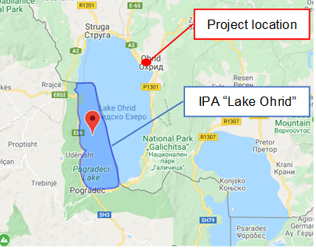 | 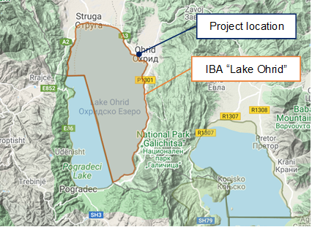
Figure 9 Location of IPA “Lake Ohrid” related to project location | Figure 10 Location of IВA “Lake Ohrid” related to project location
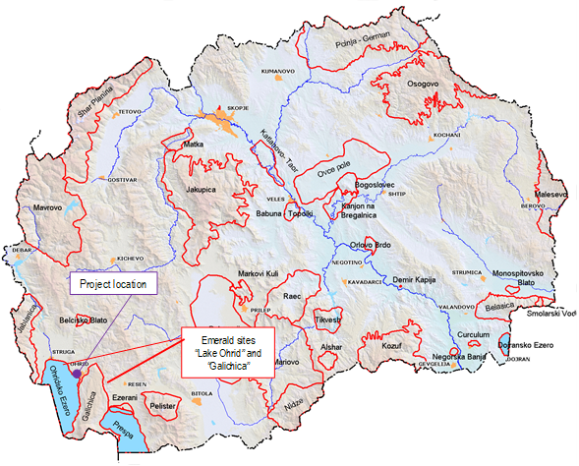 | 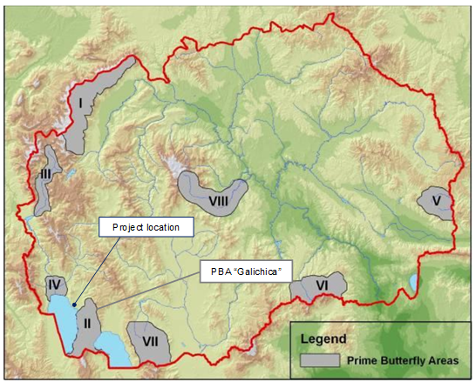
Figure 11 Location of Emerald sites “Lake Ohrid” and “Galichica” | Figure 12 Location of the project location related to PBA “Galichica”
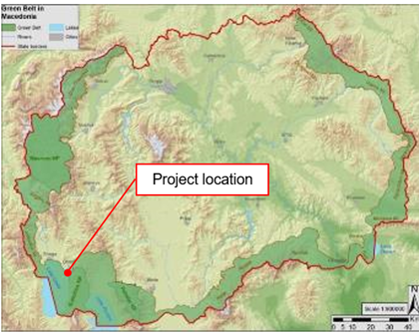 | 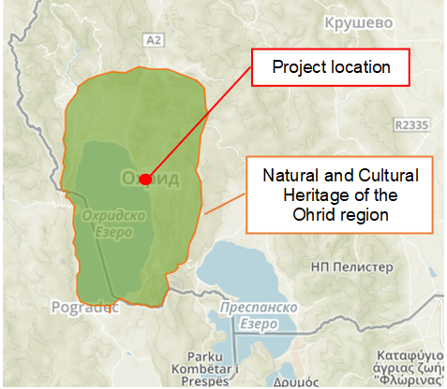
Figure 13 Location of Project location regard the Balkan Green Belt | Figure 14 Location of UNESCO site related to project location
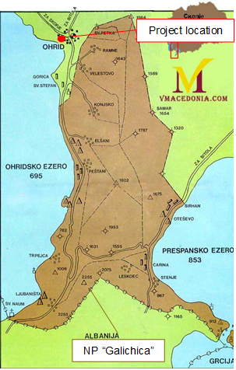 | 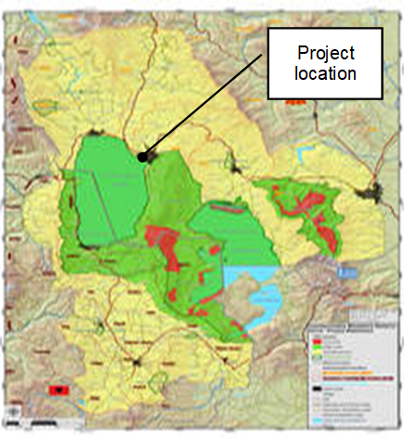
Figure 15 Location of NP “Galichica” regard the project location | Figure 16 Location of project site regard the transboundary reserve “Ohrid-Prespa”

Annex 2 Photo gallery from the site visit by representatives from MTC and Municipality of Ohrid

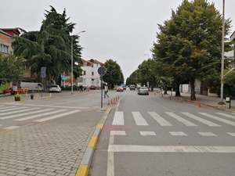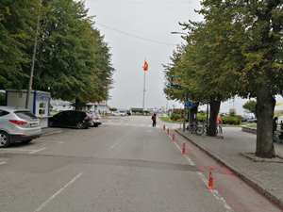

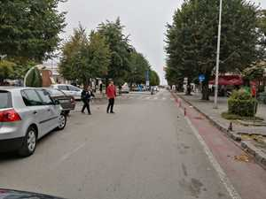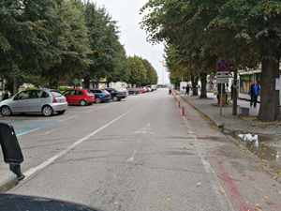
Figure 17 Local street “Makedonski Prosvetiteli”

Annex 3 COVID-19 considerations in construction/civil works projects
Taking into account the new situation with the appearance of the virus COVID 19, besides the standard measures for safety and protection at work it is necessary to implement measures for protection from COVID 19.
Undoubtedly, the Contractors will face many challenges in the new situation, such as:
- Inability to purchase protective equipment and disinfectants due to lack on the market,
- Lack of labour due to limited movement and absences from work,
- Inability to provide materials and work equipment due to congestion in all segments of life in the country,
- Employees' concerns about their livelihoods due to reduced workload, etc.
First, it is necessary to implement the measures for protection from COVID 19 adopted by the Government of the Republic of Northern Macedonia at the proposal of the Commission for Infectious Diseases and the Ministry of Health. These measures should be constantly updated in accordance with the latest provisions introduced by the Government. The Contractor is required to nominate a responsible person who will follow the measures adopted by the Government and will apply them in the operation of the construction site at the project location.
Links of the national institutions responsible for COVID 19 where the Contractor could find updated information and recommendations:
- Government of the Republic of North Macedonia - https://vlada.mk/node/20488?ln=en-gb
- Ministry of Health - http://zdravstvo.gov.mk/korona-virus/
- Ministry of Labour and Social Policy - http://mtsp.gov.mk/covid-19.nspx
- Ministry of transport and communications - http://mtc.gov.mk/Preporaki%20od%20Vlada
- Official site for COVID – 19 - https://koronavirus.gov.mk/en
On national level in addition to the measures introduced by the Government for protection from COVID 19, the Macedonian Occupational Safety and Health Association developed a Guide to Safety and Health at Work in Construction Prevention from the Corona virus. The Guide contains measures that the Contractor is required to implement in order to eliminate the possible ways of obtaining and transmitting COVID 19 among the workers on construction site.
In more detail in several chapters, the Guide contains:
- Challenges in construction;
- Obligations for the Contractor;
- Obligations for workers;
- Liabilities for Investors;
- Ways of proceeding in cases of suspected case or cases infected with COVID 19;
- Contact phones of national institutions responsible for contacting the occurrence of the event infected with COVID 19.
The text of the Guide to Safety and Health at Work in Construction Prevention from the Corona virus on the Macedonian language is given on the following link http://mzzpr.org.mk/wp-content/uploads/2020/04/covid19-%D0%B3%D1%80%D0%B0%D0%B4%D0%B5%D0%B6%D0%BD%D0%B8%D1%88%D1%82%D0%B2%D0%BE.pdf.
The Contractor also needs to implement the requirements introduced by the World Bank related to the protection of COVID 19.
Regarding the COVID-19 considerations in construction/civil works projects given by the World Bank, they are divided in several segments/issues and in details are shown on Table 3.

Table 3 COVID-19 considerations in construction/civil works projects recommended by WB
COVID-19 considerations in construction/civil works projects
Covid-19 issues | Type of activities
The Contractor should identify measures to address the COVID-19 situation taking into account the location, existing project resources, availability of supplies, capacity of local emergency/health services, the extent to which the virus already exist in the area.
PIU and Contractor should establish specific procedures for addressing COVID 19 issues on the construction site. Procedures should be implemented, documented and updated in accordance with the latest changes introduced by the Government and the conditions on the construction site.
Assessing workforce characteristics | • The Contractor should prepare a detailed profile of the project work force, key work activities, schedule for carrying out such activities, different durations of contract and rotations;  • This should include a breakdown of workers who reside at home (i.e. workers from the community), workers who lodge within the local community and workers in on-site accommodation (i.e. workers camp). Where possible, it should also identify workers that may be more at risk from COVID-19, those with underlying health issues or who may be otherwise at risk;  • Consideration should be given to ways in which to minimize movement in and out of site. This could include lengthening the term of existing contracts, to avoid workers returning home to affected areas, or returning to site from affected areas.
Entry/exit to the work site and checks on commencement of work | • Establishing a system for controlling entry/exit to the site, securing the boundaries of the site, and establishing designating entry/exit points (if they do not already exist). Entry/exit to the site should be documented;  • Training security staff on the (enhanced) system that has been put in place for securing the site and controlling entry and exit, the behaviors required of them in enforcing such system and any COVID -19 specific considerations;  • Training staff who will be monitoring entry to the site, providing them with the resources they need to document entry of workers, conducting temperature checks and recording details of any worker that is denied entry;  • Confirming that workers are fit for work before they enter the site or start work. While procedures should already be in place for this, special attention should be paid to workers with underlying health issues or who may be otherwise at risk. Consideration should be given to demobilization of staff with underlying health issues;  • Checking and recording temperatures of workers and other people entering the site or requiring self-reporting prior to or on entering the site;  • Providing daily briefings to workers prior to commencing work, focusing on COVID-19 specific considerations including cough etiquette, hand hygiene and distancing measures, using demonstrations and participatory methods;  • During the daily briefings, reminding workers to self-monitor for possible symptoms (fever, cough, and other respiratory symptoms) and to report to their supervisor or the COVID-19 focal point if they have symptoms or are feeling unwell;  • Preventing a worker from an affected area or who has been in contact with an infected person from returning to the site for 14 days or (if that is not possible) isolating such worker for 14 days;  • Preventing a sick worker from entering the site, referring them to local health facilities if necessary or requiring them to isolate at home for 14 days.
General hygiene | • Placing posters and signs around the site, with images and text in local languages (MK/ALB);  • Ensuring handwashing facilities supplied with soap, disposable paper towels and closed waste bins exist at key places throughout site, including at entrances/exits to work areas; where there is a toilet, canteen or food distribution, or provision of drinking water; in worker accommodation; at waste stations; at stores; and in common spaces. Where handwashing facilities do not exist or are not adequate, arrangements should be made to set them up. Alcohol based sanitizer (if available, 60-95% alcohol) can also be used;  - Training workers and staff on site on the signs and symptoms of COVID-19, how it is spread, how to protect themselves (including regular handwashing and social distancing) and what to do if they or other people have symptoms;  • Setting aside part of worker accommodation for precautionary self-quarantine as well as more formal isolation of staff who may be infected.
Cleaning and waste disposal | • Providing cleaning staff with adequate cleaning equipment, materials and disinfectant;  • Training cleaning staff on appropriate cleaning procedures and appropriate frequency in high use or high-risk areas;  • Where it is anticipated that cleaners will be required to clean areas that have been or are suspected to have been contaminated with COVID-19, providing them with appropriate PPE: gowns or aprons, gloves, eye protection (masks, goggles or face screens) and boots or closed work shoes. If appropriate PPE is not available, cleaners should be provided with best available alternatives;  • Training cleaners in proper hygiene (including handwashing) prior to, during and after conducting cleaning activities; how to safely use PPE (where required); in waste control (including for used PPE and cleaning materials);  • Any medical waste produced during the care of ill workers should be collected safely in designated containers or bags and treated and disposed of following relevant requirements (e.g., national - http://www.moepp.gov.mk/?nastani=%d0%bf%d1%80%d0%b5%d0%bf%d0%be%d1%80%d0%b0%d0%ba%d0%b8-%d0%b7%d0%b0-%d1%83%d0%bf%d1%80%d0%b0%d0%b2%d1%83%d0%b2%d0%b0%d1%9a%d0%b5-%d1%81%d0%be-%d0%be%d1%82%d0%bf%d0%b0%d0%b4-%d0%b7%d0%b0-%d0%b3%d1%80,  WHO). If open burning and incineration of medical wastes is necessary, this should be for as limited a duration as possible. Waste should be reduced and segregated, so that only the smallest amount of waste is incinerated.
Adjusting work practices | • Decreasing the size of work teams;  • Limiting the number of workers on site at any one time;  • Changing to a 24-hour work rotation;  • Adapting or redesigning work processes for specific work activities and tasks to enable social distancing, and training workers on these processes;  • Continuing with the usual safety trainings, adding COVID-19 specific considerations. Training should include proper use of normal PPE. While as of the date of this note, general advice is that construction workers do not require COVID-19 specific PPE, this should be kept under review;  • Arranging (where possible) for work breaks to be taken in outdoor areas within the site;  • Consider changing canteen layouts and phasing meal times to allow for social distancing and phasing access to and/or temporarily restricting access to leisure facilities that may exist on site, including gyms;  • At some point, it may be necessary to review the overall project schedule, to assess the extent to which it needs to be adjusted (or work stopped completely) to reflect prudent work practices, potential exposure of both workers and the community and availability of supplies, taking into account Government advice and instructions.
Project medical services | • Expanding medical infrastructure and preparing areas where patients can be isolated. Isolation facilities should be located away from worker accommodation and ongoing work activities. Where possible, workers should be provided with a single well-ventilated room (open windows and door). Where this is not possible, isolation facilities should allow at least 1 meter between workers in the same room, separating workers with curtains, if possible. Sick workers should limit their movements, avoiding common areas and facilities and not be allowed visitors until they have been clear of symptoms for 14 days. If they need to use common areas and facilities (e.g. kitchens or canteens), they should only do so when unaffected workers are not present and the area/facilities should be cleaned prior to and after such use.  • Training medical staff, which should include current WHO advice on COVID-19 and recommendations on the specifics of COVID-19. Where COVID-19 infection is suspected, medical providers on site should follow WHO interim guidance on infection prevention and control during health care when novel coronavirus (nCoV) infection is suspected;  • Assessing the current stock of equipment, supplies and medicines on site, and obtaining additional stock, where required and possible. This could include medical PPE, such as gowns, aprons, medical masks, gloves, eye protection, etc..;  • Review existing methods for dealing with medical waste, including systems for storage and disposal.
Local medical and other services | • Conducting preliminary discussions with specific medical facilities, to agree what should be done in the event of ill workers needing to be referred;  - Obtaining information as to the resources and capacity of local medical services (e.g. number of beds, availability of trained staff and essential supplies);  • Clarifying the way in which an ill worker will be transported to the medical facility, and checking availability of such transportation;  • Agreeing with the local medical services/specific medical facilities the scope of services to be provided, the procedure for in-take of patients and (where relevant) any costs or payments that may be involved;  • A procedure should also be prepared so that project management knows what to do in the unfortunate event that a worker ill with COVID-19 dies. While normal project procedures will continue to apply, COVID-19 may raise other issues because of the infectious nature of the disease. The project should liaise with the relevant local authorities to coordinate what should be done, including any reporting or other requirements under national law;
Instances or spread of the virus | • If a worker has symptoms of COVID-19 (e.g. fever, dry cough, fatigue) the worker should be removed immediately from work activities and isolated on site;  • The worker should be transported to the local health facilities to be tested (if testing is available and permitted under national legislation);  • If the test is positive for COVID-19 or no testing is available, the worker should continue to be isolated. This will either be at the work site or at home. If at home, the worker should be transported to their home in transportation provided by the project;  • Extensive cleaning procedures with high-alcohol content disinfectant should be undertaken in the area where the worker was present, prior to any further work being undertaken in that area. Tools used by the worker should be cleaned using disinfectant and PPE disposed of;  • Co-workers (i.e. workers with whom the sick worker was in close contact) should be required to stop work, and be required to quarantine themselves for 14 days, even if they have no symptoms;  • Family and other close contacts of the worker should be required to quarantine themselves for 14 days, even if they have no symptoms;  • If a case of COVID-19 is confirmed in a worker on the site, visitors should be restricted from entering the site and worker groups should be isolated from each other as much as possible;  • If workers live at home and has a family member who has a confirmed or suspected case of COVID-19, the worker should quarantine themselves and not be allowed on the project site for 14 days, even if they have no symptoms;  • Workers should continue to be paid throughout periods of illness, isolation or quarantine, or if they are required to stop work, in accordance with national law;  • Medical care (whether on site or in a local hospital or clinic) required by a worker should be paid for by the employer.
Continuity of supplies and project activities | • Identify back-up individuals, in case key people within the project management team (PIU, Supervising Engineer, Contractor, sub-contractors) become ill, and communicate who these are so that people are aware of the arrangements that have been put in place;  • Document procedures, so that people know what they are, and are not reliant on one person’s knowledge;  • Understand the supply chain for necessary supplies of energy, water, food, medical supplies and cleaning equipment, consider how it could be impacted, and what alternatives are available. Early pro-active review of international, regional and national supply chains, especially for those supplies that are critical for the project, is important (e.g. fuel, food, medical, cleaning and other essential supplies). Planning for a 1-2 month interruption of critical goods may be appropriate for projects in more remote areas;  • Place orders for/procure critical supplies. If not available, consider alternatives (where feasible);  • Consider existing security arrangements, and whether these will be adequate in the event of interruption to normal project operations;  • Consider at what point it may become necessary for the project to significantly reduce activities or to stop work completely, and what should be done to prepare for this, and to re-start work when it becomes possible or feasible.
Contingency planning for an outbreak | The contingency plan to be developed at each site should set out what procedures will be put in place in the event of COVID-19 reaching the site. The contingency plan should be developed in consultation with national and local healthcare facilities and follow state guidance for COVID-19 response, to ensure that arrangements are in place for the effective containment, care and treatment of workers who have contracted COVID-19. The contingency plan should also consider the response if a significant number of the workforce become ill, when it is likely that access to and from a site will be restricted to avoid spread.  Contingencies should be developed and communicated to the workforce for:  • Isolation and testing procedures for workers (and those they have been in contact with) that display symptoms;  • Care and treatment of workers, including where and how this will be provided;  • Getting adequate supplies of water, food, medical supplies and cleaning equipment in the event of an outbreak on site, especially should access to the site become restricted or movements of supplies limited.  Specifically, the plan should set out what will be done if someone may become ill with COVID-19 at a worksite. The plan should:  • Set out arrangements for putting the person in a room or area where they are isolated from others in the workplace, limiting the number of people who have contact with the person and contacting the local health authorities;  • Consider how to identify persons who may be at risk (e.g. due to a pre-existing condition such as diabetes, heart and lung disease, or as a result of older age), and support them, without inviting stigma and discrimination into your workplace; and  • Consider contingency and business continuity arrangements if there is an outbreak in a neighboring community.  Contingency plans should consider arrangements for the storage and disposal arrangements for medical waste, which may increase in volume and which can remain infectious for several days (depending upon the material). The support that site medical staff may need, as well as arrangements for transporting (without risk of cross infection) sick workers to intensive care facilities or into the care of national healthcare facilities should be discussed and agreed.  Contingency plans should also consider how to maintain worker and community safety on site should sites closed to comply with national or corporate policies, should work be suspended or should illness affect significant numbers of the workforce. It is important that worksite safety measures are reviewed by a safety specialist and implemented prior to work areas being stopped.
Training and communication with workers | • Regular information and engagement with workers (e.g. through training, town halls, tool boxes) that emphasizes what management is doing to deal with the risks of COVID-19. Workers should be given an opportunity to ask questions, express their concerns, and make suggestions;  • Training should address issues of discrimination or prejudice if a worker becomes ill and provide an understanding of the trajectory of the virus, where workers return to work;  • Training should cover all issues that would normally be required on the work site, including use of safety procedures, use of construction PPE, occupational health and safety issues, and code of conduct, taking into account that work practices may have been adjusted;  • Communications should be clear, based on fact and designed to be easily understood by workers, for example by displaying posters on handwashing and social distancing, and what to do if a worker displays symptoms.
Communication and contact with the community | • Communications should be clear, regular, based on fact and designed to be easily understood by community members;  • Communications should utilize available means. In most cases, face-to-face meetings with the community or community representatives will not be possible. Other forms of communication should be used; online platforms, social media, posters, pamphlets, radio, text messages, virtual meetings. The means used should take into account the ability of different members of the community to access them, to make sure that communication reaches these groups;  • The community should be made aware of procedures put in place at site to address issues related to COVID-19. This should include all measures being implemented to limit or prohibit contact between workers and the community. The community should be made aware of the procedure for entry/exit to the site, the training being given to workers and the procedure that will be followed by the project if a worker becomes sick.
Covid-19 reporting | Contractor should report an outbreak for a ‘Serious’ incident. The Contractor should keep the Borrower informed of any concerns or problems associated with providing care to infected workers on project sites, particularly if infection rate is approaching 50% of the workforce.

Annex 4 Form for submitting comments
Form for submitting comments and suggestions for Environmental and Social Management Plan ESMP for the project “Reconstruction of local street Makedonski Prosvetiteli, in the Municipality of Ohrid”
Main description of the project
The location where the project activities for restoration and reconstruction of the street "Makedonski Prosvetiteli" will be performed is in the central city area. The street starts from the boulevard “Tourist” to “Kej Makedonija", ie the move from the roundabout at Ohridska banka to the intersection with the street "Kej Makedonija" with a length of 400 m
- The main activities for this sub-project are: marking out and clearing up of the project site, crushing the existing asphalt and placing it as tampon layer together with the crushed stone material, putting asphalt layer, Connecting new gutters with existing storm sewer; Procurement and planting of new trees liriodendron tulipifera etc. Since this is an existing road, no significant environmental impacts are expected, but for the identified impacts, the ESMP is prepared where appropriate measures for their mitigation and minimization are presented.
Electronic version of the Environmental and Social Management Plan (ESMP) for the project “Reconstruction of local street “Makedonski Prosvetiteli”, in the Municipality of Ohrid” is available on the following web pages:
- Municipality of Ohrid : https://ohrid.gov.mk/
- MoTC PIU: http://mtc.gov.mk/

Name and surname of the person who provides comment*

Contact information* | E-mail:  ______________________________  Phone:  _____________________________
Comment on the ESMP:

Signature  ______________________ |  | Date  ____________________
If you have any comments/suggestions or amendments to the proposed measures of Environmental and Social Management Plan ESMP for the project “Reconstruction of local street Makedonski Prosvetiteli, in the Municipality of Ohrid”, please submit it to the responsible persons from the following institution:
Contact person: Irena Paunovikj
e-mail: irena.paunovikj.piu@mtc.gov.mk

Within the 14 days period after the announcement of ESMP for the project “Reconstruction of local street “Makedonski Prosvetiteli”, in the Municipality of Ohrid”,
(date of announcement: ……. )
Referent number: ______________________________
(fulfilled by the responsible persons for the project implementation)
* Fulfillment of the fields with personal data is not obligatory
Annex 5 Grievance Form for whole project implementation period
Reference Number
Full name (optional)
- I wish to raise my grievance anonymously.
- I request not to disclose my identity without my consent.
Contact information  Please mark how you wish to be contacted (by post, telephone, e-mail). | - By Post: Please provide mailing address:  ________________________________________________________________________________________________________________________________________________________________________  - By telephone: ___________________________________________________  - By E-mail
Preferred language of communication | - Macedonian  - Albanian  - Turkish  - Other: ____________________
Gender | - Female  - Male
Description of Incident for Grievance |  | What happened? Where did it happen? Whom did it happen to? What is the result of the problem?
Date of Incident / Grievance
- One-time incident/grievance (date ________________)
- Happened more than once (how many times? ______)
- On-going (currently experiencing problem)
What would you like to see happen?

Signature: _______________________________
Date: _______________________________

Please return this form to:

Name and surname | Irena Paunovikj | Tome Naneski | ------------------------
E-mail | irena.paunovikj.piu@mtc.gov.mk | tome.nane@yahoo.com | --------------------------------
Institution | Ministry of Transport and communications | Municipality of Orhid | Contractor Company
Local Roads Connectivity Project
St. Dame Gruev 6,1000 Skopje, R. N. Macedonia

