
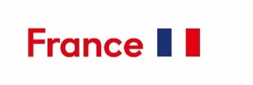

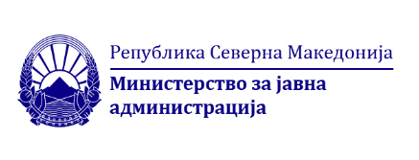
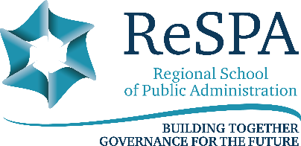
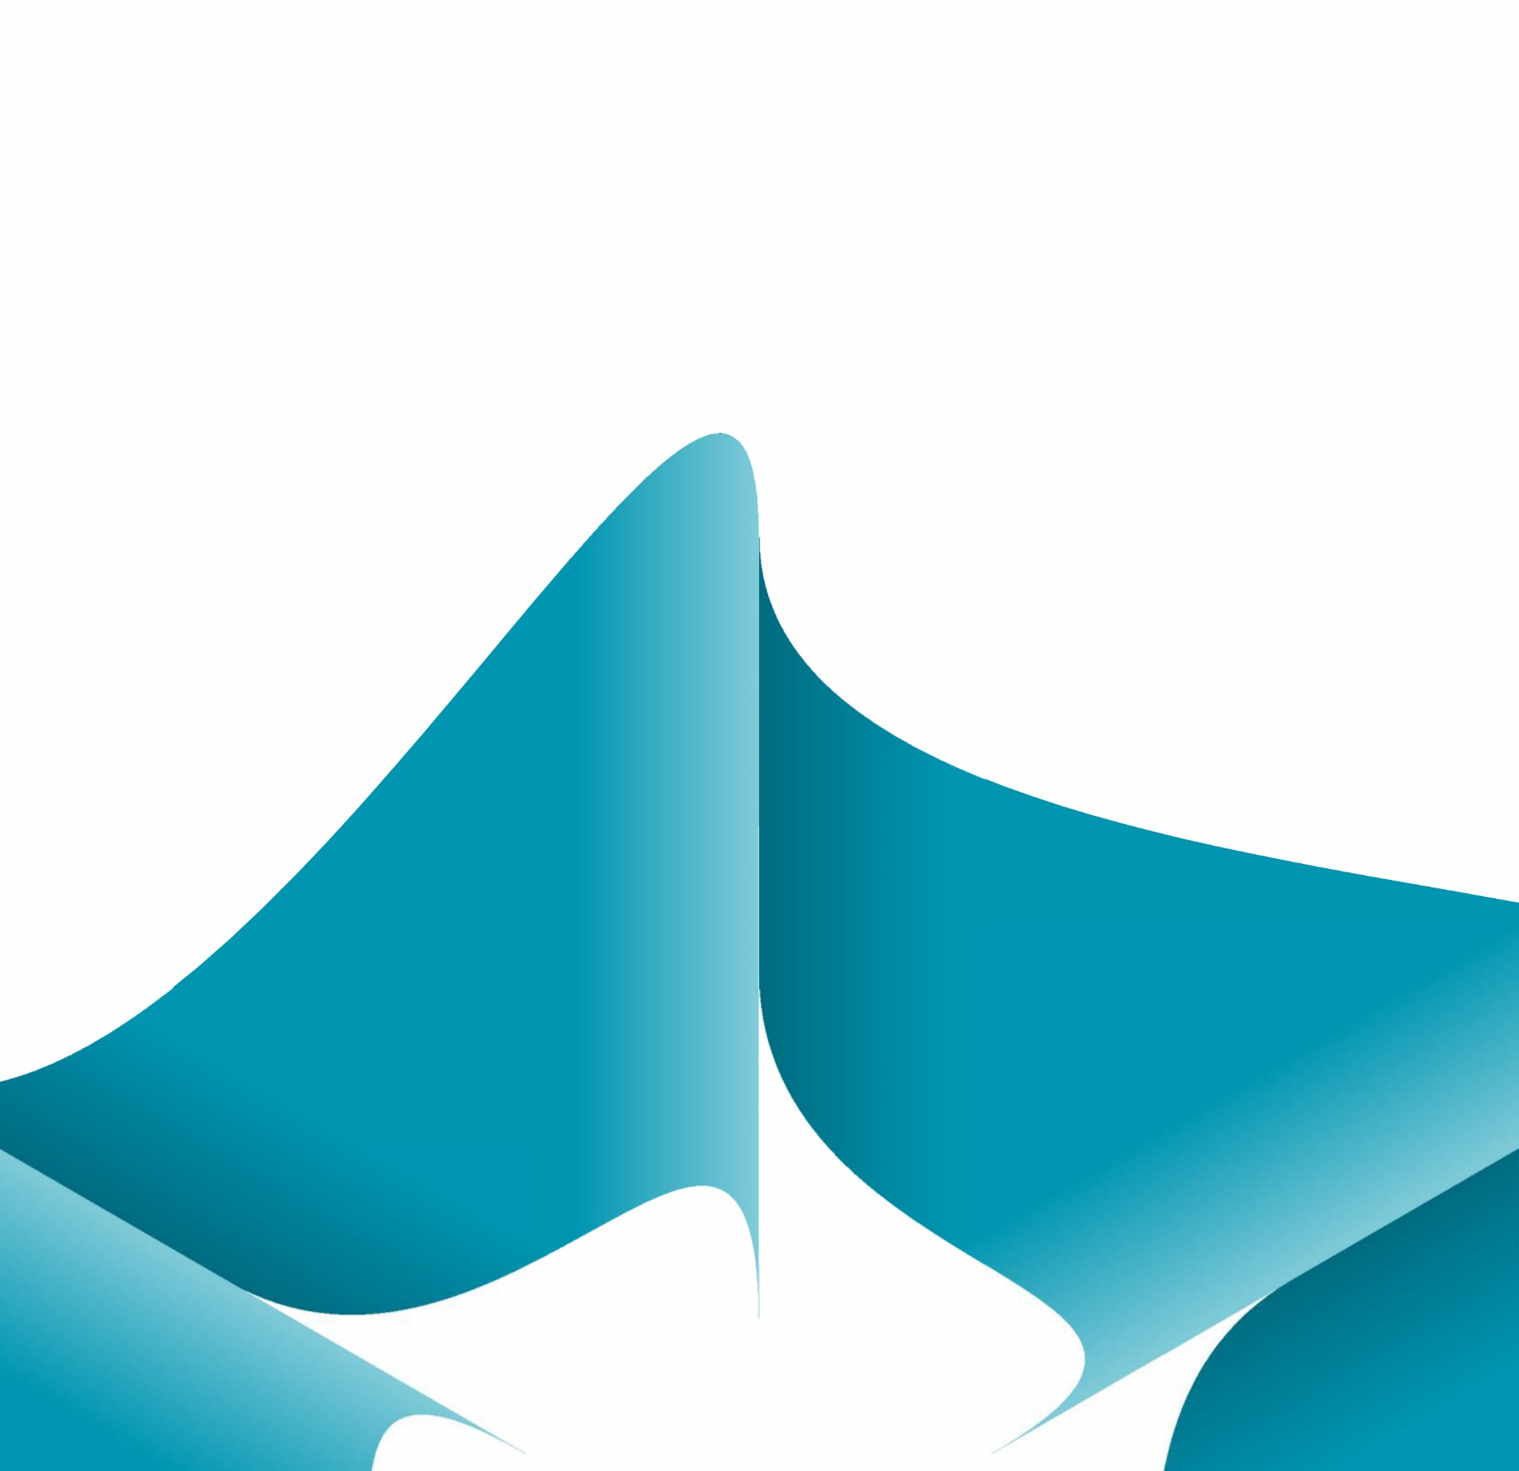
Building Capacities of Training Institutions for Public Servants
HRMPD Thematic Group Meeting
10-11 March 2026
Hotel Holiday Inn, Skopje, North Macedonia
Discussion Paper and Agenda

Background
Public administrations in the Western Balkans and the Eastern Neighbourhood are operating in an increasingly complex environment shaped by accelerated digital transformation, demographic pressures, labour market competition, geopolitical uncertainty and the demands of EU integration. These dynamics place growing expectations on the capacity, professionalism and adaptability of public servants. In this context, continuous professional development and well-structured training systems are no longer a supporting function but a strategic pillar of public administration reform, essential for ensuring effective policy implementation, high-quality service delivery and institutional resilience.

Recent assessments, including SIGMA monitoring reports, point to persistent challenges in linking training systems with broader human resource management reforms. While many administrations have made progress in developing training programmes, gaps remain in governance arrangements, quality assurance mechanisms, trainer management, evaluation of training impact and the integration of innovative learning methodologies. Training institutions often operate with limited strategic autonomy, constrained resources and insufficient capacity to respond flexibly to evolving competency needs, particularly in areas such as leadership, digital skills, evidence-based policymaking and change management.

Against this backdrop, the regional thematic group on Human Resources Management and Professional Development (HRMPD) Meeting in Skopje will focus on strengthening the institutional capacities of training providers for public servants across the Western Balkans and the Eastern Neighbourhood. The meeting is particularly timely in light of North Macedonia’s adoption of the new Law on Professional Development and Training of Administrative Servants, which establishes the Academy for Professional Development and Training of Administrative Servants as a central institutional actor. The Academy is established within the Ministry of Public Adminstration, currently working on the preparations for the establishment are supported by the Center for Change Management and the French Embassy in North Macedonia. The support covers developing the organizational structure and working procedures for multiple processes within the legal mandate of the Academy. The event will serve as a platform to examine comparative legal and organisational models, drawing on experiences from EU Member States and peer administrations, and to reflect on how training academies can be positioned to ensure professionalism, quality and sustainability.

The first day of the meeting will be dedicated to structured exchange of experience and good practices related to the core functions of public service training institutions. Discussions will cover legal frameworks and governance models, development of annual training programmes based on needs assessment, definition of training scope and methodologies, recruitment and remuneration of trainers, capacity-building of training managers, quality assurance and evaluation systems, certification of participants and the use of innovative and digital training practices. By bringing together directors of training institutions, senior training managers and EU experts, the meeting aims to identify transferable practices and practical solutions applicable across different administrative contexts.

Building on the shared knowledge and insights from the first day, the second day will adopt a problem-solving approach through World Café discussions focused on the specific challenges faced by the newly established Macedonian Academy, while also capturing common issues across the region.
These interactive sessions will facilitate peer learning, enable the mapping of challenges, good practices and support needs, and generate concrete recommendations for institutional development. The outcomes of the meeting will inform future ReSPA support under the HRMPD Thematic Group, strengthen WB–Eastern Neighbourhood cooperation, and contribute to the alignment of training systems with EU standards and principles of a professional, merit-based and future-oriented public service.
Objectives and Expected Outcomes:
Objectives:
- Strengthen the capacities of public service training institutions in the Western Balkans and the Eastern Neighbourhood in line with EU and SIGMA standards.
- Enable peer exchange on legal, institutional and operational models for public service training academies.
- Support the implementation of North Macedonia’s new Law on Professional Development and Training of Administrative Servants and the establishment of the national Academy.
- Share practical approaches to training programme design, delivery, quality assurance and innovation.
- Identify common challenges and support needs of training institutions in the region.

Expected Outcomes:
- Shared understanding of effective models for public service training academies.
- Mapped challenges, good practices and capacity gaps, with a focus on the Macedonian Academy.
- Practical recommendations to support institutional development and training quality.
- Strengthened regional cooperation among training institutions and HR authorities.
- Clear inputs for future ReSPA support and HRMPD Thematic Group activities.
Target Group
The meeting will bring together directors and senior managers of public service training institutions, and training managers from the Western Balkans and the Eastern Neighbourhood, as well as representatives of EU Member State academies and schools of public administration.
AGENDA
Tuesday, 10 March 2026
08.30 – 09.00 | Registration and Welcome Coffee
09:00 – 09:30 | Opening remarks  - Minister Goran Mincev, Ministry of Public Administration  - Maja Handjiska Trendafilova, Director of ReSPA  - Ben Nupnau, Deputy Head of the Delegation of the European Union to the Republic of North Macedonia  - H.E. Christophe Le Rigoleur, French Embassador in North Macedonia  - Neda Maleska Sachmaroska, Director of Centre for Change Management
09:30 – 09:35 | Group photo
09:30– 11:00 | From Needs Assessment to Annual Training Programmes  - Training needs assessment  - Annual training programme / catalogue  - Training for newly recruited staff  - Examinations for newly recruited staff  - Training for managerial personnel  - Record-keeping and data management  Speakers:  - Mélanie Recour, Project Leader Learning Solutions, Federal Public Service Policy & Support, Belgium  - Charlotte Duflos, Head of Communications & Partnerships, Lille Regional Institute of Administration, France  - Valentina Miličić, Assistant Director, National School for Public Administration, Croatia  - Sabrina Bandera, Head of Research, Innovation, and Strategy Division, National School of Administration (SNA), Italy  - Stanija Višekruna, Acting Assistant Director, National Academy for Public Administration, Serbia  Moderator: Aleksandra Stojanovska, Ministry of Public Administration, North Macedonia
11:00 – 11:30 | Coffee Break
11:30 – 13:00 | Trainer Management Framework and Contracting Modalities  - Selection of trainers  - Engagement of trainers  - Trainer models  - Remuneration of trainers  - Sustainability and financing  Speakers:  - Peter Vandenbruaene, Manager Key Skills Development, Federal Public Service Policy & Support, Belgium  - Charlotte Duflos, Head of Communications & Partnerships, Lille Regional Institute of Administration, France  - Valentina Miličić, Assistant Director, National School for Public Administration, Croatia  - Sabrina Bandera, Head of Research, Innovation, and Strategy Division, National School of Administration (SNA), Italy  - Dafina Dodoveci, Head of the Training and Communication Sector at the Albanian School of Public Administration  Moderator: Iskra Belcheva Ristovska, Centre for Change Management, North Macedonia
13:00 – 14:00 | Lunch Break
14:00 – 15:30 | Training Methodologies, Induction Exams and Certification  - Methodology of work  - Training methods  - Assessment and certification  Speakers:  - Mélanie Recour, Project Leader Learning Solutions, Federal Public Service Policy & Support, Belgium  - Charlotte Duflos, Head of Communications & Partnerships, Lille Regional Institute of Administration, France  - Valentina Miličić, Assistant Director, National School for Public Administration, Croatia  - Sabrina Bandera, Head of Research, Innovation, and Strategy Division, National School of Administration (SNA), Italy  - Stanija Višekruna, Acting Assistant Director, National Academy for Public Administration, Serbia  - Dalibor Ćopić, Head of Department, Civil Service Agency of the Republic of Srpska, Bosnia and Herzegovina  Moderator: Aneta Ivanova Stojanoska, Centre for Change Management, North Macedonia
15:30 – 15:45 | Summary and Closing of Day 1

Wednesday, 11 March 2026
09:00 – 09:10 | Introduction to World Café Session
09:00 – 10:30 | Quality Assurance, Evaluation, Research and Cooperation  - Quality assurance and evaluation  - Analytical and Research capacities  - Digitalisation of training delivery  - Cooperation with other training providers  - Regulation of cooperation  Speakers:  - Peter Vandenbruaene, Manager Key Skills Development, Federal Public Service Policy & Support, Belgium  - Charlotte Duflos, Head of Communications & Partnerships, Lille Regional Institute of Administration, France  - Valentina Miličić, Assistant Director, National School for Public Administration, Croatia  - Sabrina Bandera, Head of Research, Innovation, and Strategy Division, National School of Administration (SNA), Italy  - Dafina Dodoveci, Head of the Training and Communication Sector at the Albanian School of Public Administration  - Zemka Striković, Deputy Director, Human Resource Management Authority, Montenegro  Moderator: Emilija Georgieva Gjoshevski, Ministry of Public Administration, North Macedonia
10.30 – 11.00 | Coffee break
11:00 – 13.00 | World Café Session I: Challenges, Good Practices and Support Needs  - What are the key challenges?  - What works well and why?  - What can be adapted from EU, WB and EaP experiences?  - What further support is needed?  Proposed topics:  - Trainer management: selection, contracting modalities, performance assessment and methodology of work  - Training offer: scope/coverage; induction programmes and managerial programmes  - Quality assurance, evaluation and certification systems  - Analytical and research capacities (data use, monitoring and evaluation) and cooperation with other national training providers  - Digitalisation and innovative training practices  Moderator: Jelena Mrdak, ReSPA Programme Manager
13.00 – 14.00 | Lunch Break
14.00 – 15.00 | Plenary: Presentation of World Café Results  - Summary of challenges per thematic area  - Identified good practices  - Priority support needs
15:00 – 15:15 | Closing Remarks and Next Steps

