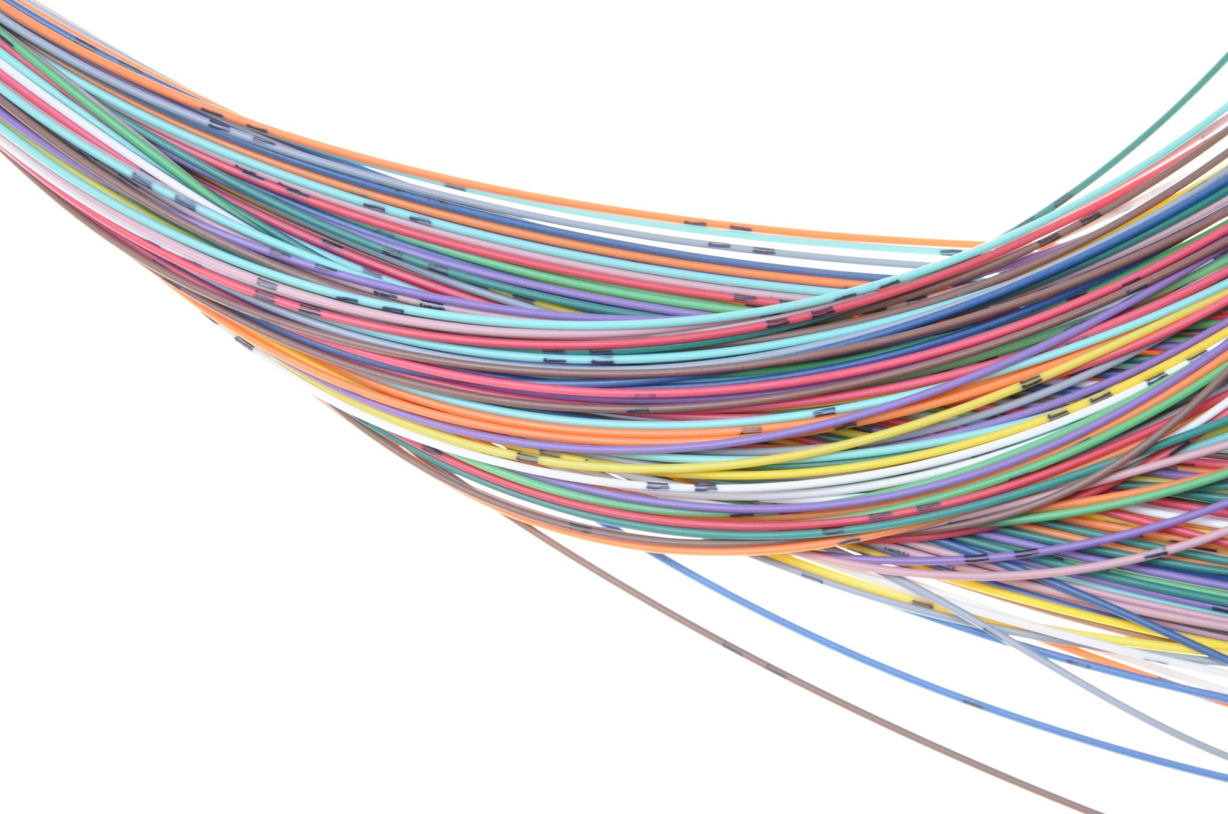
Monitoring and Reporting system Just Transition Process

Stakeholder engagement

Stakeholder engagement is critical for ensuring an inclusive, transparent, and collaborative transition process. The engagement framework for the 2025 plan includes key mechanisms for effective participation.
Stakeholder | Mechanism | Frequency | Intensity
Government entities: JTWG, JTC; TSU | Coordination meetings | Monthly | High
Local communities | Community consultative forums | Quarterly | Medium
Civil society & NGOs | Thematic roundtables | Bi-annual | Medium
International Partners (MDBs and DPs) | Coordination meetings | Quarterly | High
Private Sector | Investment Forum Sessions | Bi- annual | Medium
All stakeholders annual conference | Conference – AJTIP report and next AJTIP planning | Annual | Medium

The process includes hosting an annual Stakeholder Conference as a large-scale event aimed at evaluating implementation progress, sharing success stories and lessons learned, and encouraging collaboration and partnerships.

Proposed FreQUENCY for stakeholder reporting
Frequency | Structure and sections in the report | Responsible party/Audience
Monthly progress | Activities completed, Challenges encountered, Next steps, and  Budget utilization | MoEMMR  JTWG,
Quarterly stakeholder brief | Updates on key projects, Stakeholder contributions, and Investment progress | MoEMMR (to JTC)  International partners  JTWG  JTC
Annual Implementation Report | Overview of achievements, Gaps identified,  Financial summary, and Recommendations for the next year. | MoEMMR  International partners  JTC

Monitoring and Evaluation Framework

The Just Transition Annual implementation process adopts a monitoring and reporting mechanism to ensure accountability, tracks progress, identifies gaps, and adjusts strategies during the implementation of the Just Transition Plan. The mechanism includes:
Components of the Mechanism | Monitoring Tools | Reporting Frequency | Responsible Entities
Data collection Regularly gather quantitative and qualitative data on key performance indicators (KPIs) | Dashboard  A platform tracking real-time progress against KPIs. | Monthly progress reports supported by each working group Monthly reports Updates for use by MoEMMR, JTC and working group review. | JTWG  Collect data, monitor progress, and draft monthly updates for thematic areas. for thematic area monitoring and data collection.
Progress monitoring  Assess the status of each action area based on agreed milestones and timelines | Field visits  On-site assessments to verify progress and identify implementation challenges. | Quarterly progress reports supported by each working group Quarterly reports Detailed updates submitted to the JTC. | MoEMMR Consolidates progress reports and ensures alignment with strategic goals. Compiling reports and presenting updates to the JTC and the JTWG.
Stakeholder feedback  Collect input from communities, private sector, and institutions involved in the plan | Consultations  Engage stakeholders for feedback on impact and outcomes. | Annual stakeholder review meeting  Annual reports  Comprehensive review for stakeholders and public dissemination.
Performance Evaluation: Compare actual results against planned targets and analyze deviations | Audit reports  Third-party verification of results and financial expenditures, if existing
Reporting Summarize findings in structured reports for decision-making bodies.

Key Performance Indicators (KPIs):
Area | Indicator | Target 2025 | Data Source
Renewable energy | MW of constructed capacity by ESM | 30 MW | Ministry of Energy, Mining and Mineral Resources, MEPSO, ERC
Workforce development | Number of workers trained | 480 | ESM
Economic diversification | Private investment secured (€) | € 2 million | IFIs, Commercial banks, Chambers of commerce, Investment Forum, FITR, TIDZ
Community Inclusion | Number of low-income households supported | 1,000 | Ministry of Energy, Mining and Mineral Resources

VII. ReportING templates
Line of monthly reporting:
JTWG > MoEMMR > JTC
Monthly reporting template
Activity owner: ______________________________________________

Item | Details | KPIs (if applicable) | Responsible party | Comments/Actions required
Activity overview | - Summary of key objectives aligned with action plans. | A1: [KPI definition, target, actual]. | JTWG | Highlight significant deviations or achievements to ensure alignment with strategic goals.
Activity overview | - Overview of KPIs being tracked (e.g., A1, A2). | A2: [KPI definition, target, actual]. | JTWG
Progress update | - Key activities undertaken this month. | N/A | JTWG > MoEMMR | Provide concise updates, including completion percentages or significant achievements.
Progress update | - Major milestones reached or deliverables completed. | N/A | JTWG > MoEMMR
Challenges | - Issues encountered, such as delays, funding shortfalls, or stakeholder conflicts. | N/A | JTWG | Emphasize critical challenges needing escalation to MoEMMR for resolution.
Challenges | - Risks identified. | N/A | JTWG
Next steps | - Planned activities for the upcoming month. | N/A | JTWG | Include clear timelines and responsible entities for planned actions.
Next steps | - Milestones or deliverables expected in the next period. | N/A | JTWG
Stakeholder engagement | - Summary of stakeholders engaged (e.g., consultations, meetings, partnerships). | N/A | JTWG | Indicate how stakeholder feedback will be incorporated into subsequent activities.
Stakeholder engagement | - Key insights or recommendations provided by stakeholders. | N/A | JTWG

Line of quarterly reporting:
JTWG > MoEMMR > JTC
Quarterly progress report
Section | Details | Responsible Party | Comments/Actions Required
Executive Summary | -High-level overview of progress and key achievements. | MoEMMR | Ensure alignment with strategic goals and communicate major wins effectively.
Executive Summary | - Summary of critical updates since the previous quarter. | MoEMMR
Progress by action area | Renewable Energy: | MoEMMR, JTWG | Add narrative analysis and highlight areas needing improvement.
Progress by action area | - Key milestones achieved (e.g., installations, capacity added). | MoEMMR, JTWG
Progress by action area | Workforce Development: | MoEMMR, JTWG
Progress by action area | - Training sessions conducted. | MoEMMR, JTWG
Progress by action area | - Beneficiaries reached. | MoEMMR, JTWG
Progress by action area | Economic Diversification: | MoEMMR, JTWG
Progress by action area | - Projects launched, ongoing, or completed. | MoEMMR, JTWG
Progress by action area | - Economic impact metrics. | MoEMMR, JTWG
Key Performance Indicators | - Indicator (e.g., RE capacity installed, workers trained). | MoEMMR, JTC | Ensure clear visualization with graphs or charts for trends.
Key Performance Indicators | - Target for Quarter. | MoEMMR, JTC | Ensure clear visualization with graphs or charts for trends.
Key Performance Indicators | - Actual Result. | MoEMMR, JTC | Ensure clear visualization with graphs or charts for trends.
Key Performance Indicators | - Variance (if any). | MoEMMR, JTC | Ensure clear visualization with graphs or charts for trends.
Key Performance Indicators | - Comments on Variance. | MoEMMR, JTC | Ensure clear visualization with graphs or charts for trends.
Challenges and risks | - Description of challenges encountered (e.g., policy delays, stakeholder issues). | MoEMMR, JTC | Emphasize strategic implications and propose actionable solutions.
Challenges and risks | - Mitigation actions taken. | MoEMMR, JTC
Challenges and risks | - Ongoing or potential risks. | MoEMMR, JTC
Stakeholder feedback | - Key insights from consultations, surveys, or field visits. | JTC | Categorize feedback by stakeholder type and relevance to action areas.
Stakeholder feedback | - Summary of recommendations from stakeholders. | JTC
Financial overview | - Expenditure by action area (planned vs. actual). | MoEMMR, International Partners | Include detailed annex for financial breakdown, if required.
Financial overview | - Cumulative expenditure to date. | MoEMMR, International Partners | Include detailed annex for financial breakdown, if required.
Financial overview | - Major deviations from budget allocations. | MoEMMR, International Partners | Include detailed annex for financial breakdown, if required.
Recommendations | - Adjustments proposed for the next quarter. | All stakeholders | Highlight time-sensitive or critical recommendations for immediate consideration by decision-makers.
Recommendations | - Rationale for changes (e.g., aligning resources, revising targets). | All stakeholders
This structure will ensure clarity, facilitates quick reviews at each stage, and highlights areas requiring attention or action.
In order to better optimize the reporting process, the following activities will be developed early 2025:
- Develop standard templates for JTWG to fill out before submission to ensure uniformity.
- A dashboard or graphs for KPIs to allow quick understanding of progress and bottlenecks.
- Categorize challenges by severity to prioritize resolution efforts.
- Include a feedback loop mechanism to update stakeholders on how their input influenced plans or decisions.

